Angular

Planning:

ANGULAR FRONTEND (TYPESCRIPT->JAVASCRIPT+STRONG TYPING) -> SPRING BOOT REST API (JAVA) -> SECURITY AND AUTHENTICATION SETTINGS -> DATABASE.

Architecture:

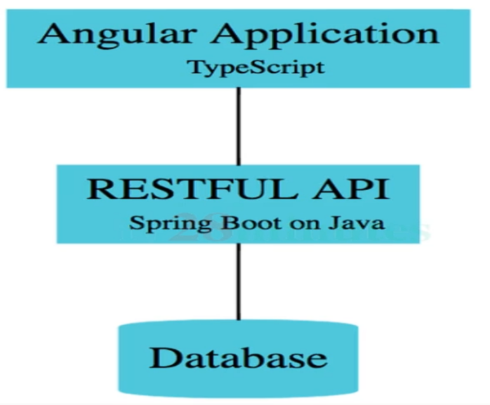

BROWSER->ANGULAR APP->RESTFUL API->DATABASE -> RESTFUL API->ANUGLAR APP->ROWSER

The angular structure use the modern JavaScript, where you have the HTML,CSS and JavaScript files separated, but imported as a single file and the dependencies are known as modules.

import {Component} from “@angular/core”<-module;

ES7

@Component({

selector: ‘app-root’->tag that will say where the component will be rended on index.html=> <html><app-root></html>

templateUrl: ‘./app.component.html’;

styleUrls: [‘./app.component.css’]

})

export class AppComponent {

title = ‘todo’;-> property / atribute;

}

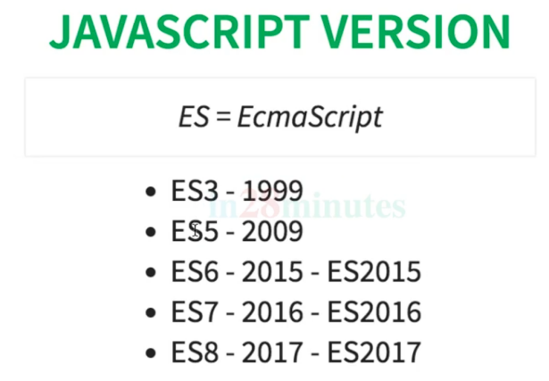

EcmaScript is the pattern established like an interface and the javascript is the implementation.

JavaScript x JavaxTypeScript

JS-> No types

var value; (undefined type, can receive any type)

value = 5 (number)

value = “five” (text)

function add (number1,number2) {

return number1+number2;

}

interface DoSomething{}

JAVA-> With types

int value; (defined type to receive specific type of value)

value = 5 (number)\/

value = “five” (text)XXX Compilation error

public int add (int number1, int number2) {

return number1+number2;

}

public interface DoSomething{}

TypeScript

value:number; (defined type to receive specific type of value)

value = 1 (number)\/

value = “five” (text)XXX Compilation error

function add (number1: number,number2:number):number {

return number1+number2;

}

interface DoSomething{}

For creating and managing the angular projects we use the command line interface from Angular (angular cli), installing the node packages through <https://nodejs.org/en/download>, then npm install -g @angular/cli.

Once installed, we have the below commands:

* **ng new** project name -> it creates the whole structure for an angular project;
* **ng lint (sonar)** -> it checks if the code is following the pattern of clean code;
* **ng build->** it generates an ‘.apk,.exe’ of the project that is compiled to run in an external server with all the files html, css and where .ts was translated to .js;
* **ng dist ->** once built, it runs the app on prod;
* **ng test->** it generates and run the test scenarios with the name of specifications to point success or failure;
* **ng e2e->** it builds the app, test it and run it to confirm if there are errors in the process
* **ng generate->** it creates new components,routes, configs and services
* **ng serve->** it runs the application locally.

The directory app with all the components needed and the routes, in the root, assets for images,videos,sounds, environments for local or prod env. We have the package.json where we define the modules that will be used, the main.ts where we initialize the application telling we want to up the content from appComponent as the root component, the index.html that is the page that will be first loaded with a base html page and the content of the root component, also we have the styles.css file containing the global css for the app.

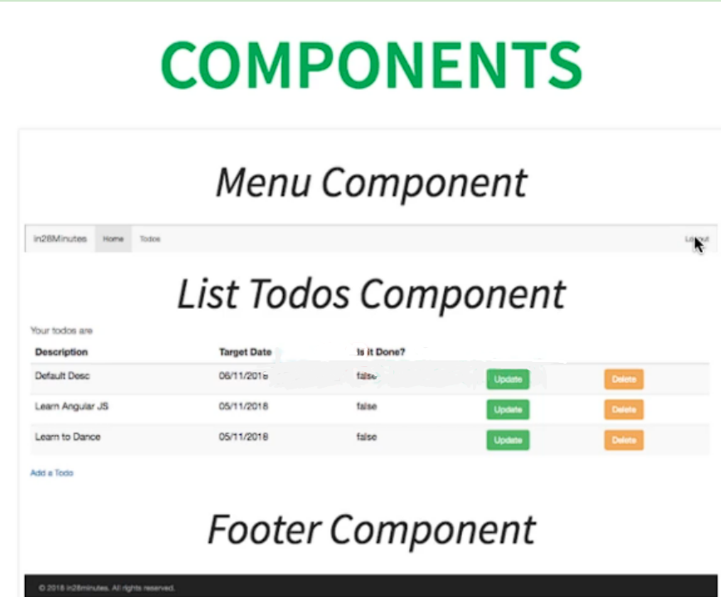

Components represent parts of the page that will return the template (html), the style (css) and the interaction (typescript) when clicking in some button for example update a to do, delete a todo, add a todo.

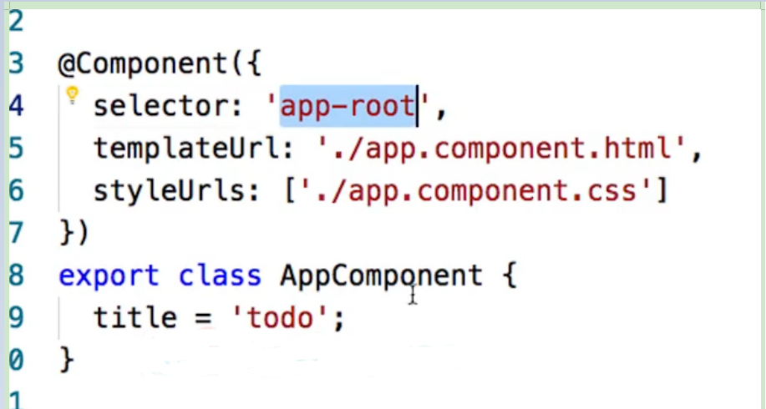

@Component is the decorator like an annotation that identifies the class as a component that will import the html and css content.

As parameters, we pass the selector that will represent the tag to be render in the index.html with whole content comprising the template and the style .

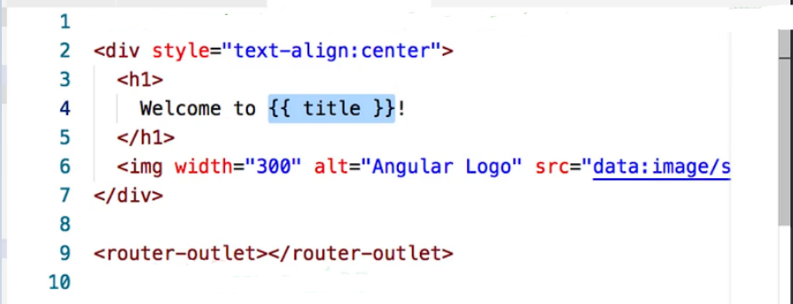

The property ‘title’ is defined in the typescript class and its value can be used in the template through the **interpolation** **{{**property**}}**, being part of data biding from component to template.

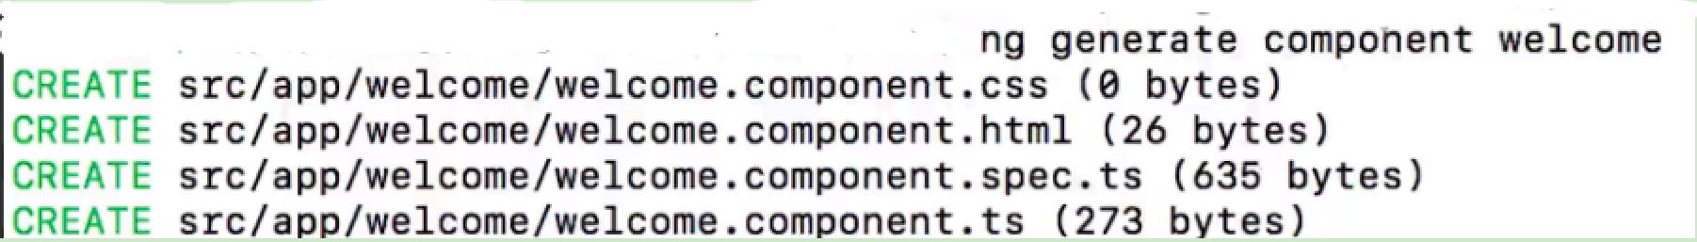

To create a new component considering all the four files (html,css,spec.ts, ts) at once, we use the command ng generate component ‘name’ in a separate terminal.

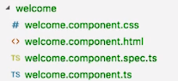

So, to render this new component, we need to import it to the root component:

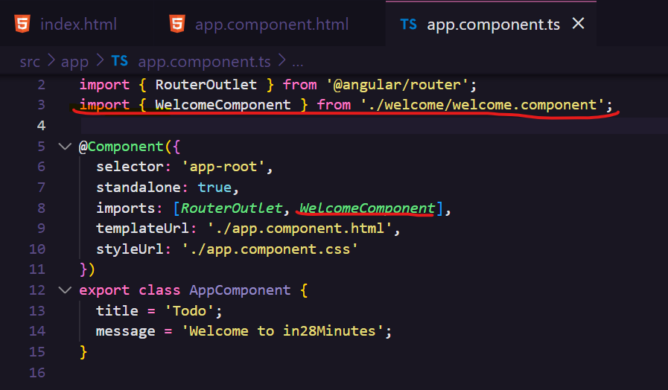

And then use its content in the root template through the tag:

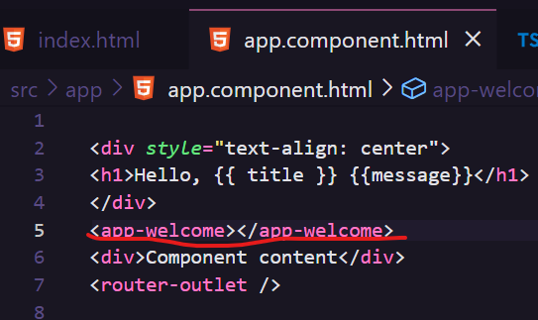

Having one component inside another.

The reason why the new component doesn’t need to be declared on @ngModule on app.module.ts to be used is that, since angular 13, it is independent and just need to be imported to be used in any place.

**Standalone Update: Why Angular Standalone Components?**

Angular 13 has introduced a novel functionality known as Angular standalone components. These components streamline the process of Angular development and minimize the need for repetitive code. Unlike conventional Angular modules, you DO NOT need to have NgModule files for standalone components. Consequently, you can effortlessly import and utilize them in any section of an application.

#### Benefits

* Improved Developer Experience
* Increased modularity
* Improved performance

More details here :  [https://github.com/in28minutes/full-stack-with-angular-and-spring-boot/blob/master/step-by-step-changes-to-standalone.md#why-angular-standalone-components](https://github.com/in28minutes/full-stack-with-angular-and-spring-boot/blob/master/step-by-step-changes-to-standalone.md" \l "why-angular-standalone-components" \t "https://wipro.udemy.com/course/full-stack-application-development-with-spring-boot-and-angular/learn/lecture/_blank)

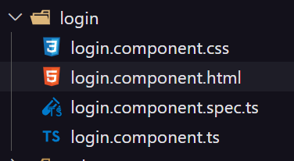

ng generate component login --skip-import --standalone

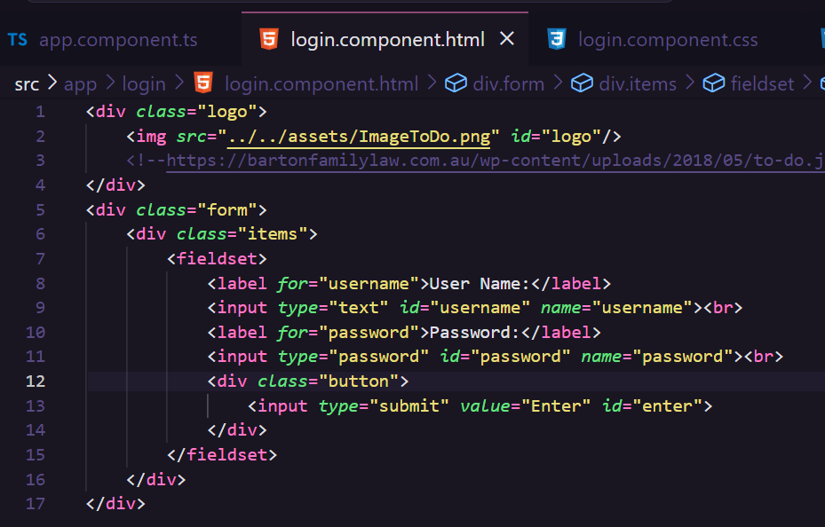

*.logo* {

    display: flex;

    justify-content: center;

    align-items: center;

    margin-top: 50px;

}

*.logo* img*#logo* {

    height: 280px;

    width: 280px;

}

*.form* {

    display: flex;

    justify-content: center;

    align-items: center;

    min-height: calc(100vh - 625px);

}

*.items* {

    display: flex;

    justify-content: center;

    align-items: center;

    background-color: #fff740;

    font-family: 'Gill Sans', 'Gill Sans MT', Calibri, 'Trebuchet MS', sans-serif;

    font-size: 22px;

}

*.items* fieldset {

    border: 2px solid black;

}

*.items* label,

input {

    margin: 20px;

}

*.items* label {

    color: black;

    font-weight: 700;

}

*.items* input {

    color: white;

    font-weight: 700;

    background-color: purple;

    padding: 5px;

    border: 2px solid black;

    border-radius: 30px;

}

*.items* input*#password* {

    margin-left: 38px;

}

*.button* {

    display: flex;

    justify-content: center;

    align-items: center;

}

*.button* input*#enter* {

    margin-top: 15px;

    background-color: purple;

    font-weight: 700;

    color: white;

    font-family: "Gill Sans", "Gill Sans MT", Calibri, "Trebuchet MS", sans-serif;

    font-size: 25px;

    padding: 15px;

    border: 2px solid black;

    border-radius: 30px;

    cursor: pointer;

}

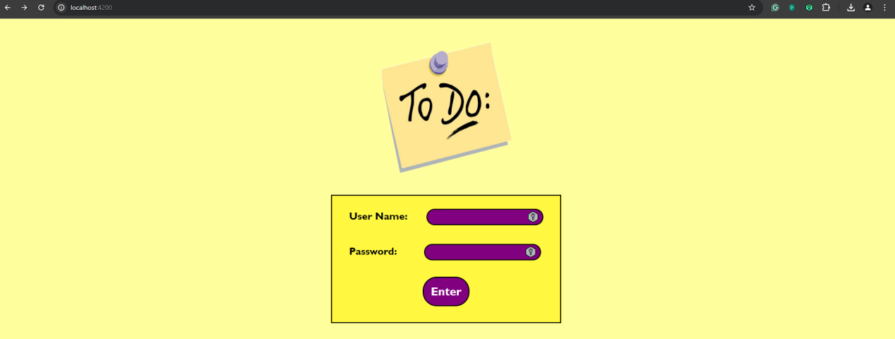

Now once, we write the username and password, we want to make the login actually. For that happening, we declare the click event in the button between parenthesis (click) then we point what action should be thrown like below:

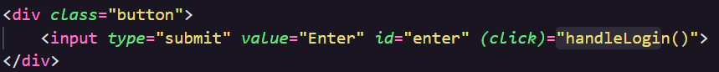

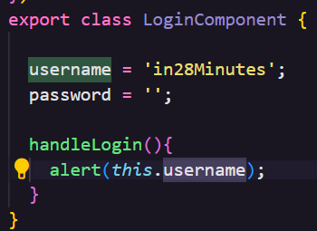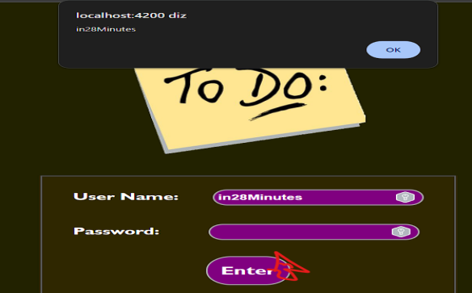

This thrown action is defined in the logic view (component), in the example we show the value of the property username.

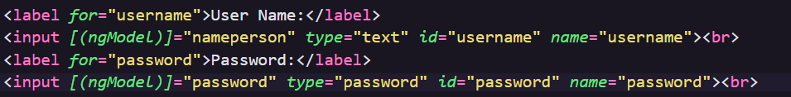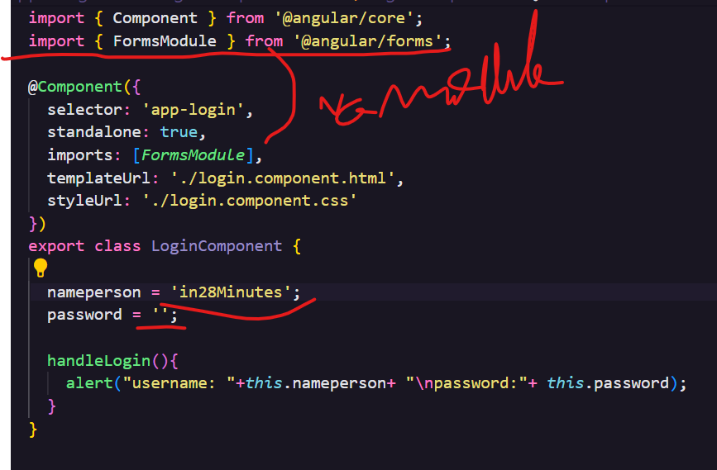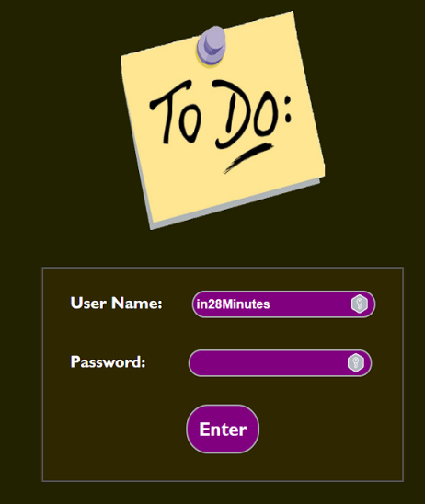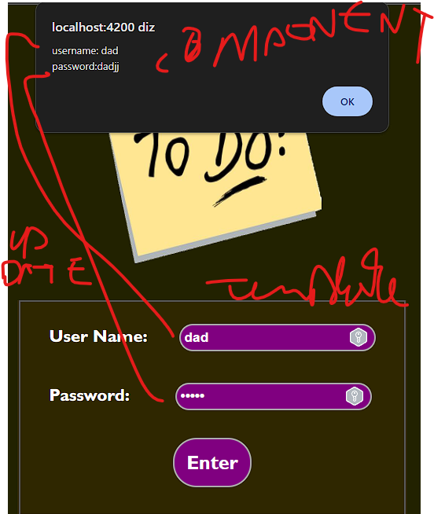

The banana in the box approach [()] is a mix of interpolation and event biding because inside the template, we recover the value of the component property and update its value when typing new values in the template through [(ngModel)]=”property” this is called two-way biding, as in, the data link between component and template, template and component.

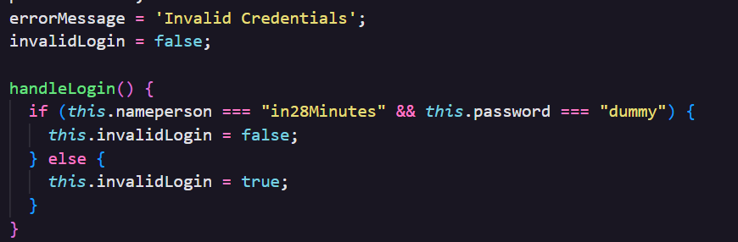

For a simple authentication step for now, we can hardcore it, creating properties for showing that the login is invalid or not through a text and a state checking the username and password.



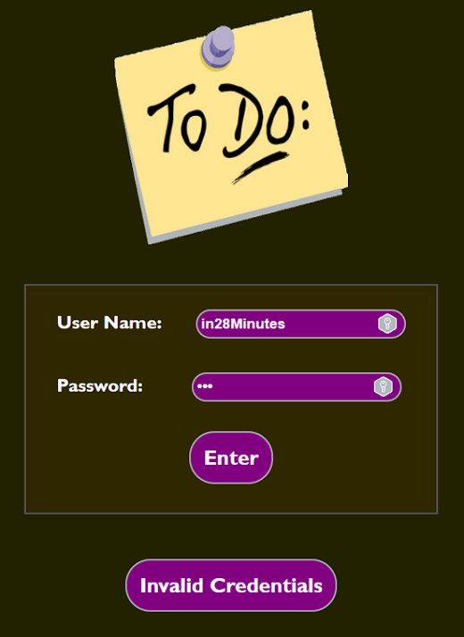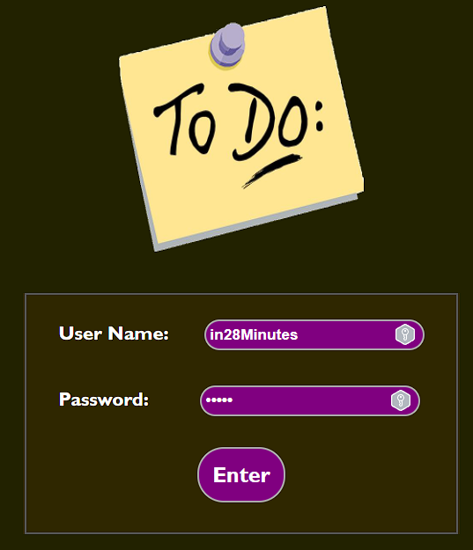

This is an opportunity for another directive (broaden the meaning), for showing the message or not in the template, we use *ngIf=”state”, as in, if the state is true the content is displayed, if the login is invalid show the message error.

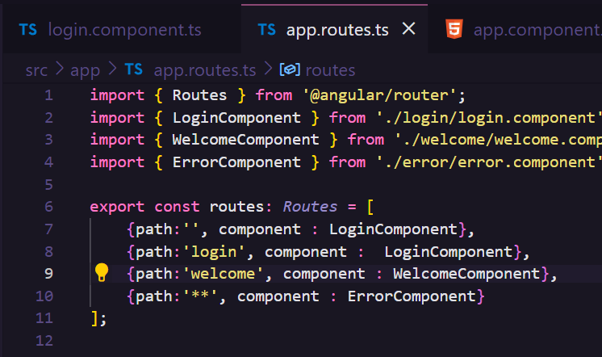

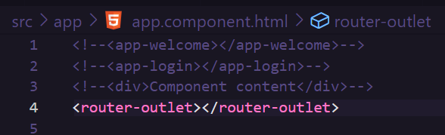

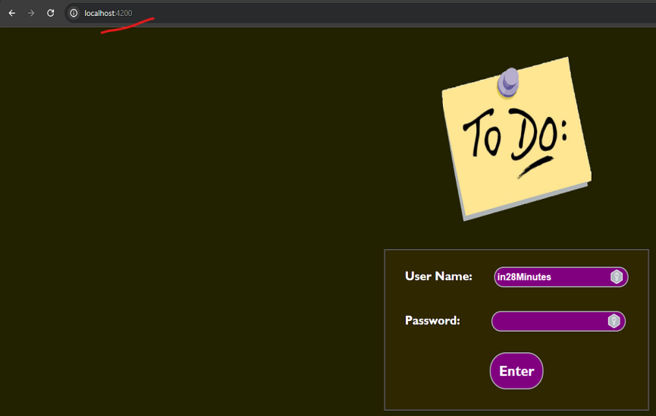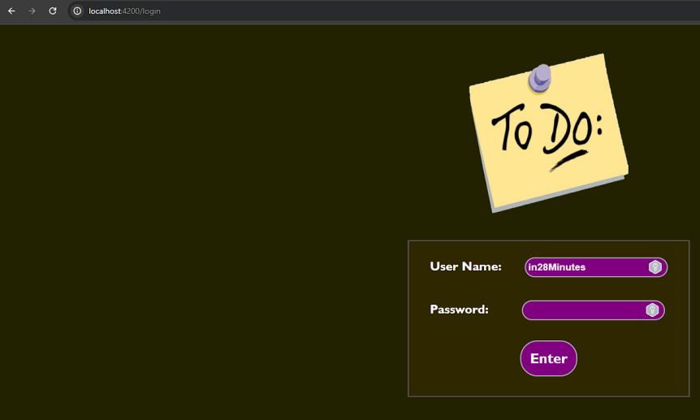

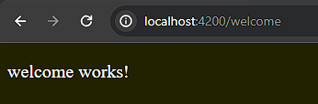

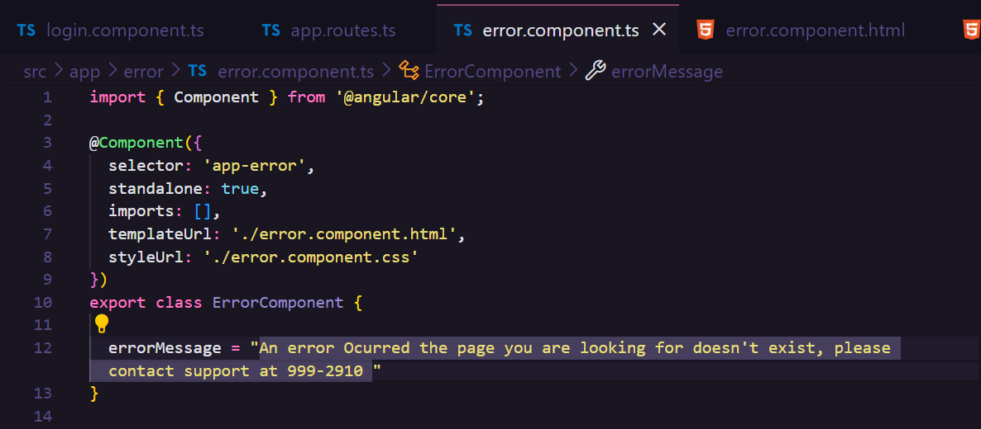

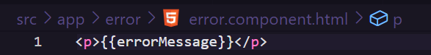

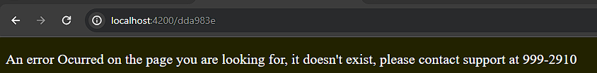

The next step is to ‘route’ our components, as in, map the possible routes(endpoints,urls) and render the specific component, in case any invalid route is typed (**) like a 404 page(not found) render the specific component.

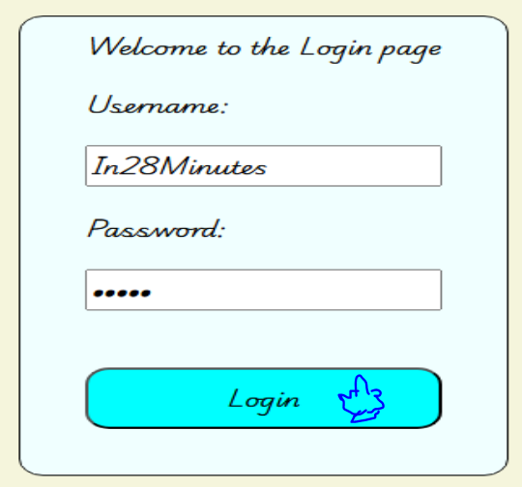

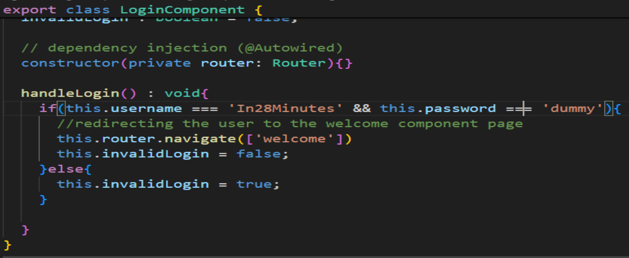

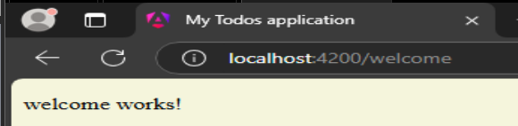

To make the login button redirect the user to the welcome page, in login typescript file is needed to include a dependency injection of the **router module** for then use it when the correct username and password be entered, the browser navigates to the welcome page (component).

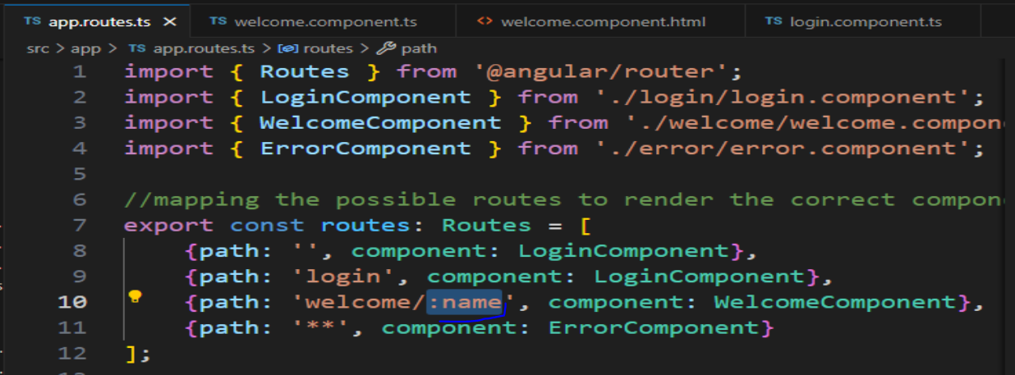

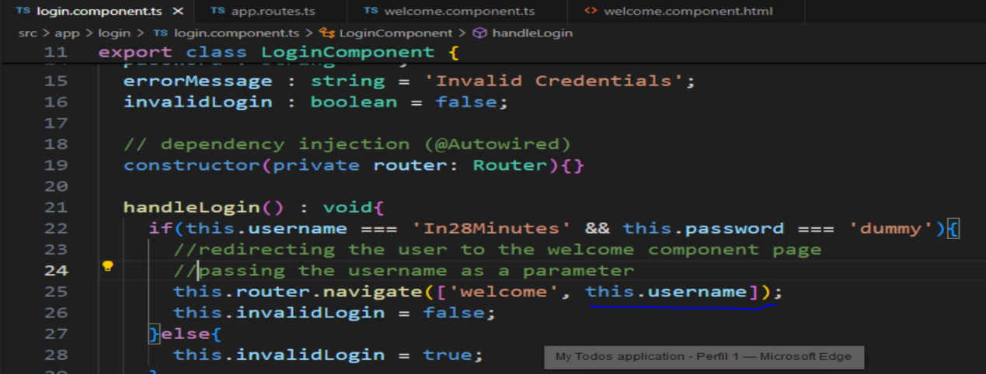

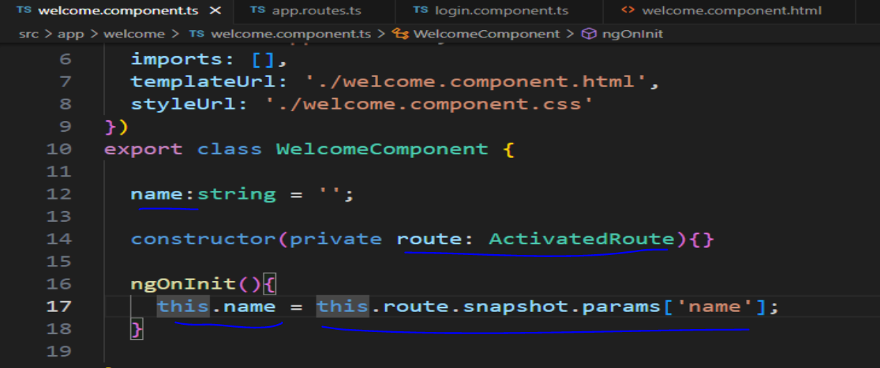

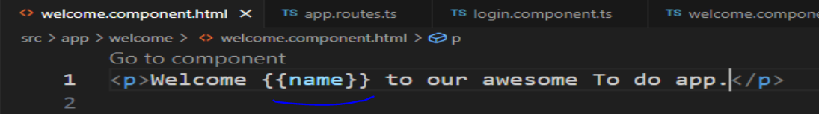

On the welcome page, we want to identify the user that is logged in our application, for that, it is needed to declare on app.routes, the welcome path with the parameter -> **path: ‘welcome/:name’**. On the login file, pass the parameter when redirecting to the welcome page -> **this.route.navigate([‘welcome’, this.username]).**

On the welcome file(.ts), capture its value using the constructor, through the dependency injection object of the type **ActivatedRoute,** set this value to a property to be shown in the template via interpolation -> **this. name = this.route.snapshot.params[‘name’] (.ts) {{name}} (.html).**

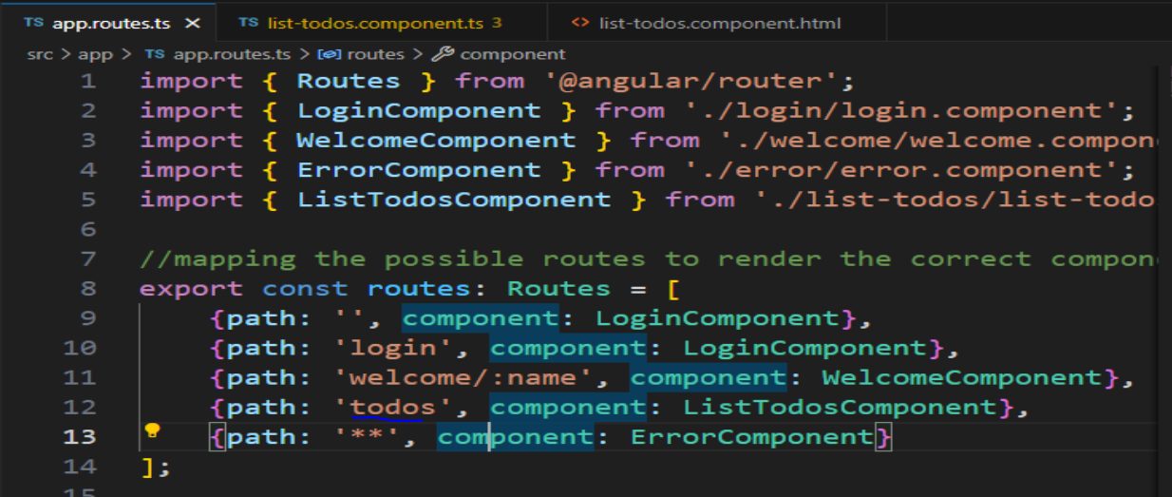

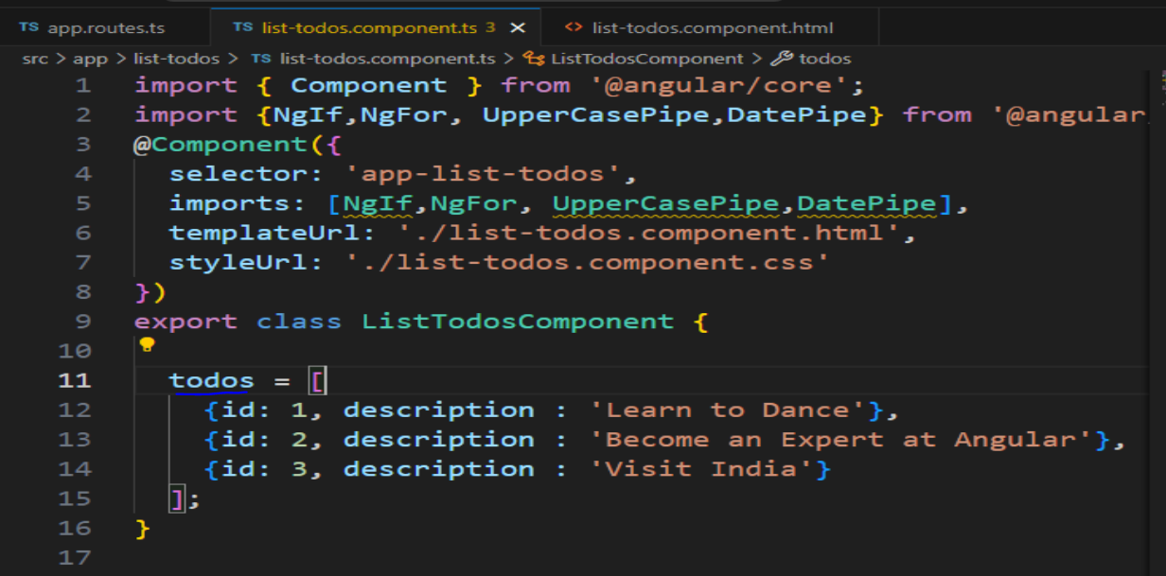

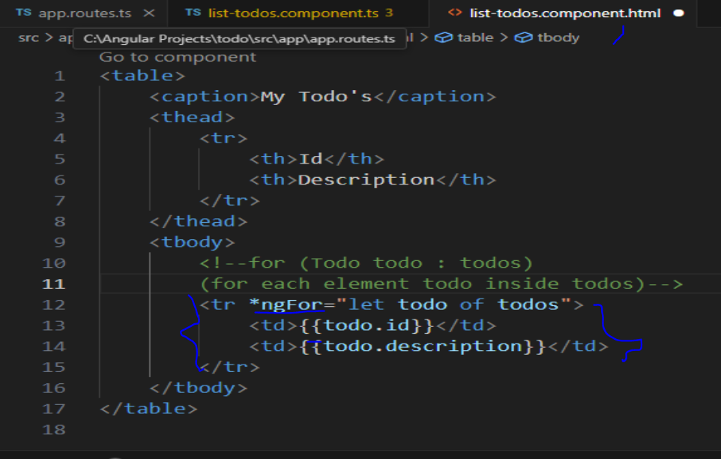

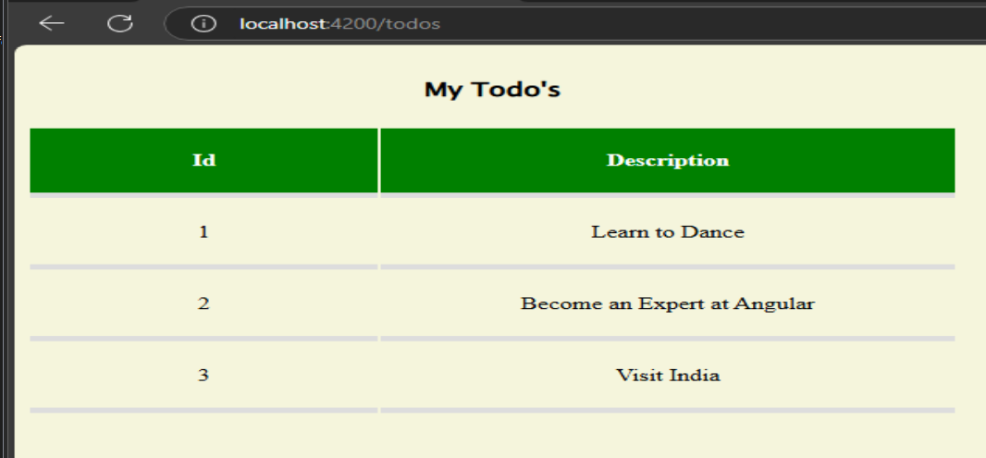

On the listTodo component, we want to create a list of todos. We map this component on app.routes.ts ->**{path: ‘todos’, component: listTodoComponent}.** Create a list of todos on the ts file -> **todos = [{id: 1, description: ‘Learn to dance’},{id:2, description: ‘Become an Expert at Angular’},{id: 3, description: ‘Visit India’}].** On the template inside the table structure -> **<tr *ngFor=’ let todo of todos’><td>{{todo.id}}</td><td>{{todo.description}}</td></tr>** , the directive *ngFor represents the repeating structure **for,** making looping a list, as in, sweeping the list saying for each element inside the list do an action.

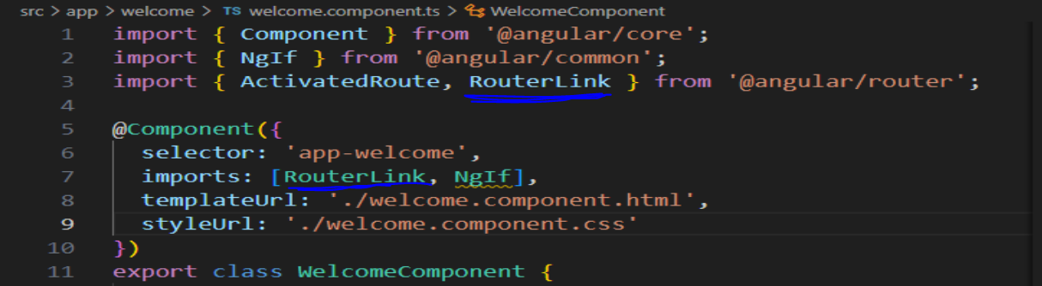

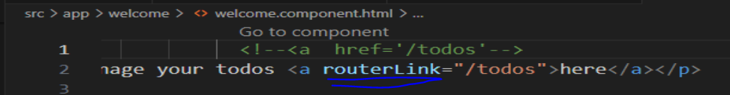

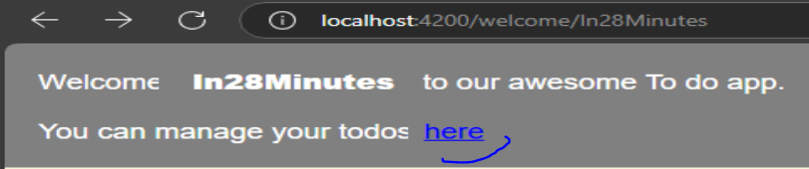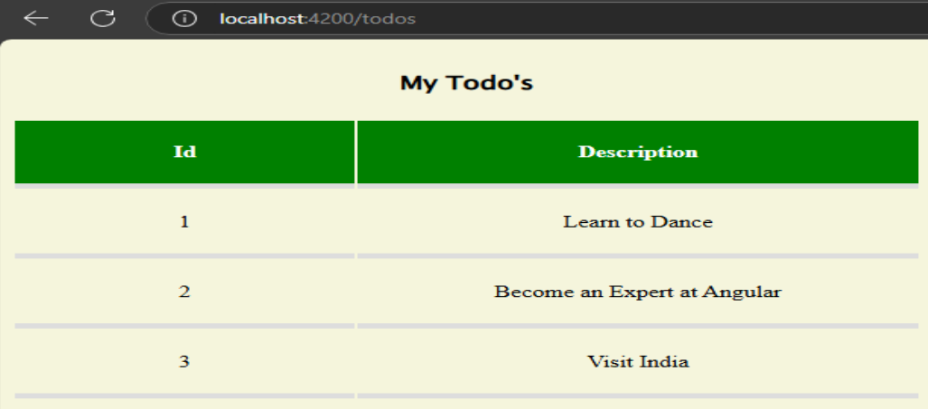

Another way to navigate between components is to create a link to connect them, to solve this, the **routerLink directive** is used inside the **<a>** tag as an attribute.

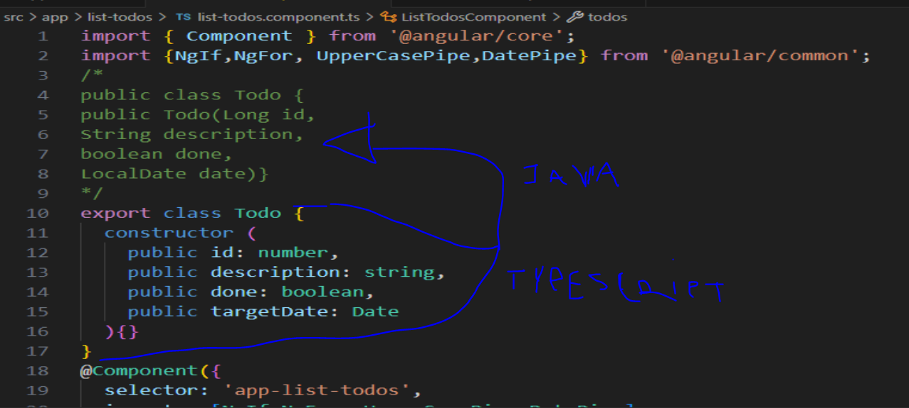

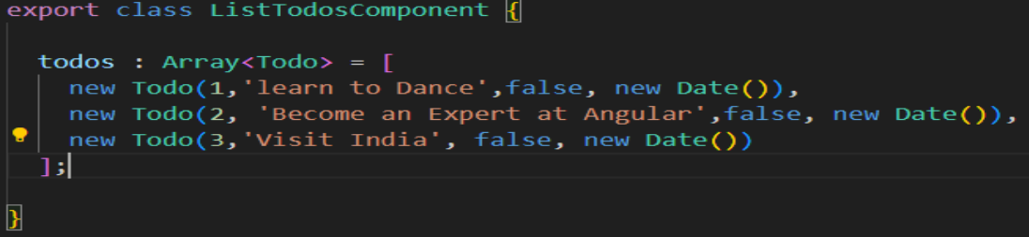

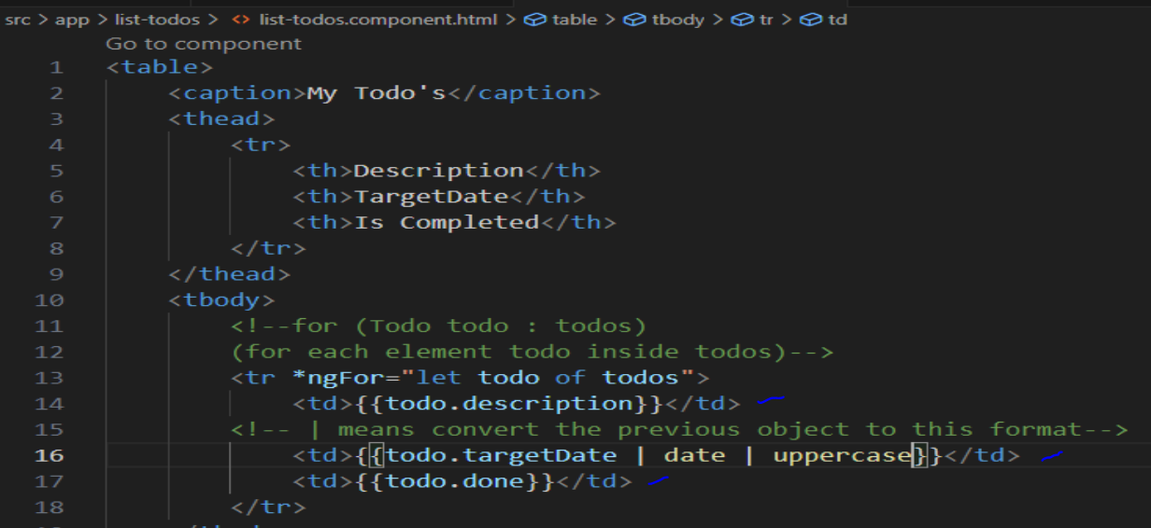

A more feasible way to control the todo’s list, it is to create a todo class -> **export class Todo {constructor(public id: number, public description: string, public done:boolean, public targetDate: date)}**(todo.ts) to create objects / instances of this class -> **todo : Array<Todo> = [new Todo(1, 'learn to Dance', false, new Date()]**(todo.ts). Then, render the content on the template table -> **<tr *ngFor=”let todo of todos”><td>{{todo.description}} </td><td>{{todo.targetDate | date | uppercase}}</td><td>{{todo.done}}</td> </tr>.**

Just a quick review about modules, any .ts file can be consider one module that will contains the logic or functionalities of the system with one or more classes in it and in angular all these files together make part of a group of components that will for form an angular module to be rendered on the screen (template), like this: @NgModule({ declarations: [ AppComponent, WelcomeComponent,LoginComponent,ErrorComponent,ListTodosComponent].

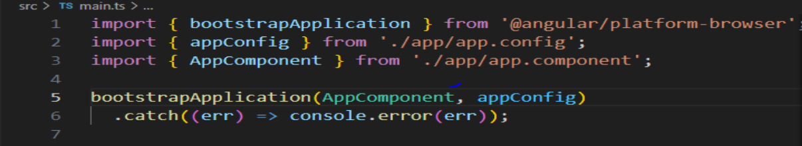

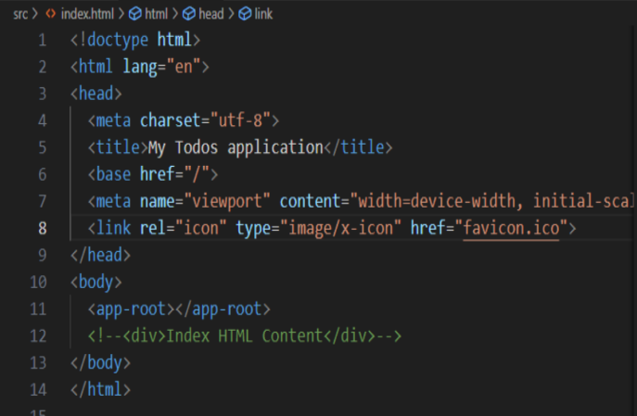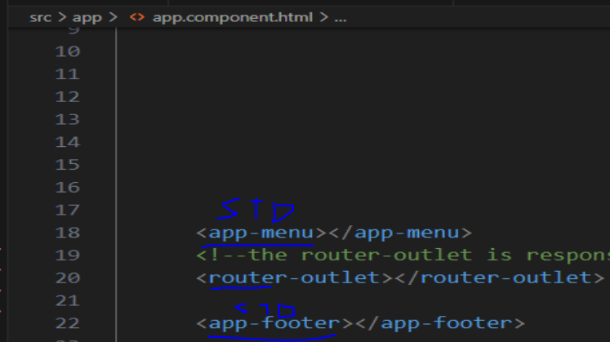

As a quick review, the appComponent is the root component, because it’s always the first component to be rendered in the index.html (root template). It’s because the **angular** bootstrap is used to initialize the appComponent as the root component along with the routes of the project and the standalone components to be rendered at the **index.html** (<app-root>).



On the project, the bootstrap will be used as a framework to style the application in a more optimized way, instead of CSS styles codes directly.

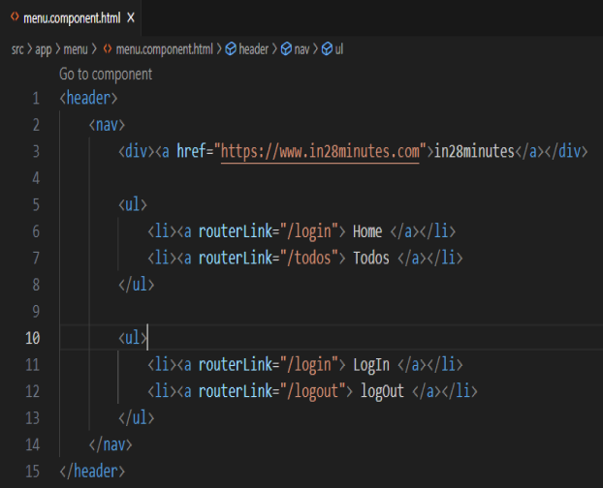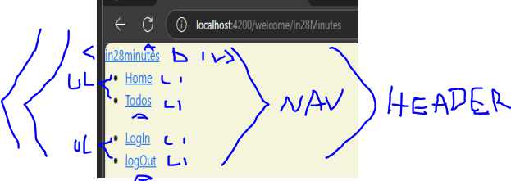

Using the html structure and angular on template, the tags are:

<header> means that everything in header, will be consider a header area </header>¹

<nav>means that everything in nav, will be consider a navigation area</nav>¹

<div> division area <a routerLink²=”route”> with an anchor to redirect to another route </div>

¹ semantic meaning, not visual

² angular directive to communicate template and logic view to replace the href attribute

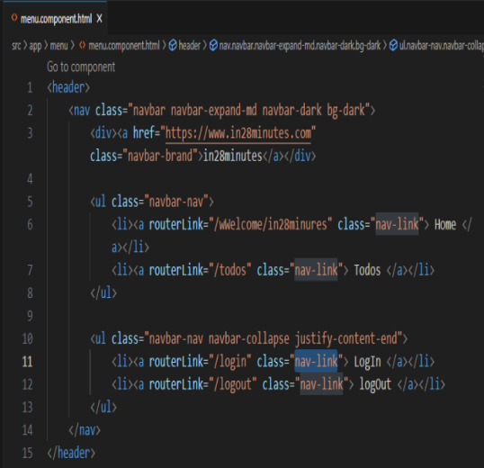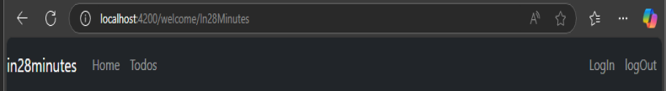

Bootstrap css classes:

navbar -> style to identify the navigation bar

navbar-expand-md -> style to expand the navigation bar in medium size

navbar-dark bg-dark -> style to change the background color of the navigation bar to dark black

navbar-brand -> style to stand out the brand

navbar-nav-> style to identify the navigation bar and padding

navbar-collapse justify-content-end -> style to identify the navigation bar and align the items at the right corner ending

nav-link-> navigation link style

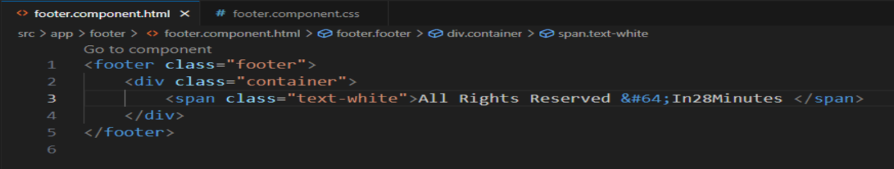

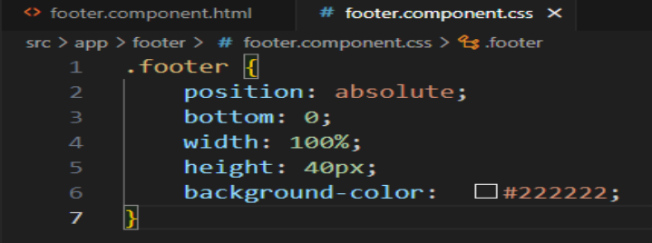 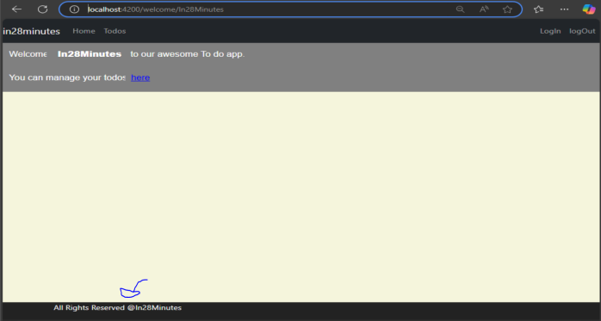

&#64; -> @ symbol

The tag <footer> means that content inside it will be the footer area.

The tag <span> means a little piece of content with less importance

Bootstrap css classes:

container

text-white

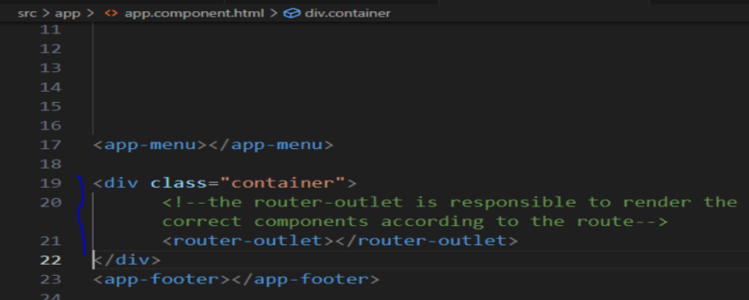

Class container used to give more padding and centering the content properly

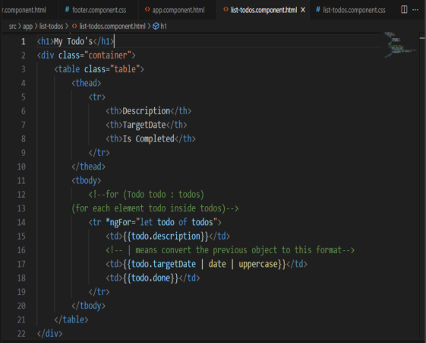 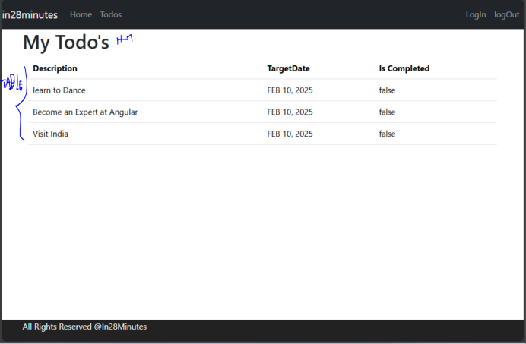

For the todo component, apply the same “container” on the table and include the class “table” for bootstrap gives a better centering on the content and give some style to the table.

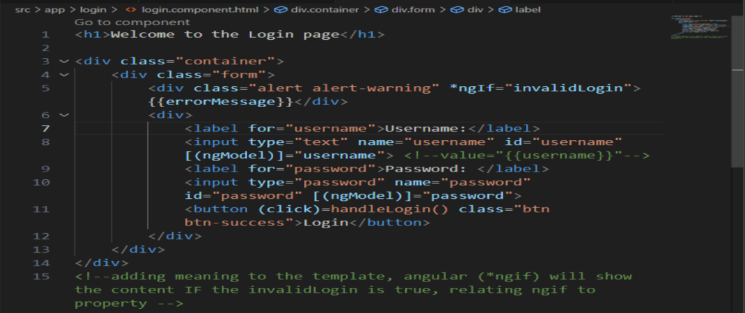

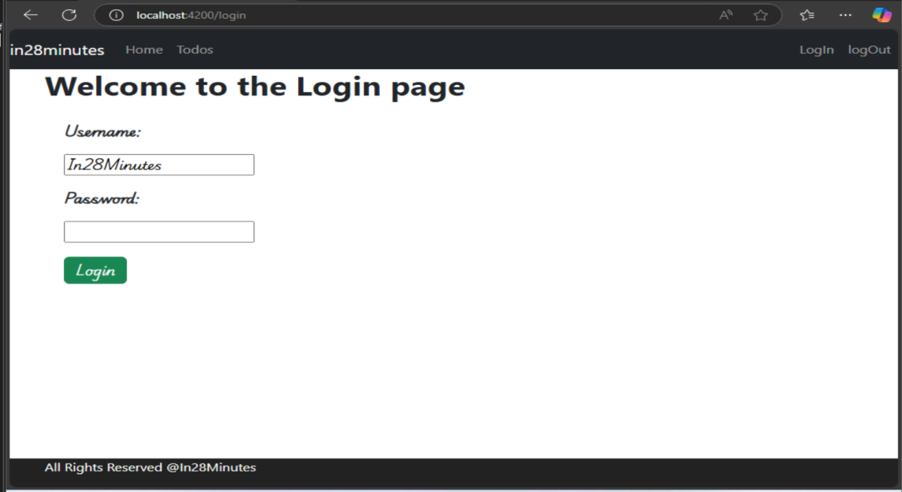

For the login component, apply the same container, the alert alert-warning for invalid login field and the btn btn-success for the button.

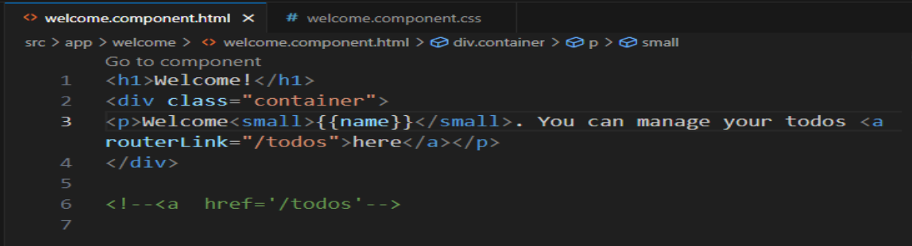

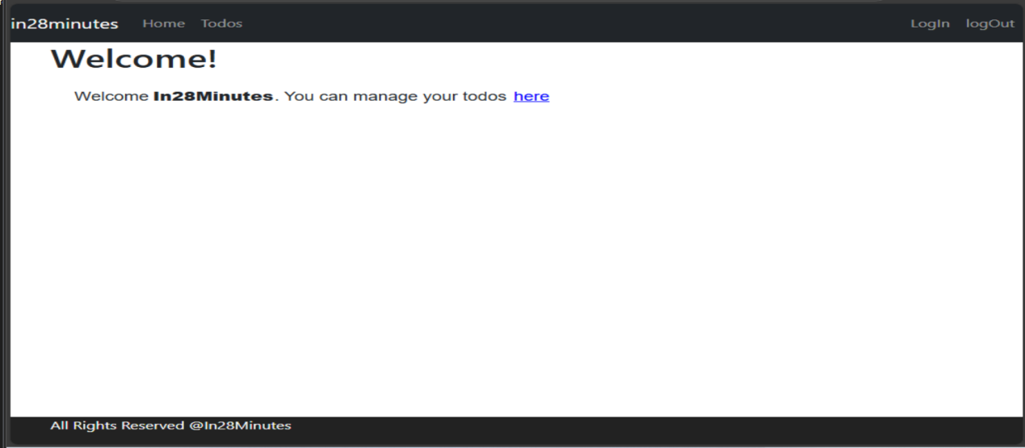

For the welcome component, apply the same container.

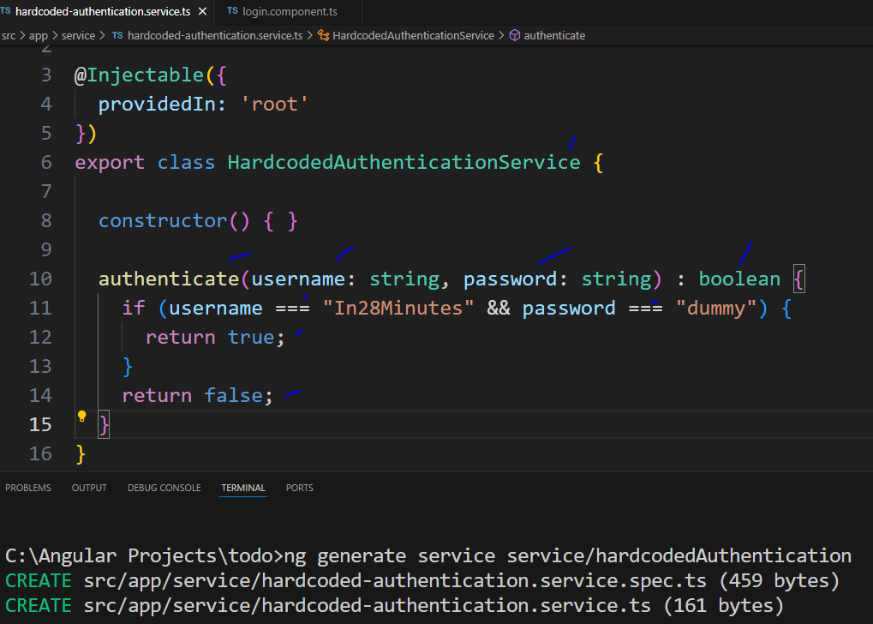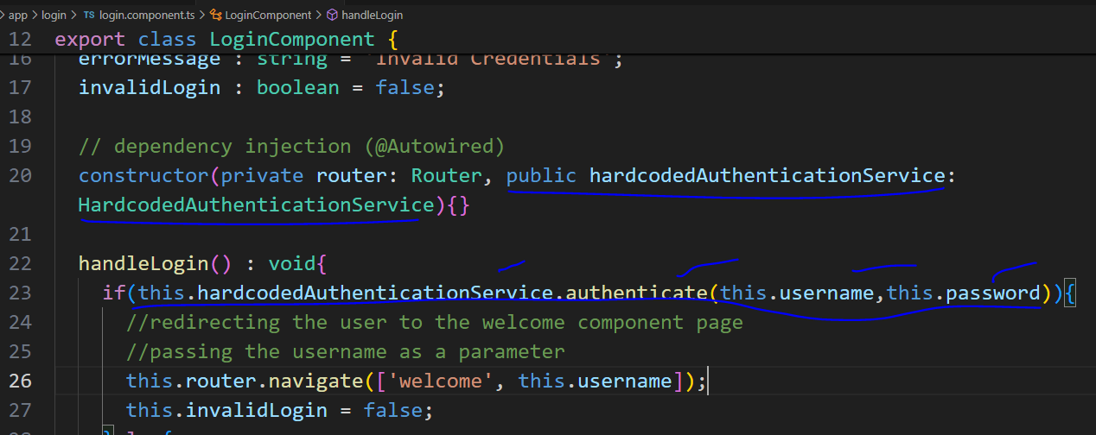

Now for improving the authentication logic, it is needed to create a service to center the authentication logic (business rules) **for all components**. For that, on the terminal, **ng generate service service/hardcodedAuthentication**. The service will contain the @Injectable decorator, to identify the class as a service, and be injectable/reusable in any part of the project through dependency injection on the component constructor. The logic used in the service is to verify if the username and password parameters are the expected ones, if it’s okay, return true else false.

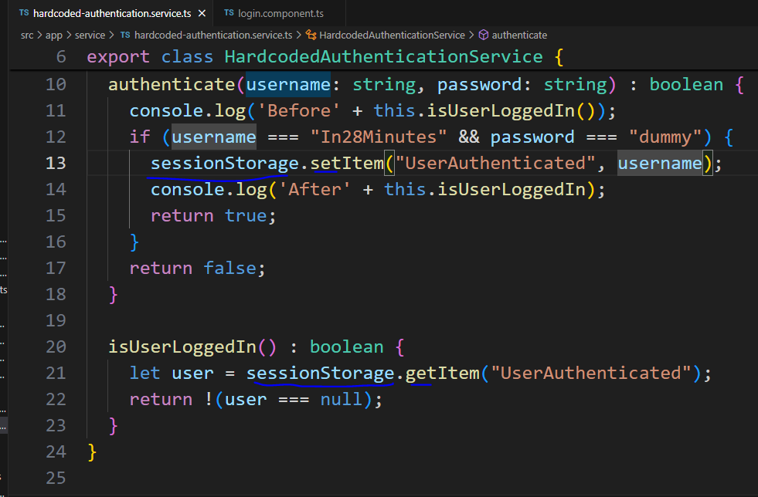

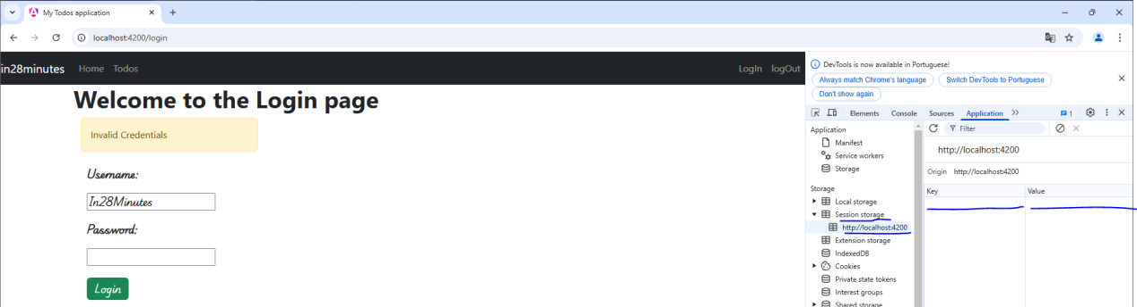

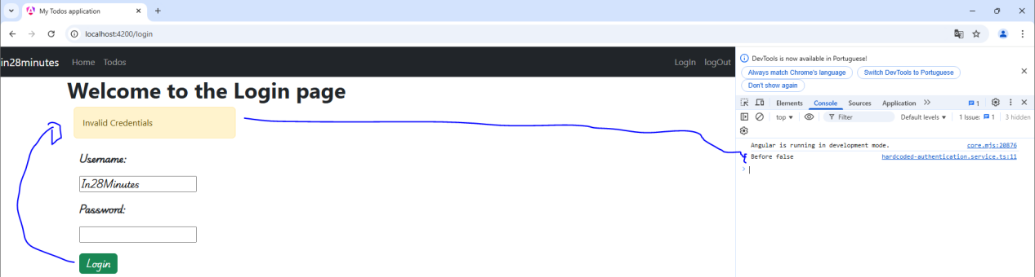

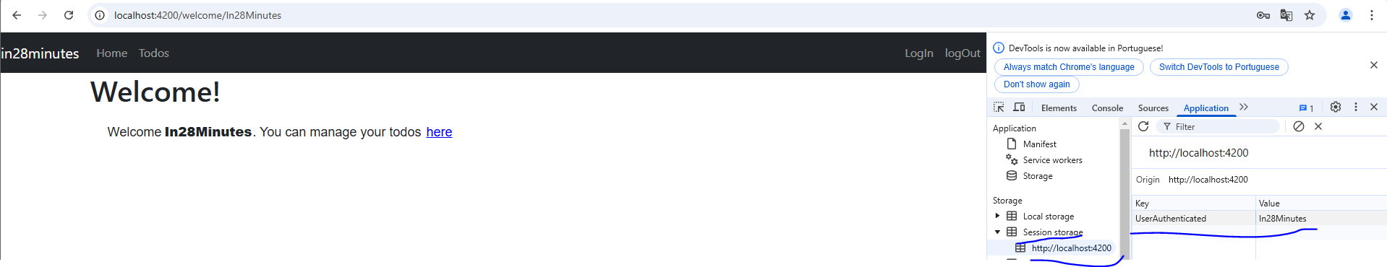

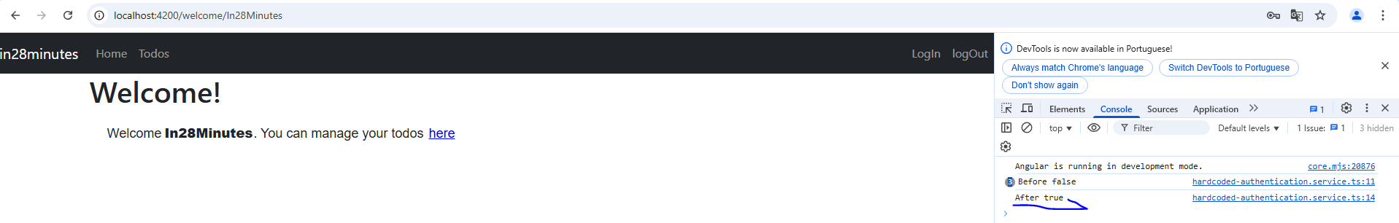

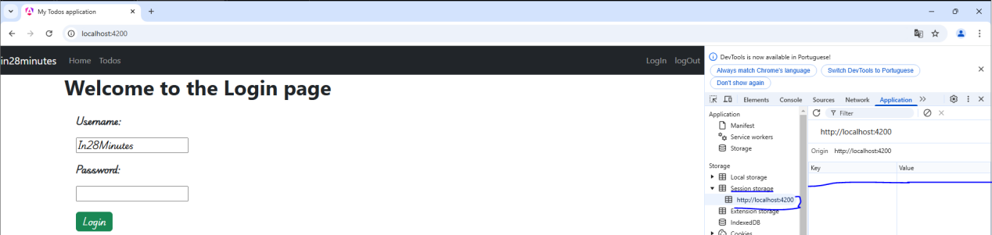

(after closing the browser)

A way to refine the authentication and make sure the user is logged in is to use the **session storage** feature from the browser. It allows us to store the username at browser storage while his session is open, after the browser is closed this data is erased, if we used the local storage, after the browser is closed that would still be there (less safe). The logic is that when the user clicks on the login button with an invalid login, the authentication service will check if the user is ‘saved’ on the session storage of the browser and return false on the console, now if the user enters with a valid login, the username is saved on the session storage and return true on the console. After closing the browser, the session is finished and the data is erased.

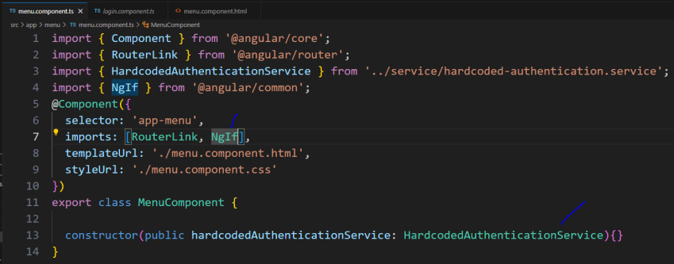

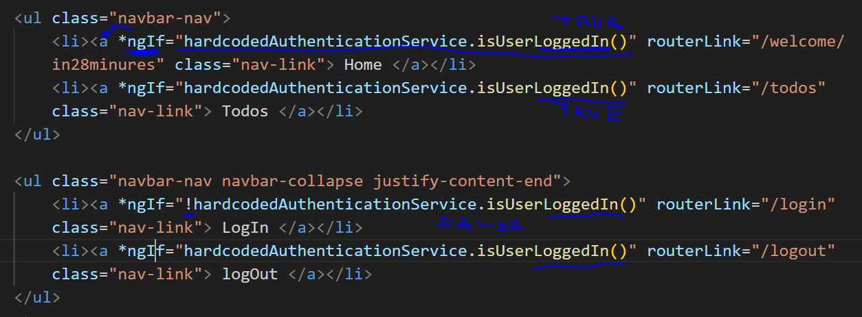

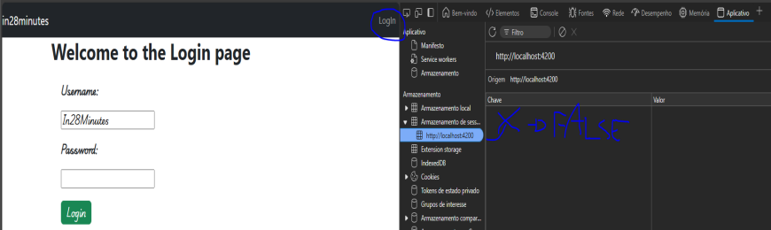

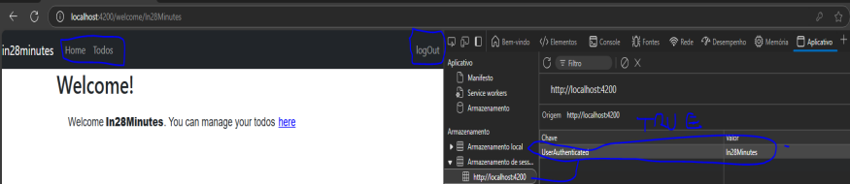

Once with the loggedIn state in hands, it makes sense, to render the menu links if the user is loggedIn or not. True: Home, Todos and Log out. Off: Login.

For now, it’s possible to reuse the loggedIn function (Service) directly on the template with directive **\*ngIf**  to render the links **according to the state**.

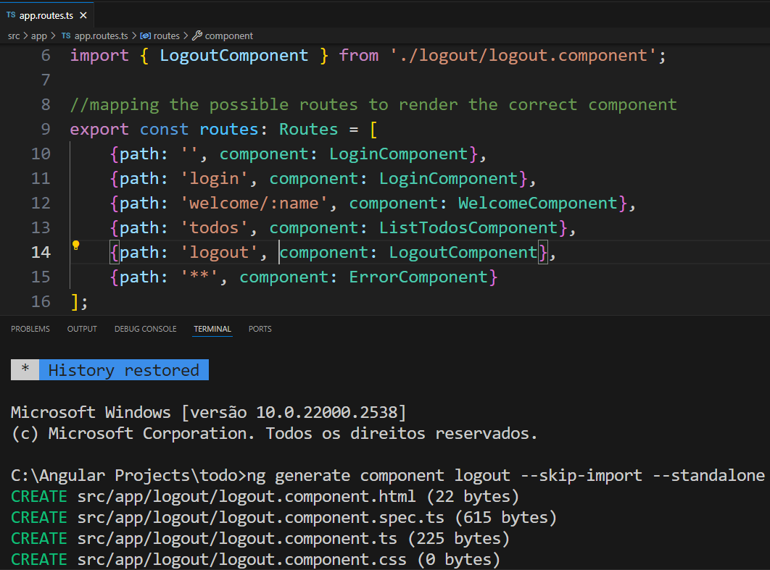

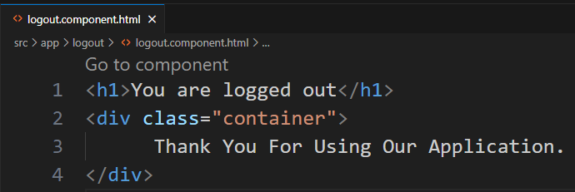

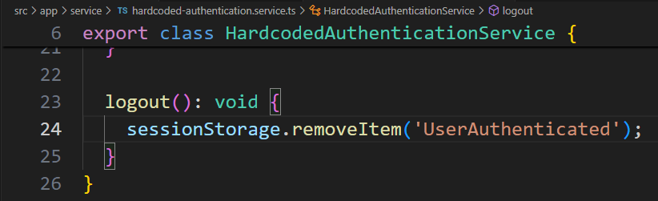

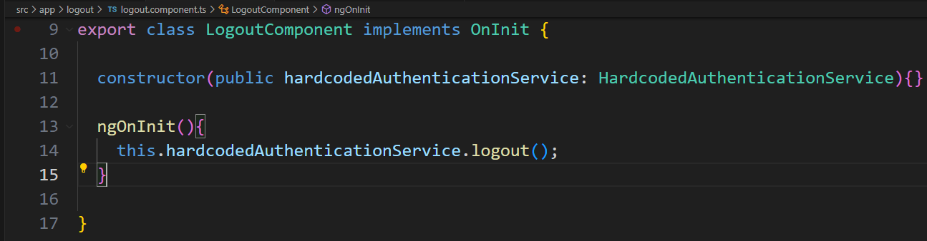

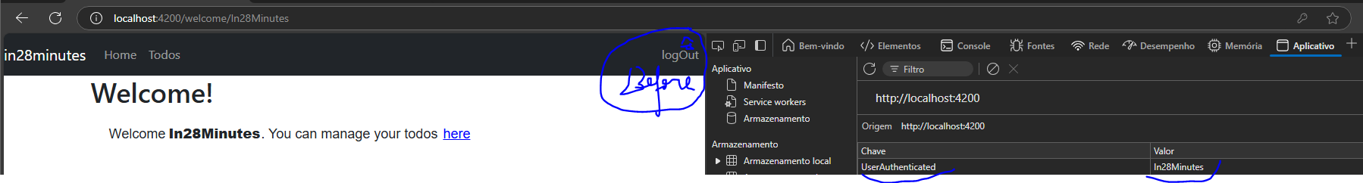

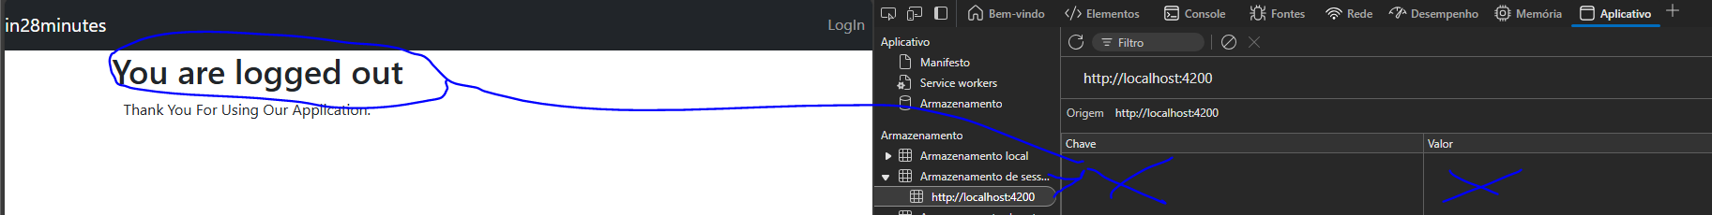

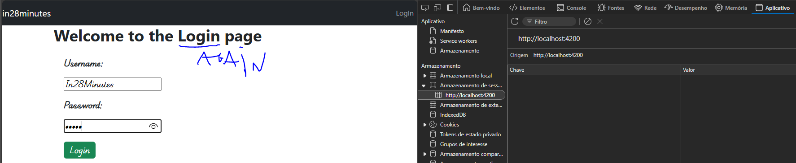

After completing the loggedIn, now it is important to deal with the log out, this control is being done by **sessionStorage** from the browser, if loggedIn means **data** on it, logged out means **no data** on it. This way, in the service one more function is created **to remove** **this data from the sessionStorage -> sessionStorage.removeItem(‘AuthenticatedUser’)** and use it on the logout component.

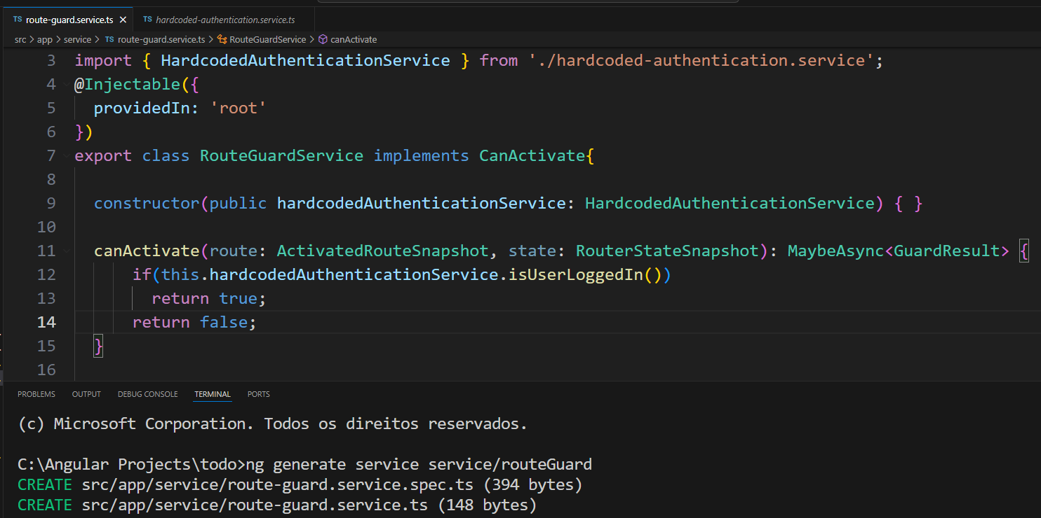

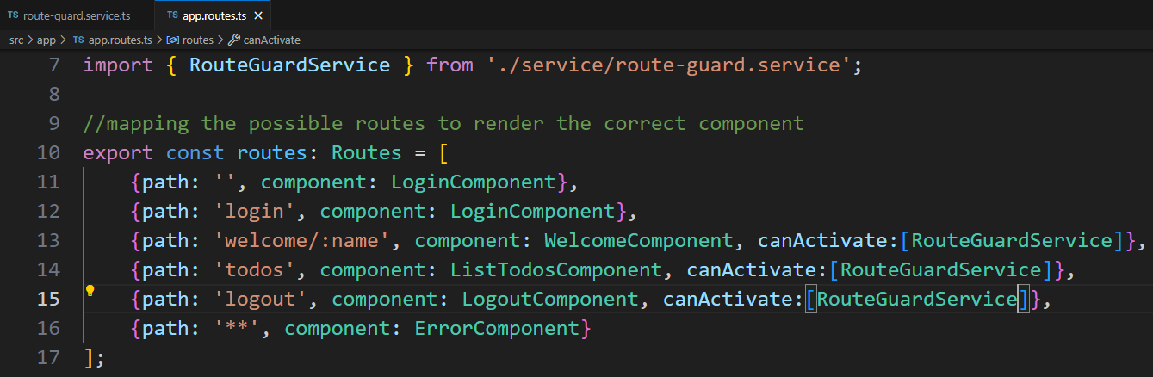

To finish the frontend part with Angular, it is needed to control the routes that the client can access based on the **condition** logged in || out, for that it will be created a specific service called route guard that will implement the **CanActivate** interface and return true or false as result to be used in the **app.routes.ts** in the array -> {path:route, component: component, **canActivate:[RouteGuardService]**.

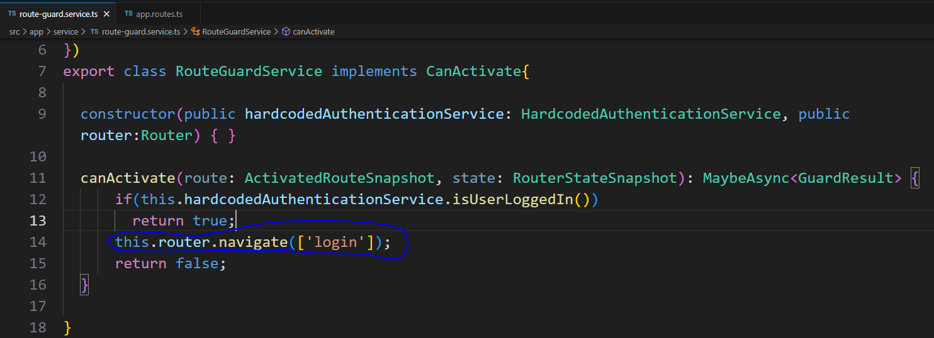

Improving it, if the user is not logged in and tries to access another routes, it is more important that he be redirected to the login page. For that, the **router reference** sorts it out-> **this.router.navigate([‘login’])**.

MicroServices

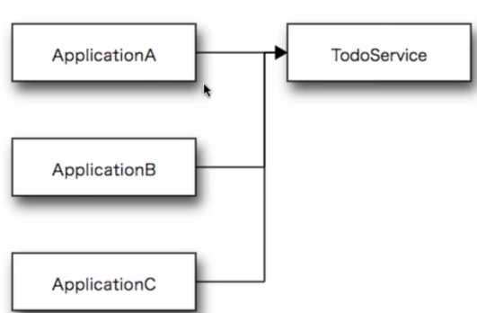

Web service is a software designed to support **interoperable** **machine-to-machine | app to app interaction** **over a network**, allowing that **different softwares (Java, CSharp, PHP) communicate** and exchange data without necessity of conversion of language | code. Working as a service provider or server, and the client as a service consumer.

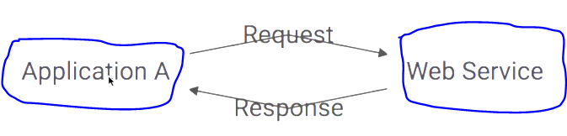

The interactions between the apps requires an **input** to generate **processing** and delivering an **output** that can be summarized in **request and response**. For instance, the app A consumes from the web service a Ranga’s todos list then the web service receives the **request**, look for it in the database and **respond** the customer with this list.

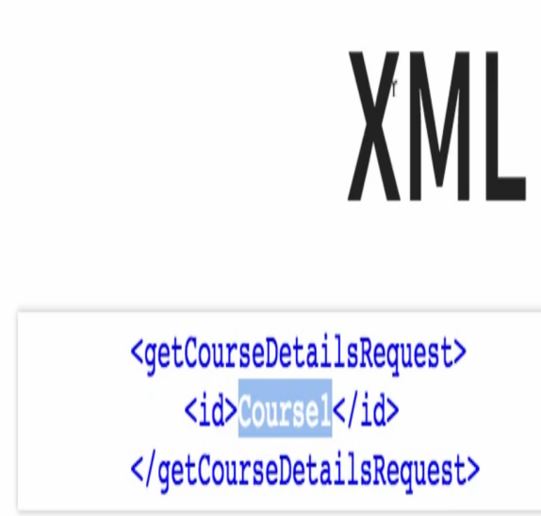 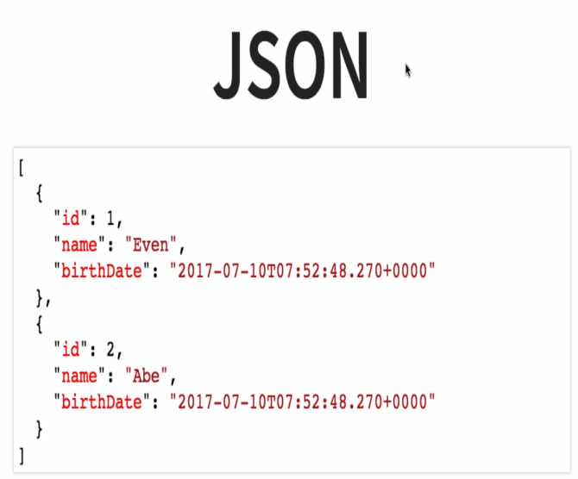

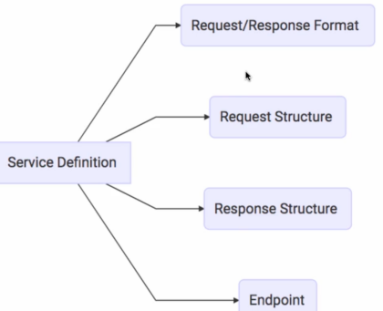 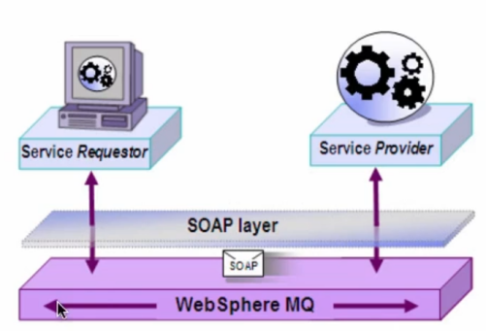

Even if the web service is developed in Java, it might be able to communicate with other platforms for that, two possible request & responses formats can be used:

XML (Extensible Markup Language) or JSON (JavaScript Object Notation).

Along with the format, the route / endpoint will be the way used by the customer to request / call the specific service. The transportation side uses the http protocol with a verb (get,post,put,delete) or by the co**m**munication **q**ueue.

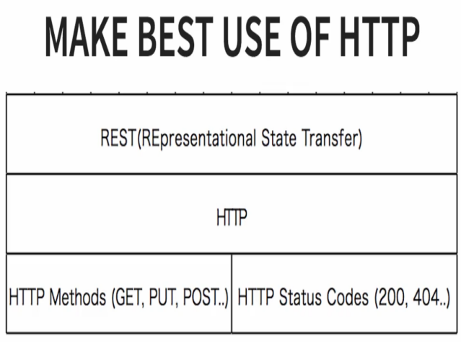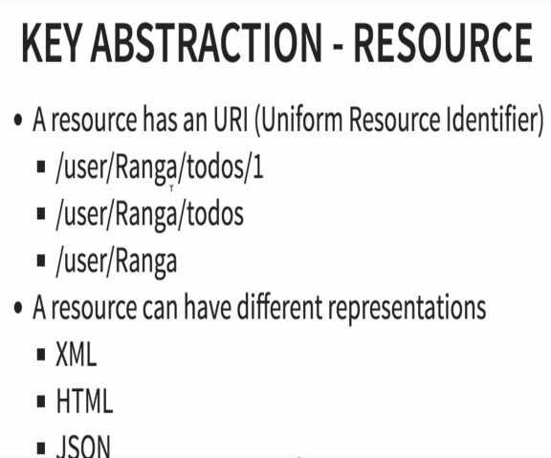 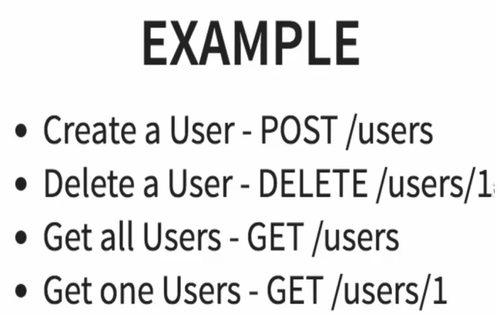 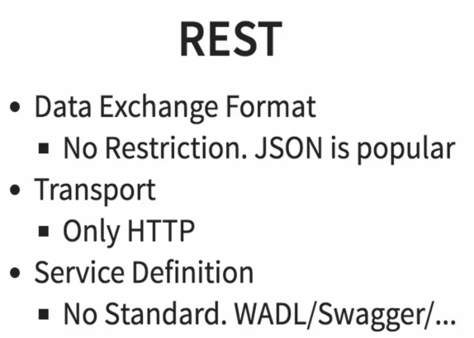

REST -> Representational State Transfer

HTTP-> Hipertext Transfer Protocol

URL-> Uniform Resource Locator aka address/domain

URI-> Uniform Resource Identifier

When navigating over the web, every time the consumer browser makes a request through an URL, it does a GET http request to receive the copy of the website (html) and the server responds sucessfully with a 200 status code. If this same user clicks over a button to register in the website, the browser will make a POST http request with some data in the body of the request like name, email, password and so on.

The REST idea is to reuse the http structure to share the content consumed by the client and the operations with it, using URIs as routes along with the URL to exposure the service. For instance:

/user/Ranga/todos/1-> bring me the first todo of the Ranga’s list todo.

/user/Ranga/todos/-> bring me the Ranga’s list todo.

/user/Ranga-> bring the user data or the content that this user has access.

**Before going ahead with the section 5 it is advised to make an overall review about Spring and JPA.**

Apprendix:

Why, What are the goals, how it works, comparison with Spring and Spring MVC.

Highlights: Spring intialzr, starter projects, auto configuration, developer tools, actuator.

Before Spring **Boot** in 2016, every new project in spring, it would be needed to configure:

1. Dependency Management (pom.xml)
2. Define Web App Configuration (web.xml)
3. Manage Spring Beans (context.xml)
4. Deploy of non-functional requirements (nfrs).

Creating a project with Spring intialzr:

start.spring.io

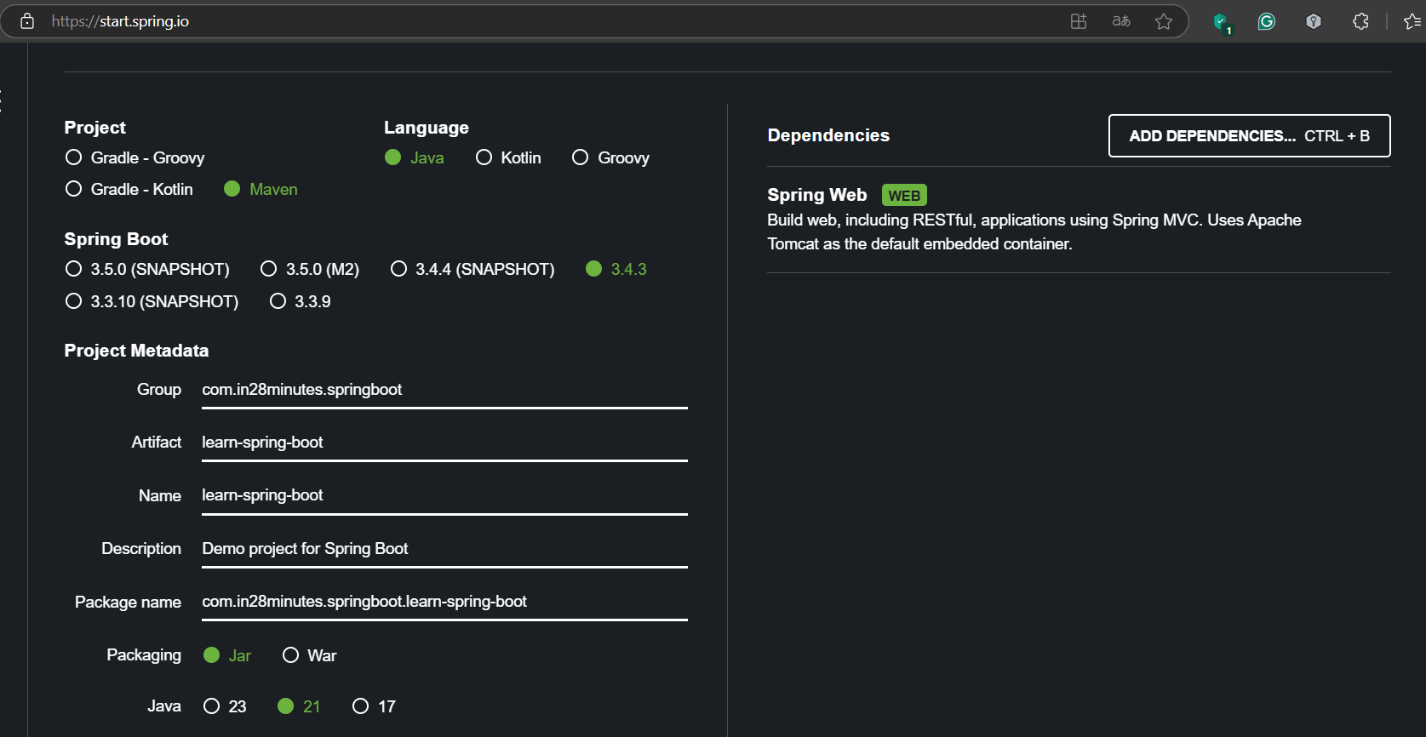

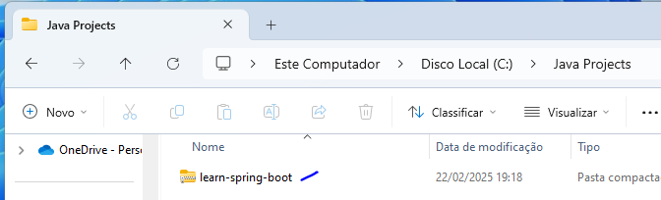

The idea is to make a rest api to bring back a list of courses like this [{id:1,name:’learn AWS’, author:’In28Minutes’}]. After importing the project, create a controller class like courseController and put @RestController to identify the class as a Rest API controller in fact, then create a method to return the list of courses and include the uri/endpoint “/courses” using the @RequestMapping(“/courses”). Being needed to have the class Course to represent this object in real life.

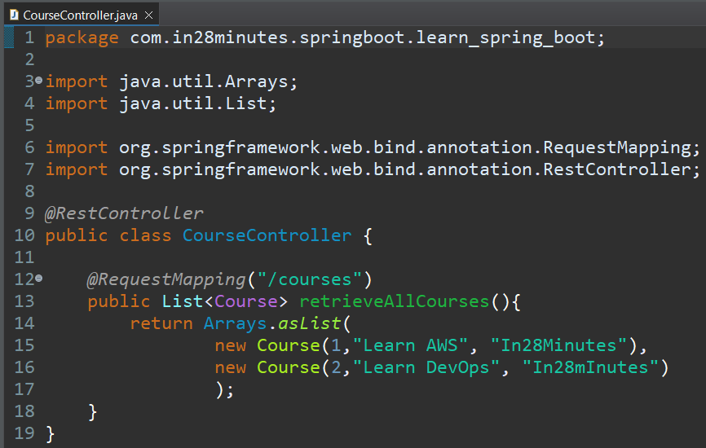

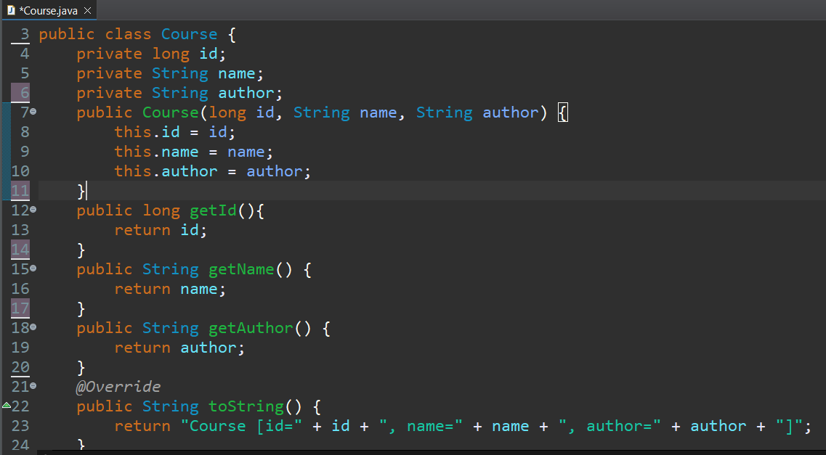

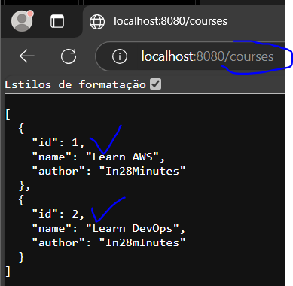

The goal of the spring boot is **quickly** building **production-ready** apps:

**Quickly:**

* Spring initialzr-> fast project creation
* Spring Boot starter projects -> fast dependency grouping
* Spring Boot Auto Configuration-> Automatic configurations like tomcat, h2 database, @beans (injection dependency) and others based on the dependencies.
* Spring Boot DevTools -> Running managing of the server like restart the server automatically if there is code change to increase the productivity. Except by insertion of new dependencies on pom.xml.

**Production-ready features:**

* Logging(reports on terminal)
* Profiles through properties file for each environment (dev,qa,stage,prod).
* Monitoring (Spring Boot Actuator)-> hardware and software managing on the cloud like metrics of more/less memory, hard disk space, using of cpu;

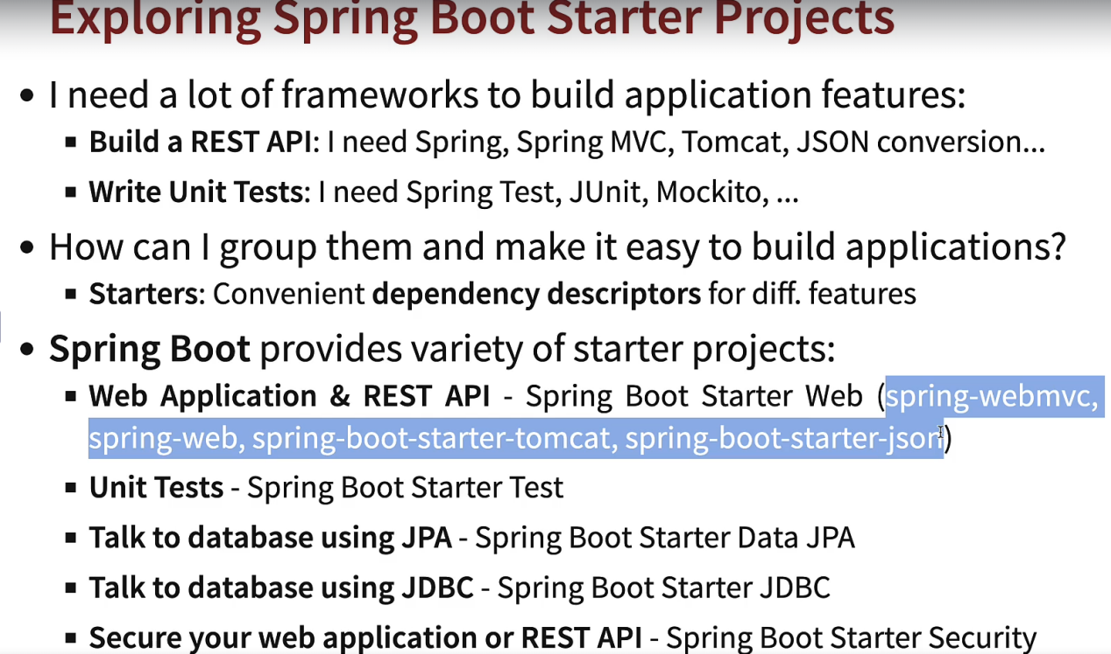

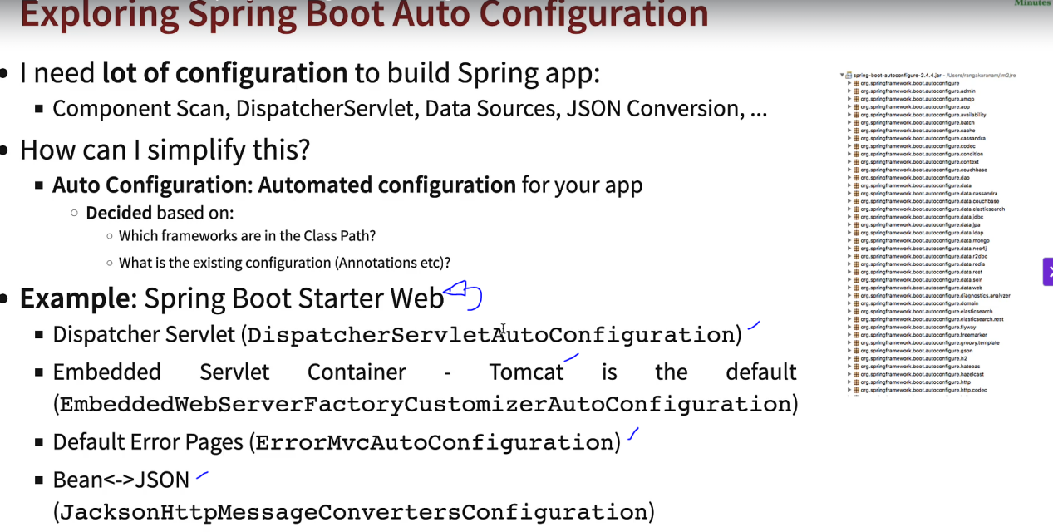

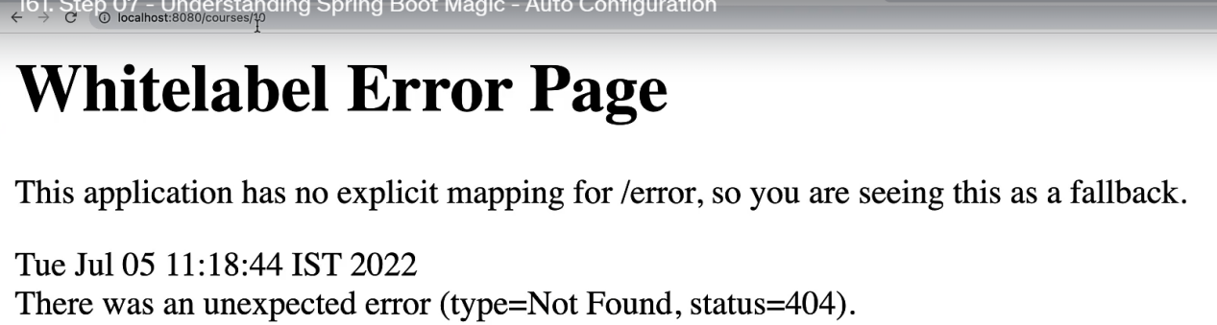



Starter projects will group several dependencies at once and based on it, the spring boot auto configuration will configure these dependencies to work without manual configuration by the developer like an error page when the endpoint is not mapped by the controller, but it can also be overridden in the application.properties like debug (show the operational processes) the spring initialization until the server is up and ready.

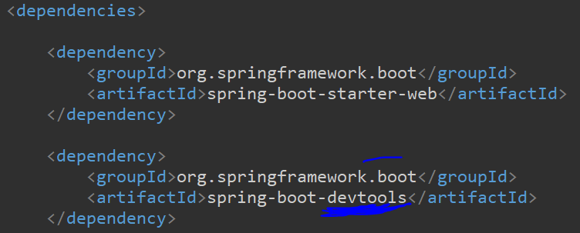

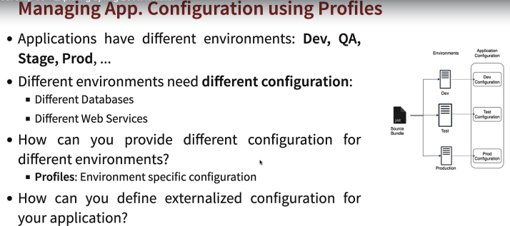

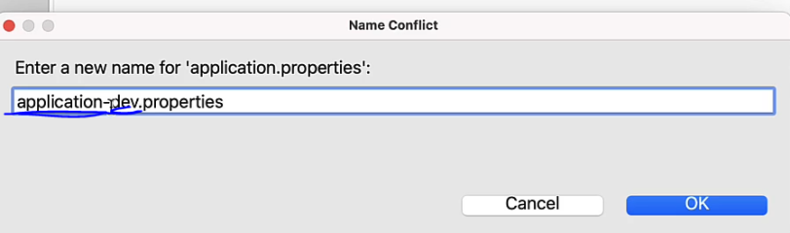



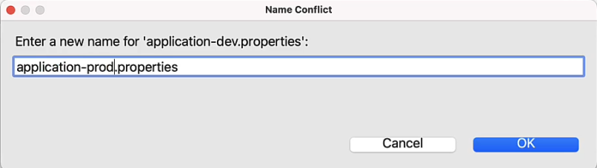



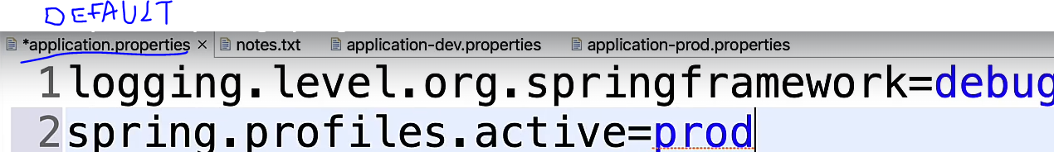

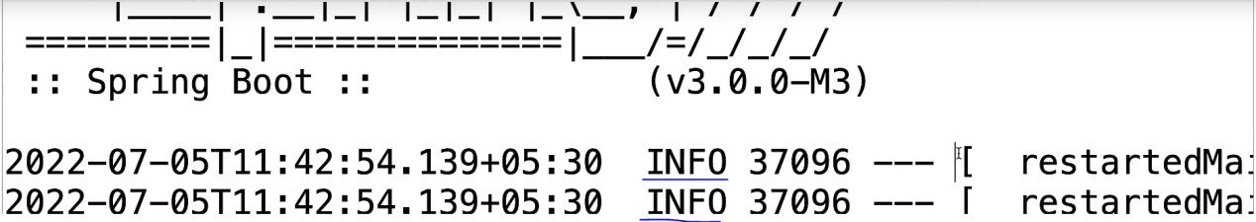



Levels:

Trace

Debug

Info

Warning

Error

Off

To specify the environment, create a new file with the environment name application-environmentname.properties. So for example create two files application-dev.properties and application-prod.properties, on dev type logging.level.org.springframework=trace will bring trace info and below, on prod type logging.level.org.springframework= info will bring info and below.

Supposing that we are consuming an external webservice called currency-service, then it is needed to create a few properties to **configure** this connection according to the environment.

Application.properties

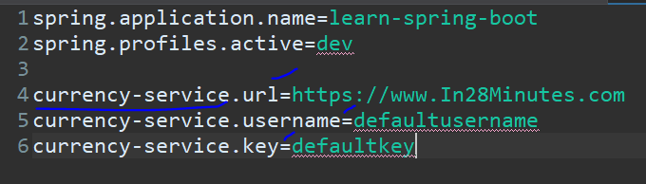 On the application.properties type:

currency-service.key=defaultkey

* prefix.propertyName=value

On the application-dev.properties type:

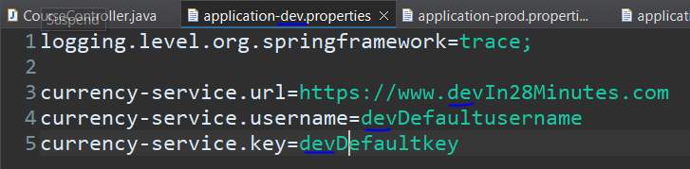

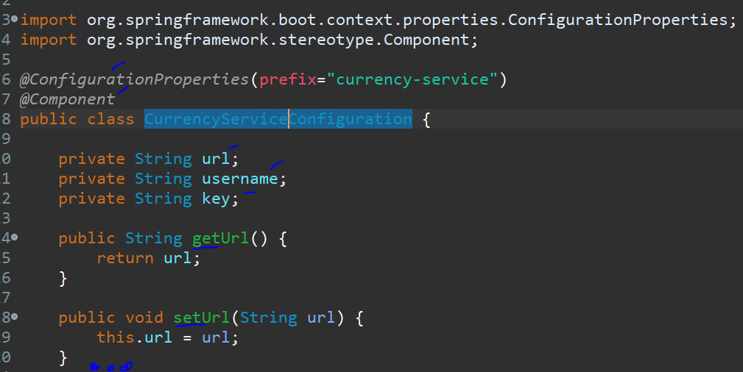

Create a new class called CurrencyServiceConfiguration with these properties along with their getters and setters. As Spring features, the annotations:

@ConfigurationProperties(prefix=”currency-service”) -> This annotation, identifies the class as the one with the properties of the webservice with prefix currency-service

@Component -> This annotation, identifies the class as a Spring Component, making possible to make a bean dependency injection (@Autowired).

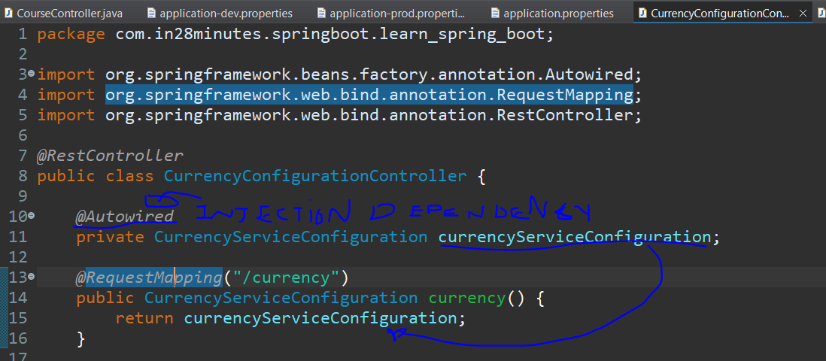

To test this approach, it is needed to create a controller to expose it. Using the dependency injection of the configuration class to return this properties filled in.

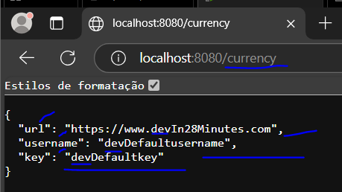

Embedded servers

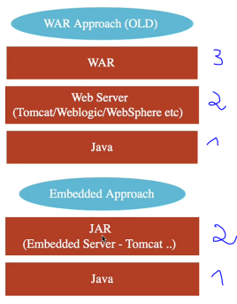

*War-> Web ARchive (zipped project)

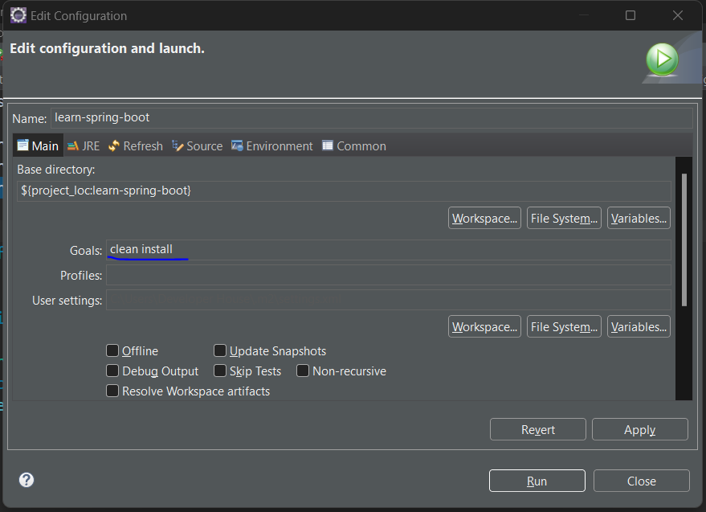

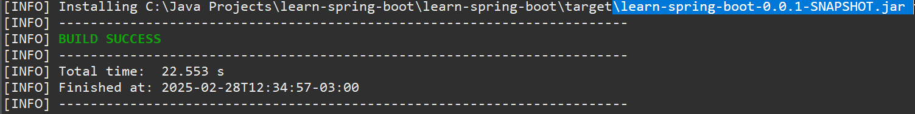

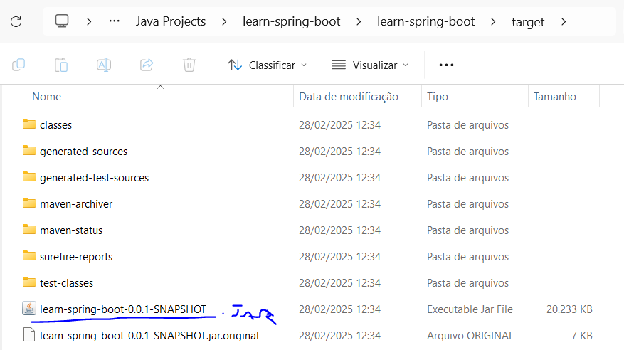

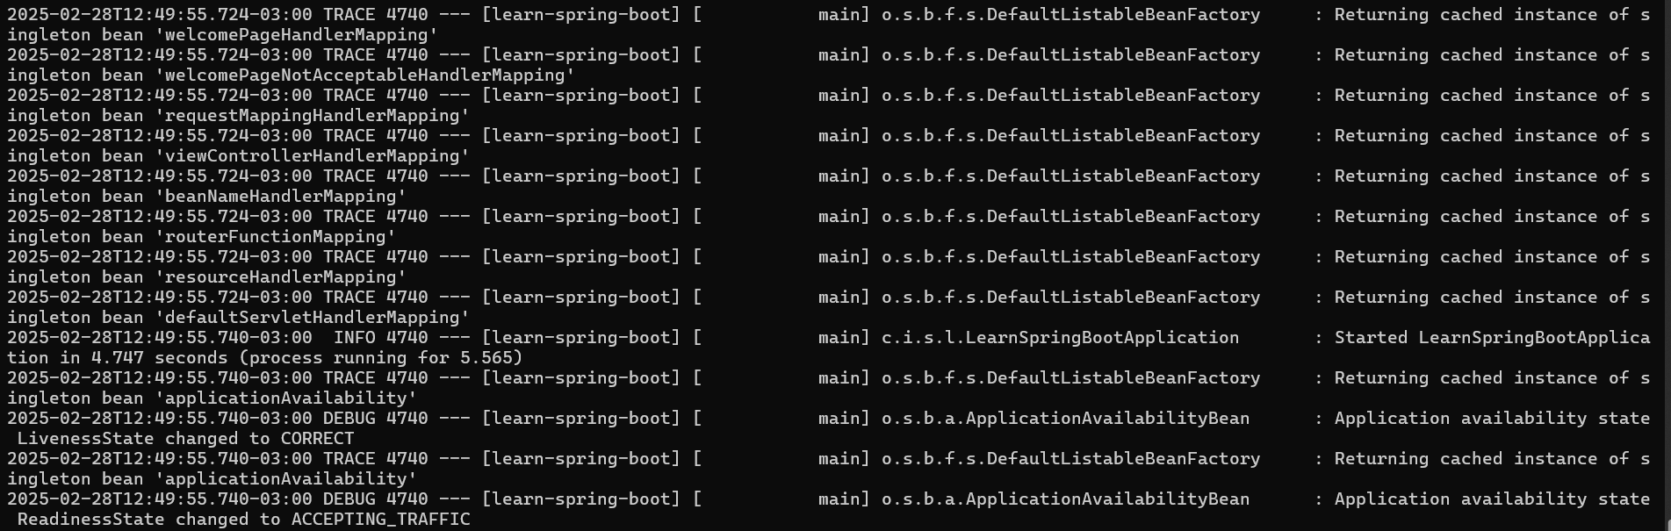

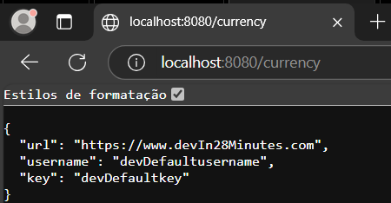

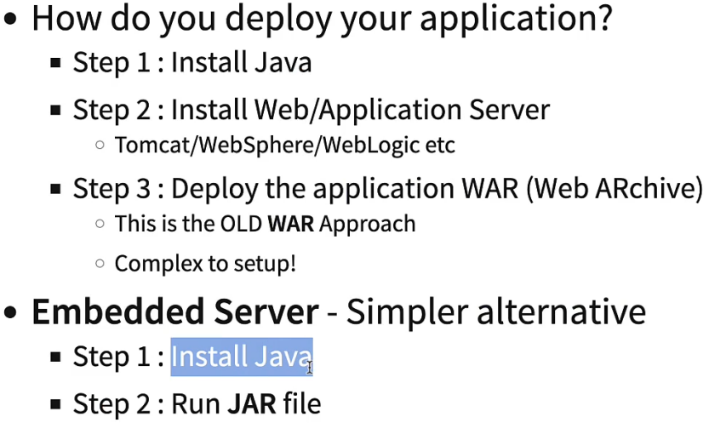

When using this command **clean install** the system will erase any previous outdated version, then build, run and test a new one with the new code, and the end it generates an executable of this new version as .jar (.apk,.exe). Once, the project is exported, it can be executed on the terminal. As alternative embedded servers:spring-boot-starter-**tomcat/jetty/undertow**

**Spring boot Actuator** will help to monitor and manage the application on the cloud and it will expose a few endpoints:

* Beans -> List of Spring beans
* Health-> Information of running status like up and running or up and error
* Metrics-> Using of memory, space, cpu, network, demand
* Mapping -> Details around request mapping

Pom.xml:

<dependency>

<groupId>org.springframework.boot</groupId>

<artifactId>spring-boot-starter-actuator</artifactId>

</dependency>

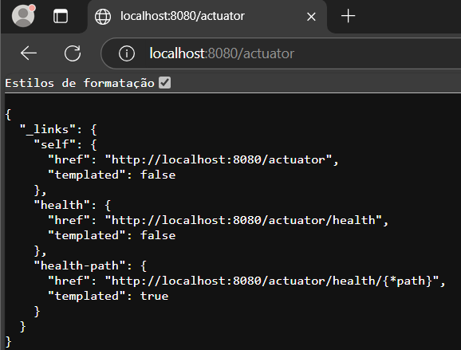

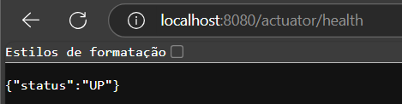

To edit which endpoints that are available or see them all (*), on the application.properties include the line: management.endpoints.web.exposure.include= health,metrics or management.endpoints.web.exposure.include=*.

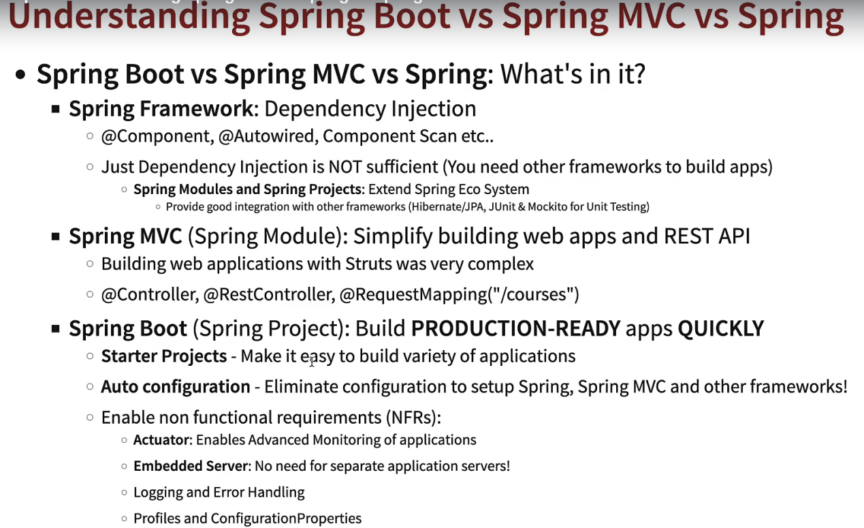

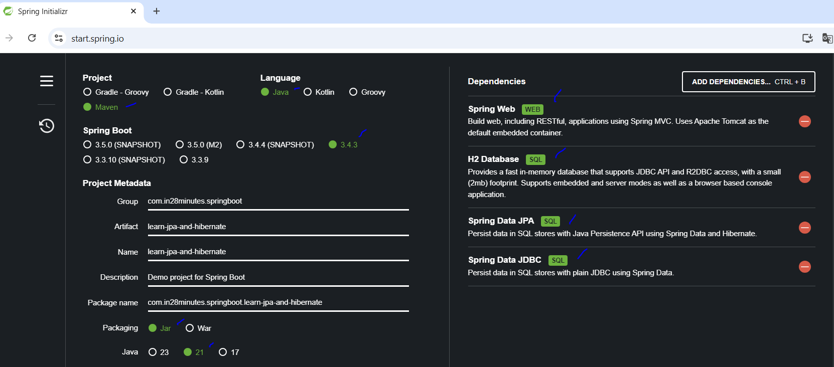

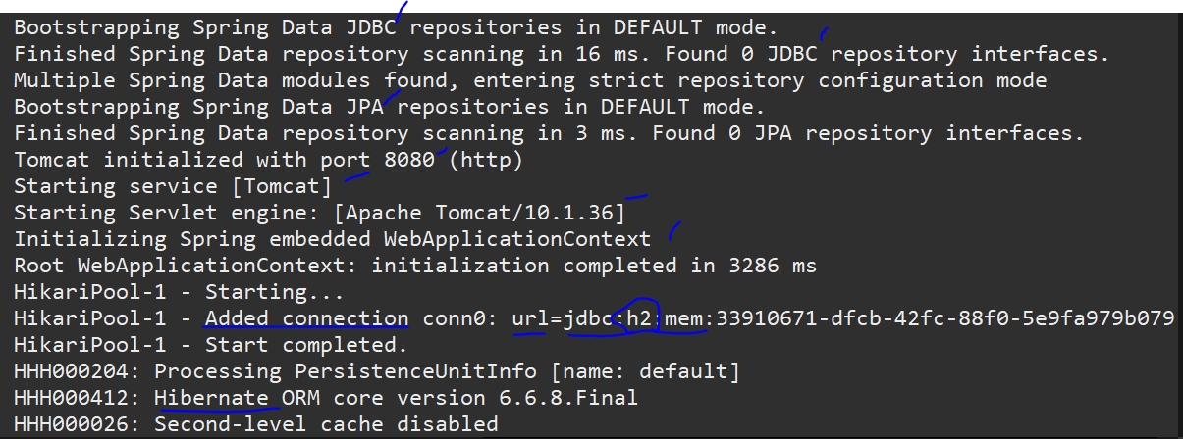

From this moment ahead, it’s time to have an appendix section for manipulating specifically the database using **JPA, Hibernate and JDBC**. Creating a project with the dependencies: spring web, h2 database, spring data JPA, spring data JDBC. With these dependencies loaded, the creation and configuration of the database is auto configured, the tomcat server, the jpa and jdbc modules too.

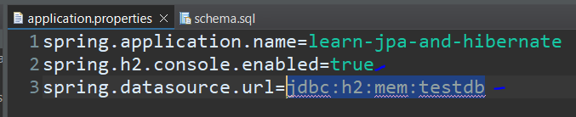

To access the database through console and specify the database url, it is needed to include two properties on application.properties:

* Spring.h2.console.enabled=true (Access database through browser)
* Spring.datasource.url=jdbc:h2:mem:testdb (specify the database url)

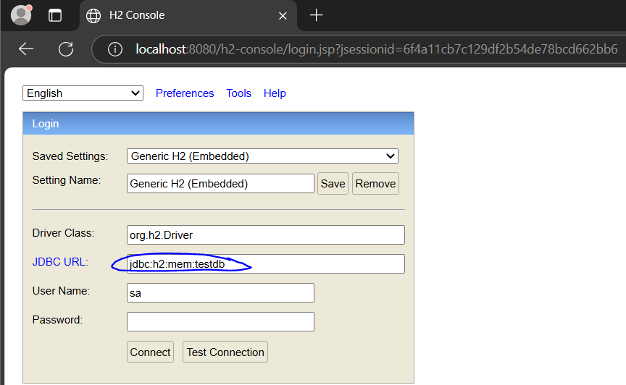

Once configured, it can be accessed by the browser through the url localhost:8080/h2-console.

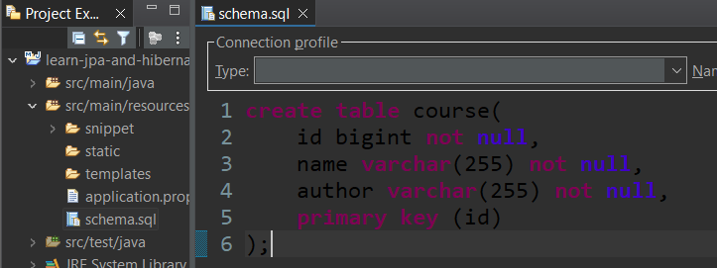

Also would be interesting if this database already had a table like course.For that, it is needed to create a file called schema.sql containing the following code:

Create table course (

Id bigint not null, // bigint is the long in java

Name varchar(255) not null, //varchar is the string in java

Author varchar(255) not null,

Primary key(id) //defining the primary key of the table

);

Once the server is restarted, this is the result:

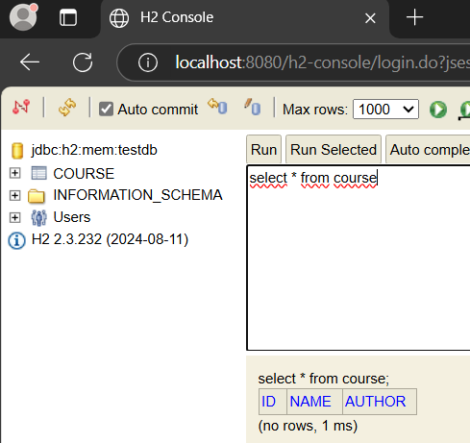

Jdbc (raw, without spring **boot)**

Public void deleteTodo(int id){

PreparedStatement st = null;

Try{

St = db.conn.prepareStatement(“delete from todo where id=**?**”);

St.setInt(**1**, id);

St.execute();

}catch(SQLException e){

Logger.fatal(“Query failed : ”+ e);

} finally {

If ( st != null){

Try {St.close();}

Catch(SqlException e){}

}

}

}

Spring **data** jdbc

Public void deleteTodo(int id){

**JdbcTemplate**.update(“delete from todo where id = ?”, id);

}

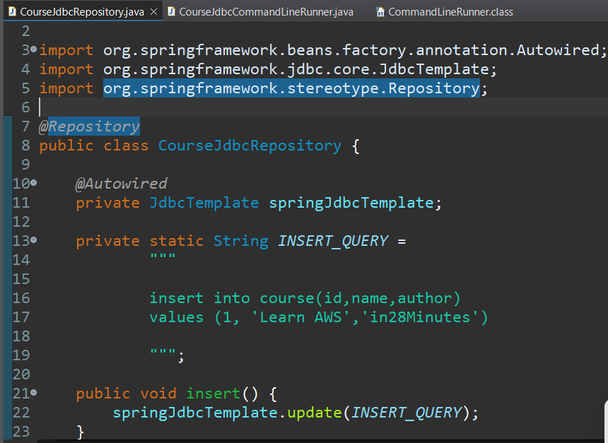

Spring Jdbc x Jdbc, both can be used for manipulating data on database with a lot of sql code, but with spring, **less java code is written**. Based on it, it is needed to create a class containing the object **jdbcTemplate**, the sql statement and a method to execute the operation, then this class is considered a repository (data access layer).

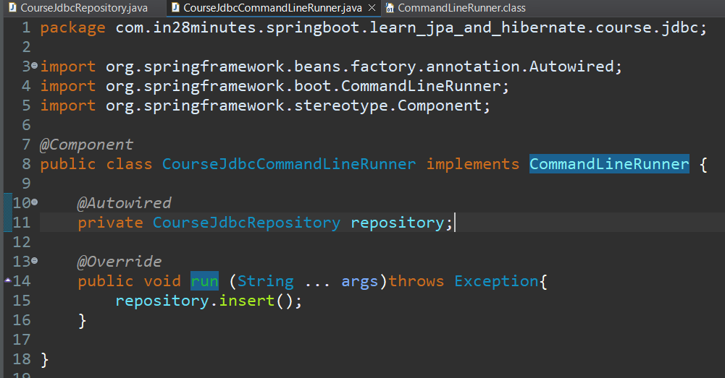

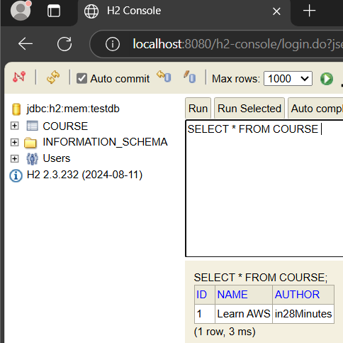

For executing it when the application starts, the interface commandLineRunner needs to be implemented by a new class as a spring component and call the operation from the repository. This way, the app starts creating the database in memory, with the table course created and **with a register inserted**.

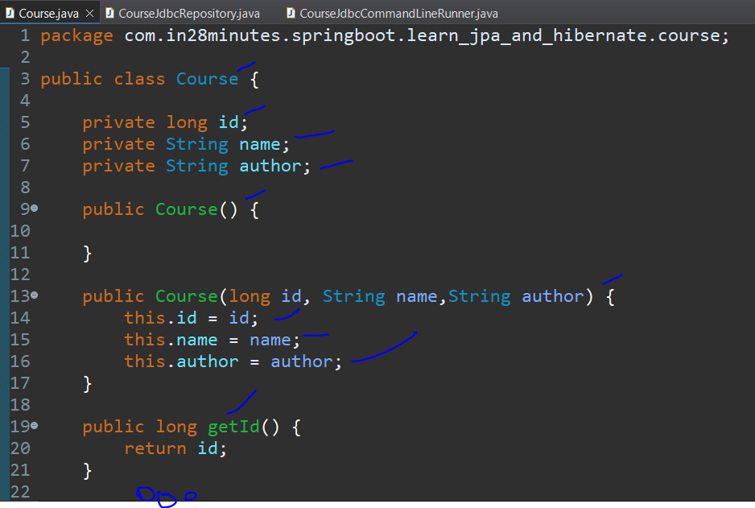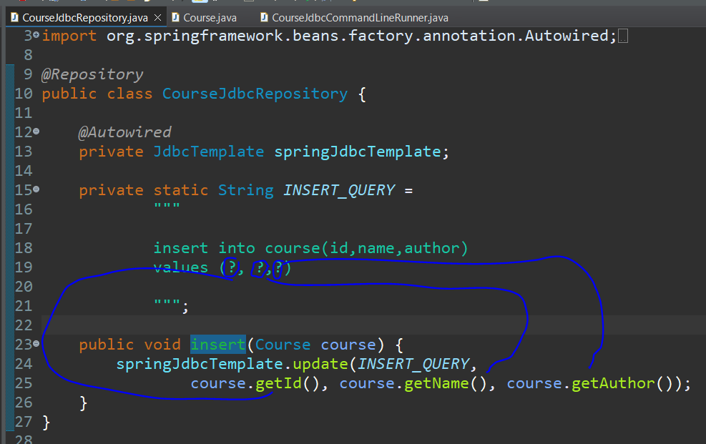

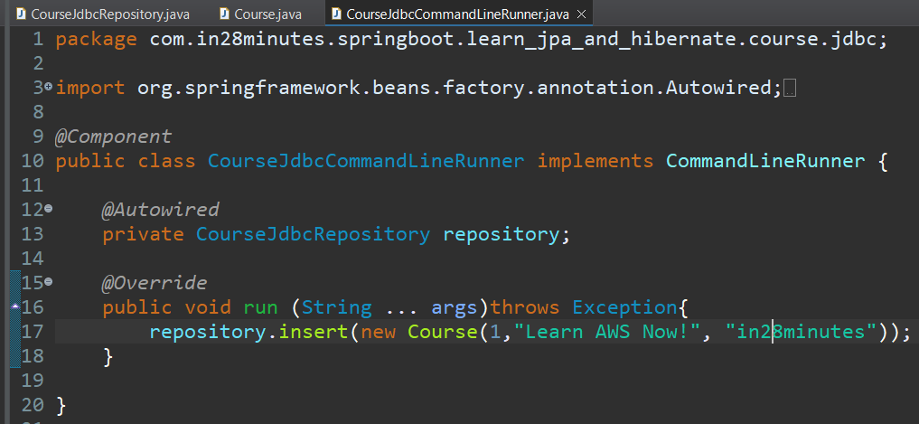

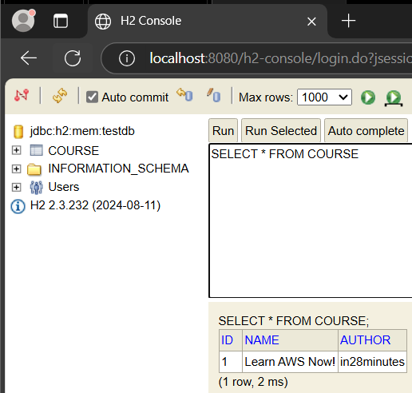

Replacing the hardcoded values on the insert statement, it is needed to create a class that will represent this course containing the attributes. On the repository class replace the values by question mark symbols, making the insert method receive the new object course, inputing the get methods separated by coma in update method to represent these questions marks positioning. Finally, update the run method on commandLineRunner, passing a course instance.

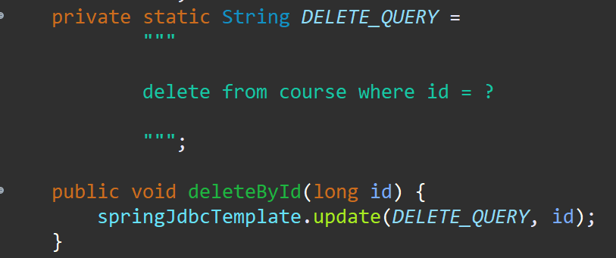

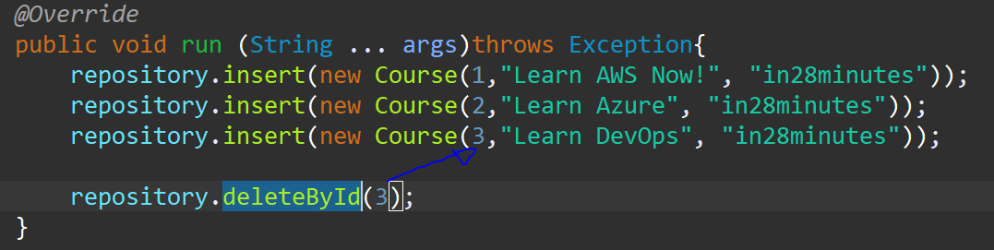

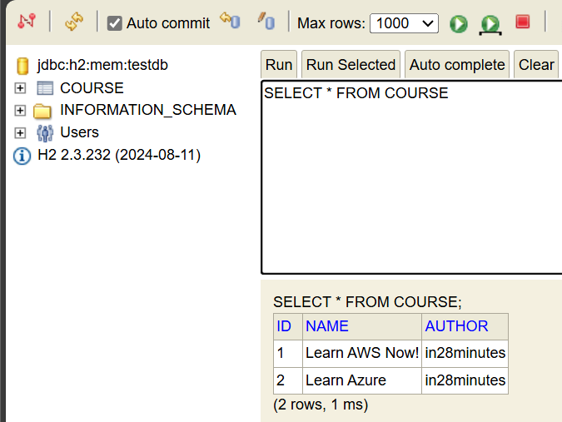

Applying the same logic, the delete query creates an sql statement of deletion, then we use a method to delete the register by id and call the method on the commandLineRunner.

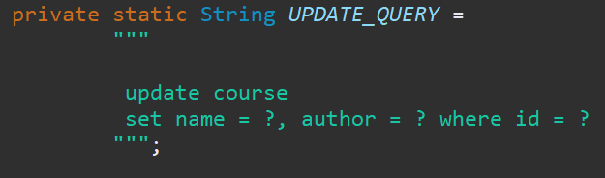

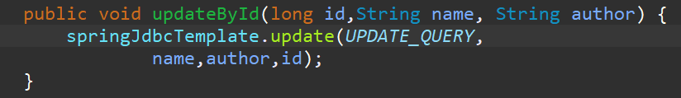

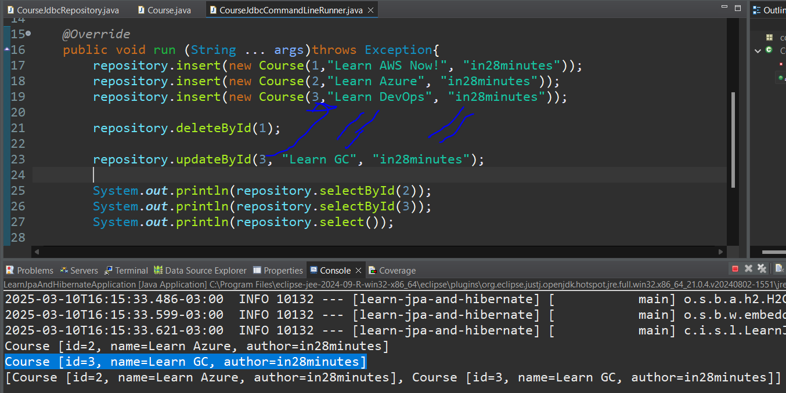

Applying the same logic, the update query creates a sql statement of update, then we create a method to update the register by id, with the values to be updated and call it on the commandLineRunner.

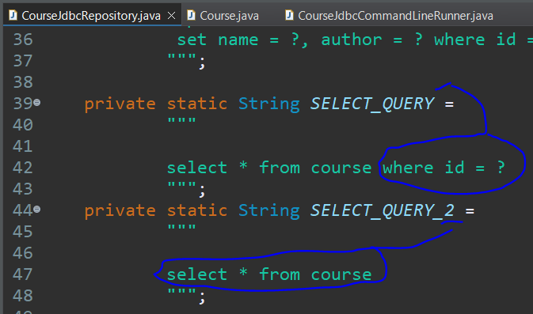

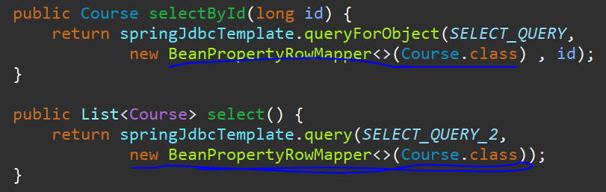

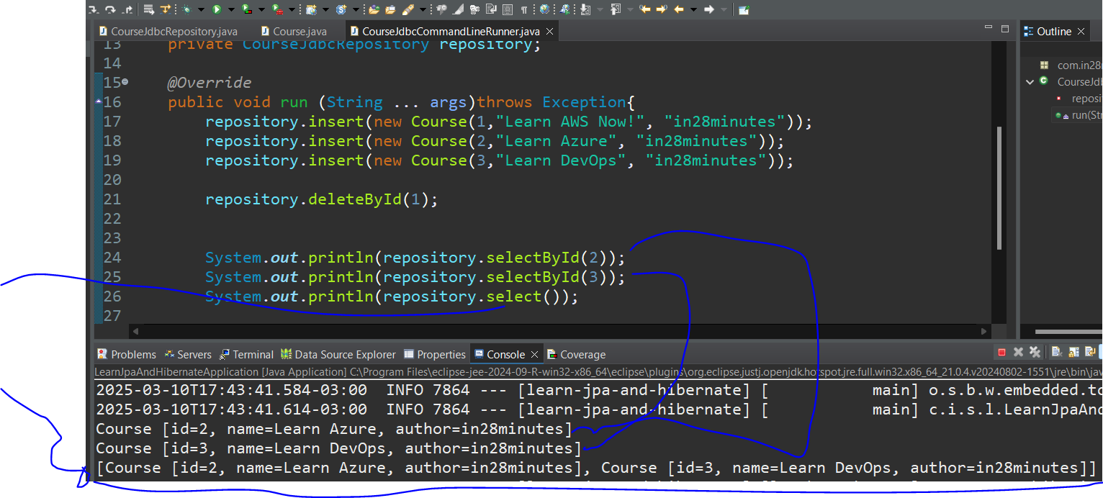

The logic is almost the same, sql statement for selection with or without id, the method to return one row or multiple rows, but for **select operation** is needed to instantiate **a new object** to shell the resultset based on the class Course for both queryForObject (retrieve one row) and query(retrieve all).

**JPA (Java Persistence API)(raw)**

On JPA, when creating the classes that will represent the tables on the database, it is needed to include the annotations:

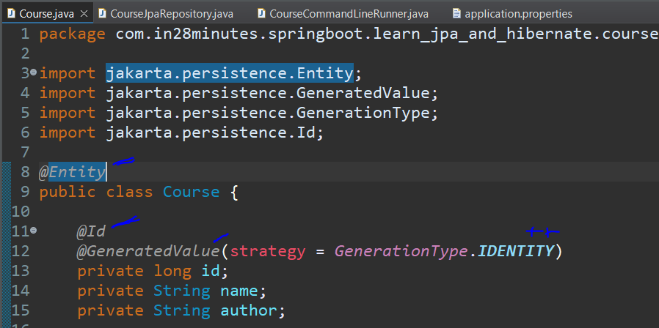

@Entity-> Map the java class as a table in the database

@Table(name=”any name”)-> Specify the name of the table **independently** the name of the class

@Id-> Define the primary key of the table

@GeneratedValue(strategy = GenerationType.IDENTITY)-> generate incremental ids starting by 1 and plus 1 at each new register

@Column(name=”any name”)-> Specify the name of the field/column of the table **independently** the name of the class attribute

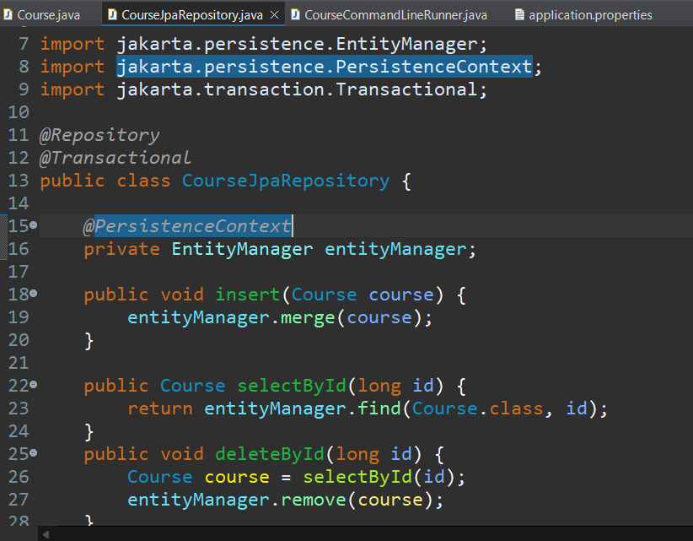

@Repository -> Identify the class as the data access layer for **a specific table**

@Transactional-> To declare that the repository will make database transactions

@PersistenceContext -> When using the Entity Manager object is better to use @persistenceContext instead of @Autowired to instantiate it, to be directly connected to it and the persistence on database.

To do the operations, it is only needed to use the entityManager object and it’s methods:

Merge-> to insert/update a new row

Find-> to select **a** row according to the class and id

Remove-> to delete a row from the table according to the object.

**In a direct comparison with jdbc, it is not needed to write sql statements, only few java code.**

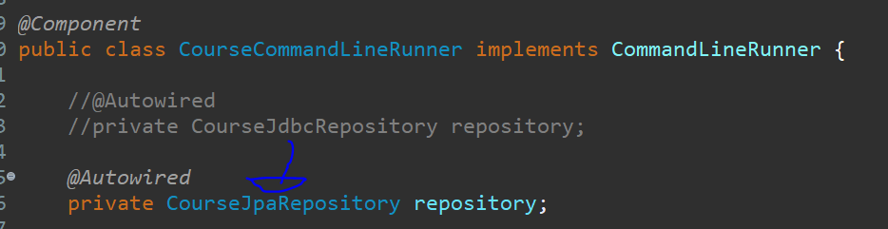

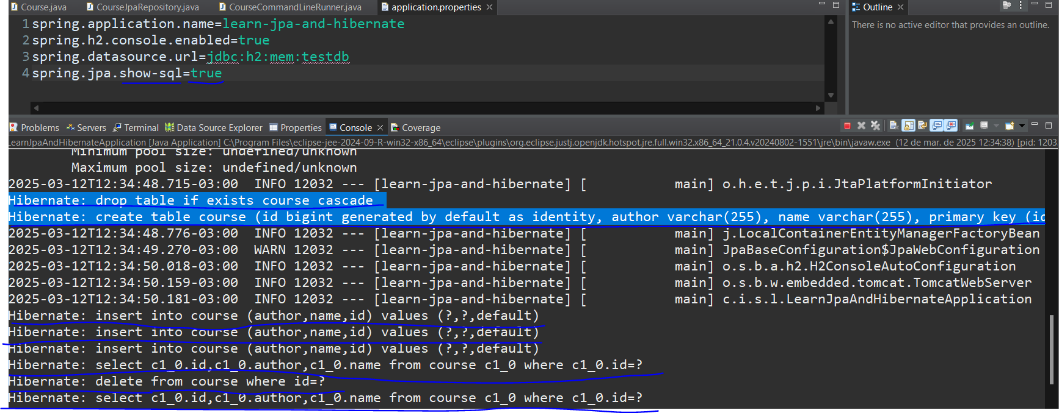

On the property file, include spring.jpa.showl-sql=true, for display the sql code on the terminal.

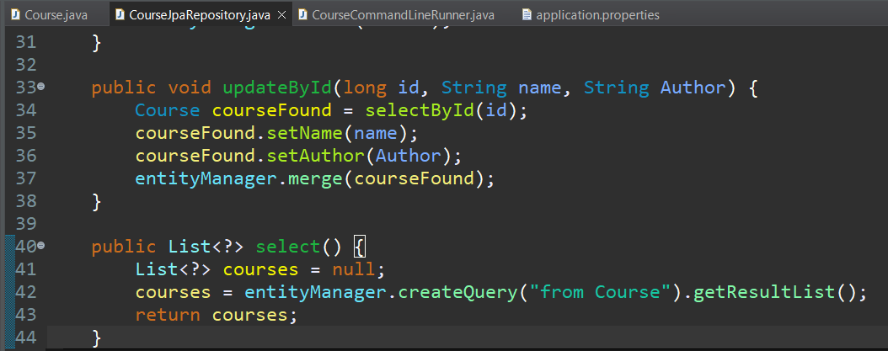

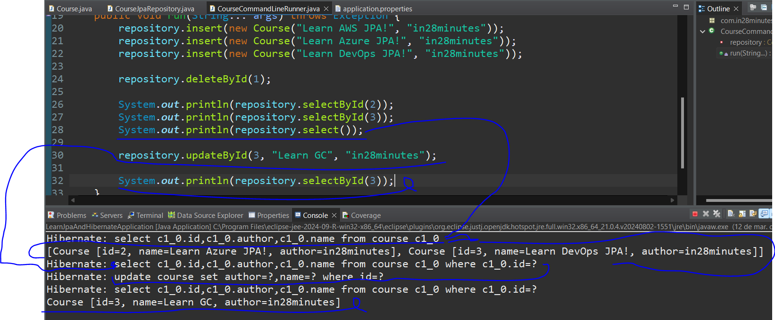

To update a row is needed to find the row by the primary key, store it in a new Course object, set new values and use the merge method with the new object. Now, for select all the rows, is needed to use the method createQuery from entityManager passing “from Course” as sql statement and get the result list as a generic type.

Spring **Data** JPA

On Spring Data JPA, the entityManager object and its operations are working **on background** without generating manual java code, this way, it is only needed to create an interface that will **extend** the **JpaRepository** interface passing as type <Class name, Id type>. With this interface on hands (@Autowired), the database operations/methods are just waiting for **p**arameters to be used. *3**l**-> **l** means long

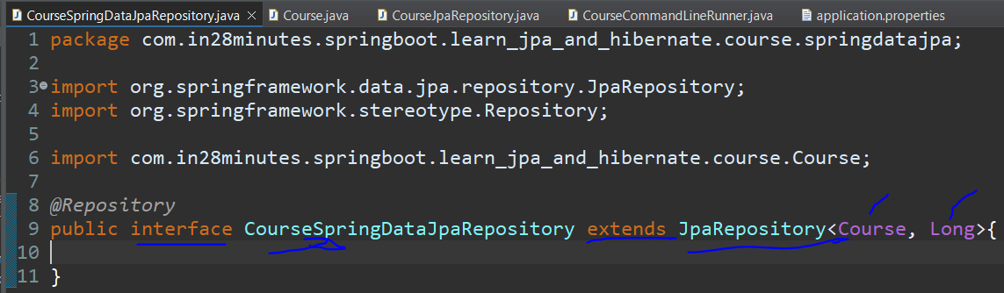

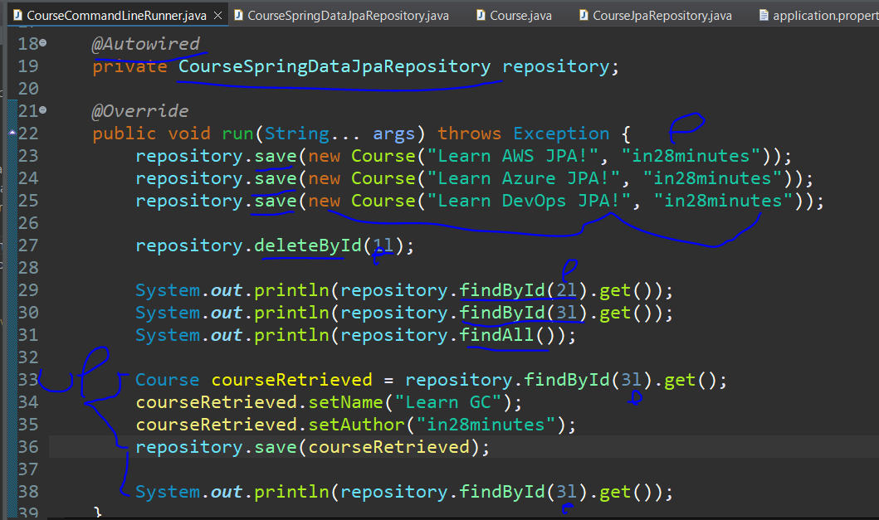

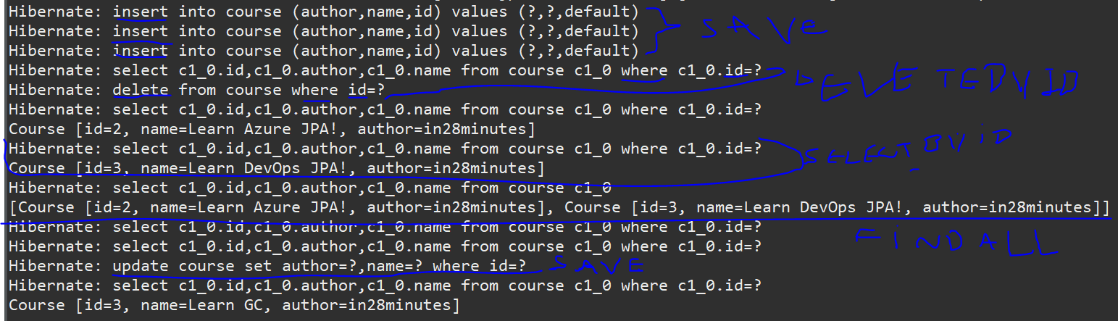

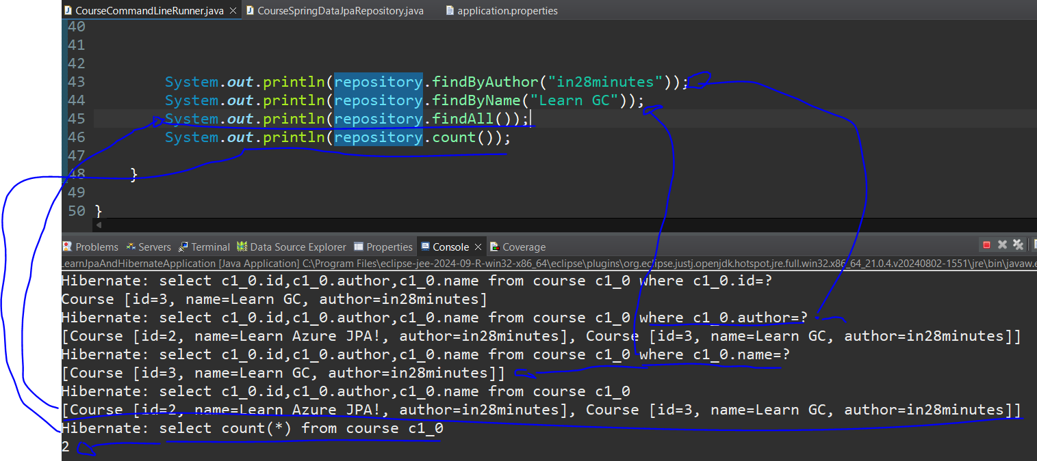

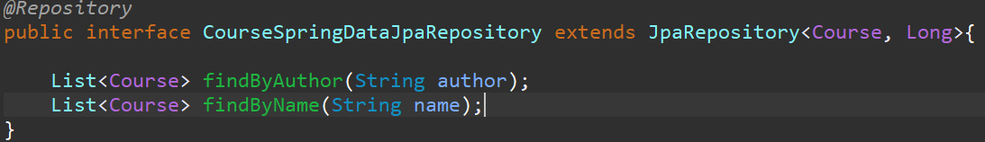

The JpaRepository also allows to define customized methods in our new interface and directly use them without worrying about the logic, for example find some course by Author, Name.

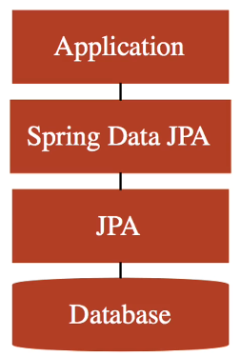

As a result of the structure, the app uses the Spring Data JPA that uses JPA in background to access the database.

So to finalize the appendix, whats is the difference between JPA and Hibernate? JPA is the **specification** in how to map the entities, attributes and manage the entities (entity manager, crud) and hibernate is **one of the possible implementations** of the JPA. So, it’s important to always import from the **specification** when using the @Annotations, because the specification hardly changes, now the implementation changes more easily.

Building a sample spring boot restful API

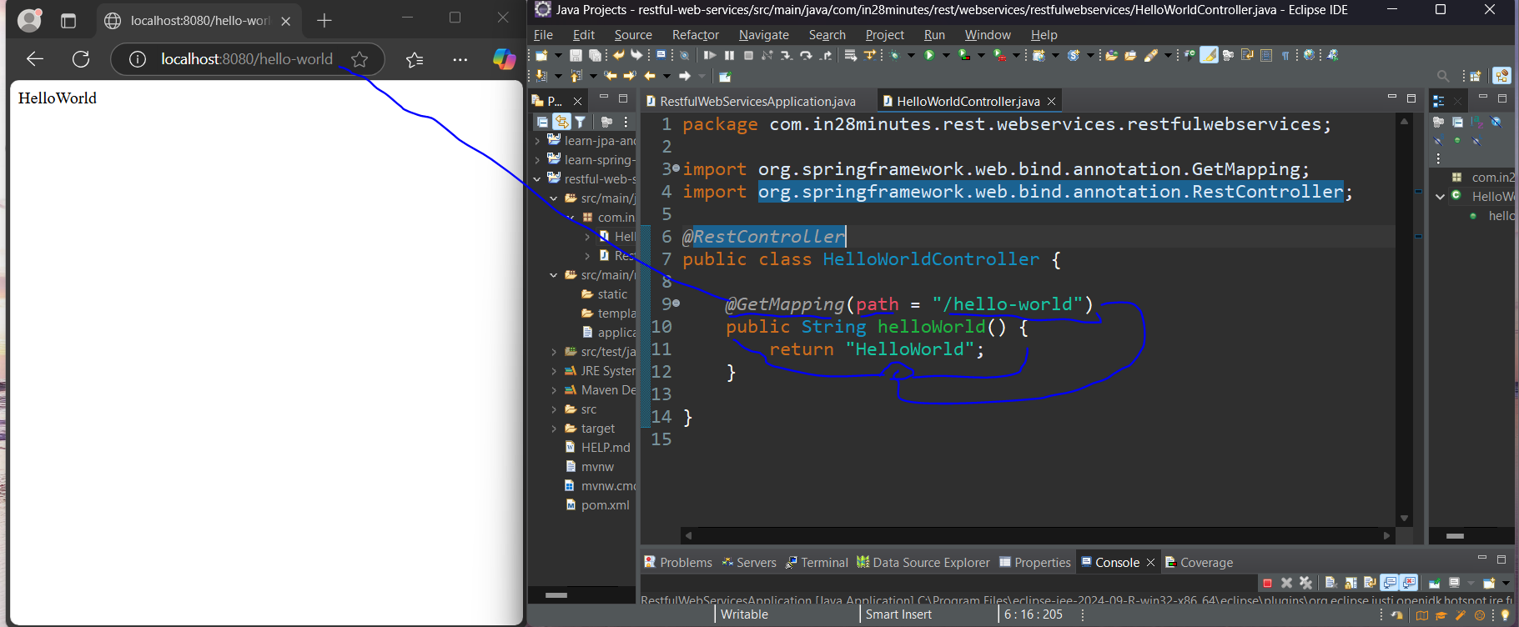

After generating the project with spring web, devtools, h2 and spring data jpa dependencies, it is needed to create a **controller** class that will have the responsibility to exposure the endpoints/uris and serve the http requests, containing a method to return the String Hello World. As important, the annotations will make this happen:

@RestController -> it identifies the class as a restful controller component to expose endpoints/uris and serve the http requests.

@GetMapping(path = “/hello-world”) -> it maps all the GET requests with the path(uri) “/hello-world” and trigger the method below the annotation.

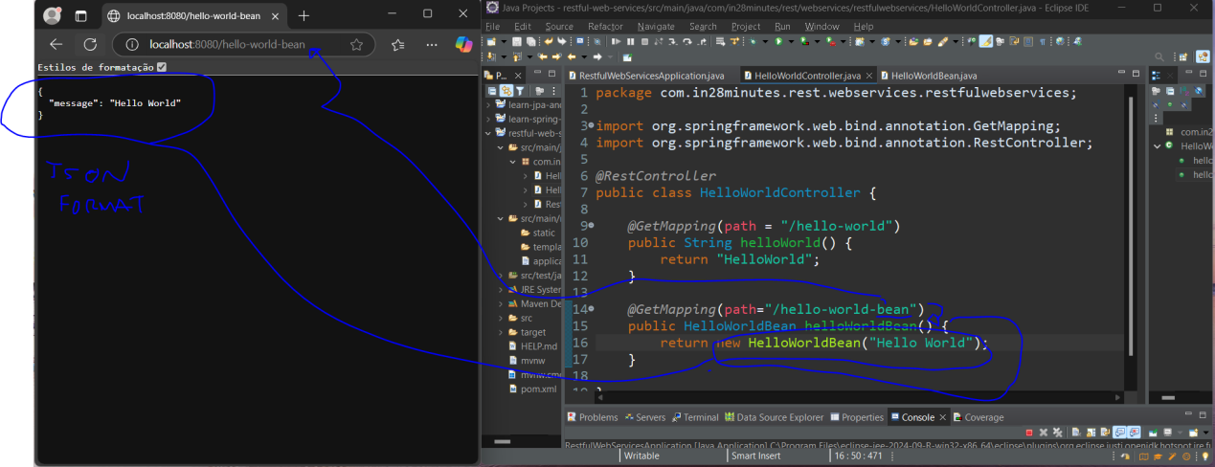

In the real world, many times, what the request expects is a json object, for that it is needed to create a method mapped as a get request that will return this bean(object). Based on it, it is created the method helloWorldBean with the annotation @GetMapping(path=”hello-world-bean”) returning this bean in json format.

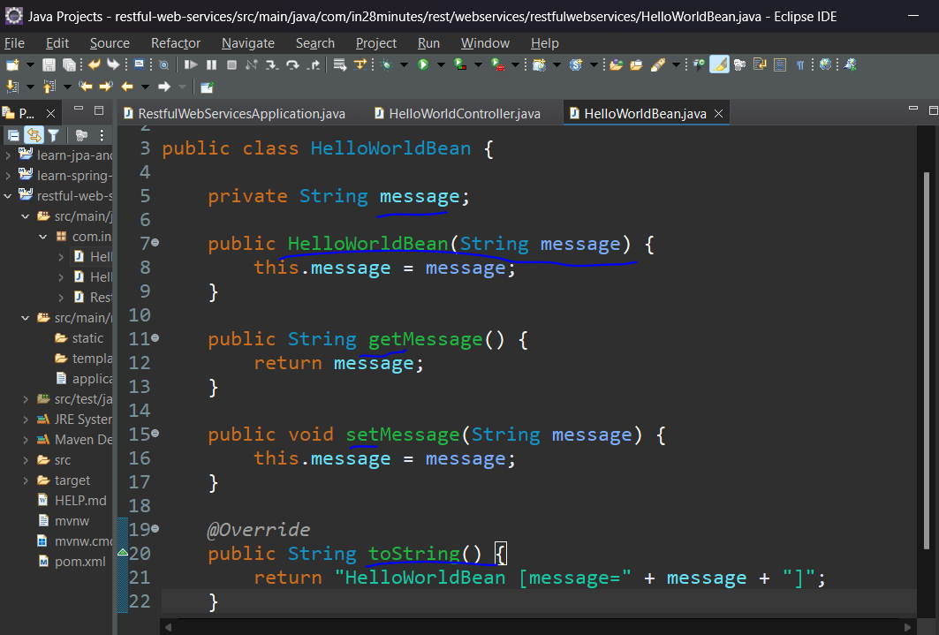

The Bean structure is a simple class with the attribute message, a constructor receiving this message, getter, setter and toString methods.

Some important points, every request is mapped to a specific controller that will trigger one specific method to return a response. The **dispatch servlet** that comes from sping mvc is the front controller that will handle **all the requests of the app** and point out which is the controller responsible for serving that specifically request to discover the method responsible for the operation. Then, our @RestController will take care of the response. Finally, the HttpMessageConverter and Jackson2Object are the jars responsible for converting a bean to a JSON and a JSON to a bean.

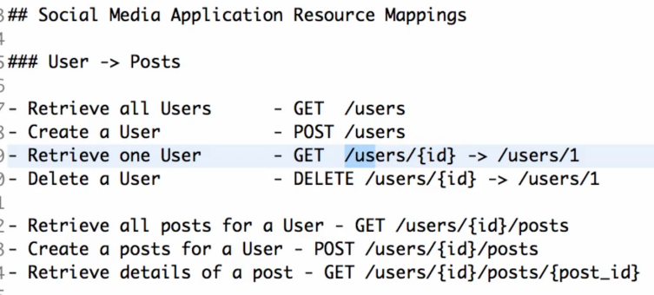

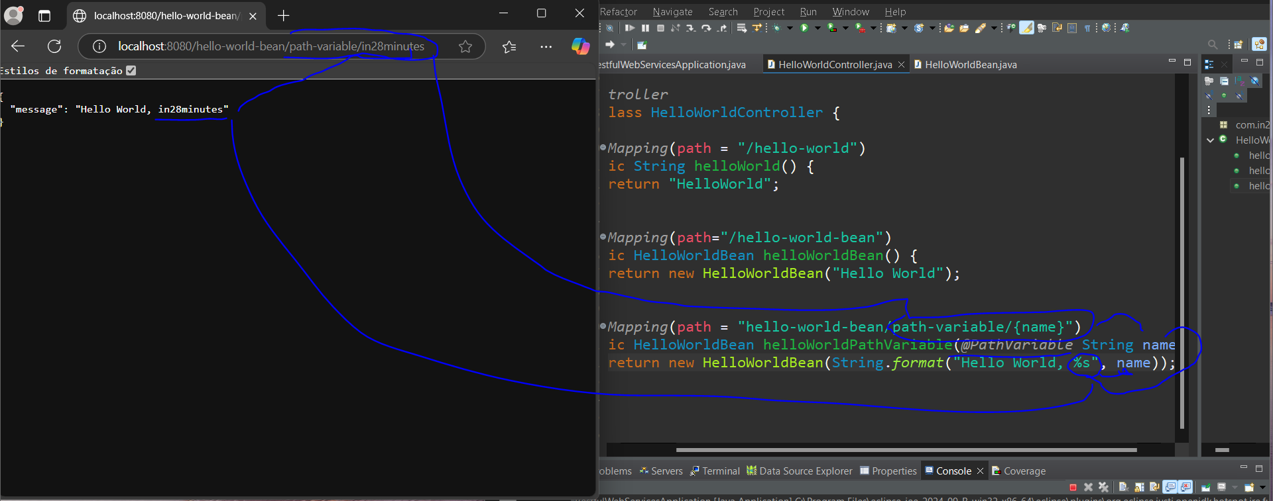

To finalize the section, the user can pass some value through the url (domain+uri), as in the information received **through the url** is identified as a **{variable}** that can be used **on the mapping.** the method, this value is known as **@PathVariable** the **name** of the user can be used to build the message on the instance of the bean-> string.format(“Hello World, %s”, **name**);. *%s-> kind of data of the variable, s for String, l for Long, i for Integer and so on.

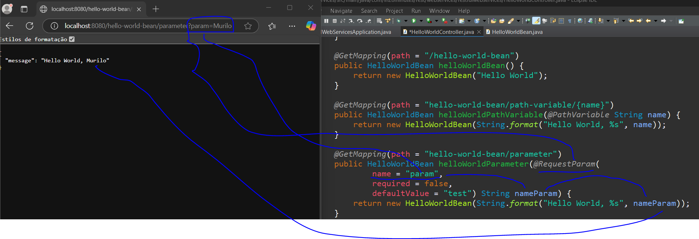

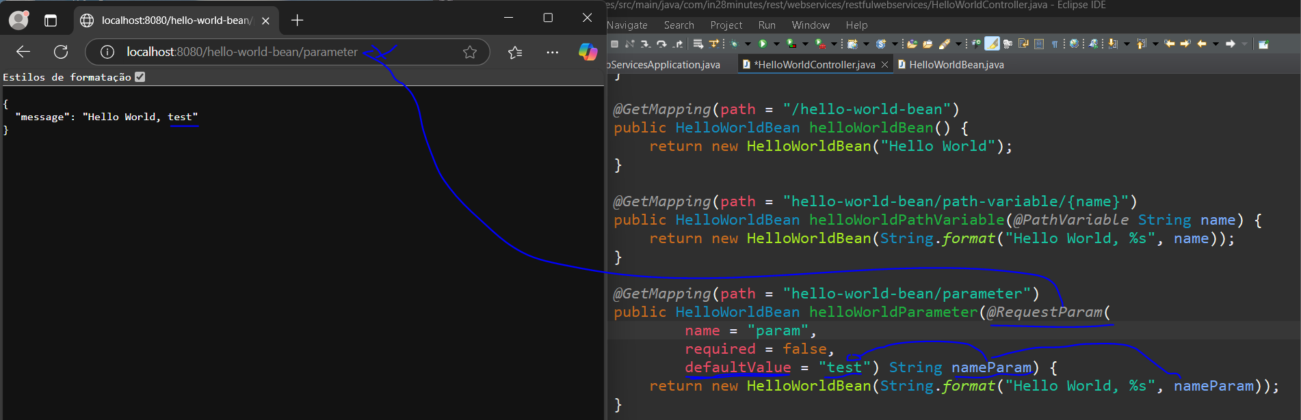

Another way to receive information through the url is using a parameter, in this case the request parameter, for that it is needed to use the **@RequestParam annotation** on the method signature and give details to it like name = “param”, required = true/false and in case of null use the field defaultValue = “test” to save some information.

Angular and Spring Boot Integration

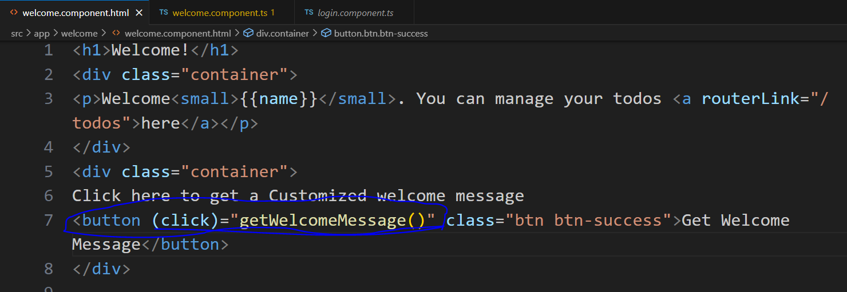

This integration starts with a test, lets say that the angular app needs to get a customized message from the back-end, creating a button on the welcome.component.**html** containing a click event biding calling the method “getWelcomeMessage()” that is present on the .ts file.

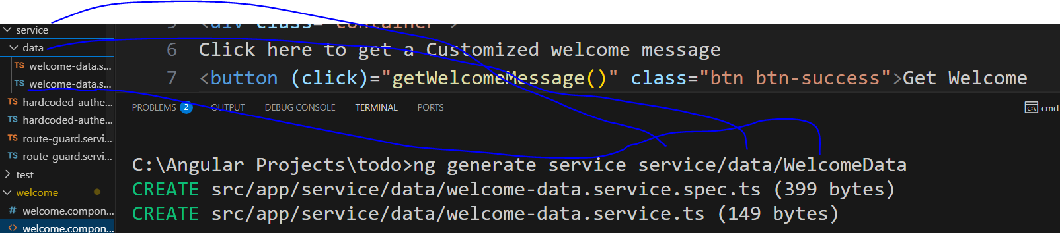

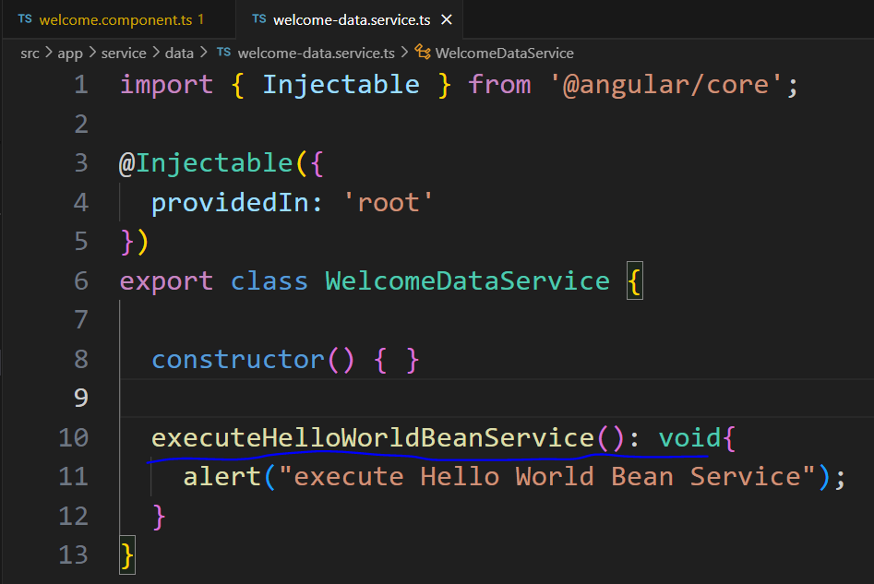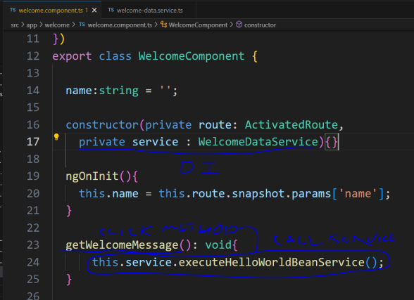

To focus this back-end integration logic, it is created the service WelcomeDataService with the method executeHelloWorldBeanService. For using this service, it is need that it be ‘used’ through the dependency injection on the constructor of the welcome component and inside the method related to the (click) event to call the execute service method.

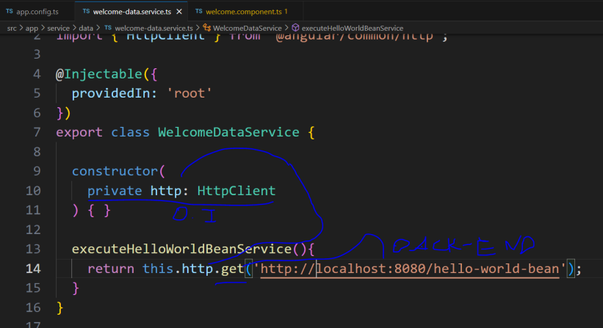

For testing the connection in fact, it is needed to make the dependency injection of the httpClient class on the service, when clicking on the button it will call the service method, this method will use this reference to make the get request to the back-end (“localhost:8080/hello-world-bean”), for now, it will return an Observable object, because actually, it is not making the call exactly.

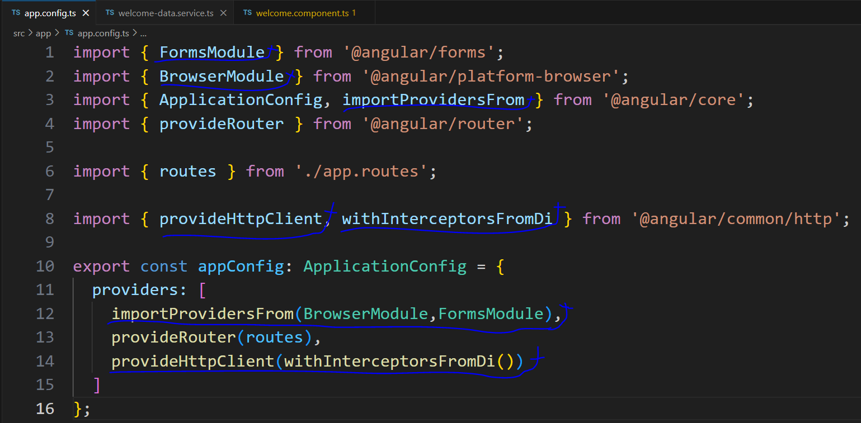

For using this httpClient Module, it is needed to import the modules FormsModule, BrowserModule, importProvidersFrom, provideHttpClient, withInterceptorsFromDi. Then, use the importProvidersFrom passing the BrowserModule and FormsModule as parameters and using the provideHttpClient passing the withInterceptorsFromDi as parameter.

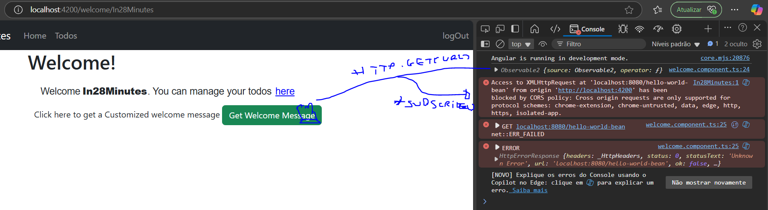

For really making the request to back-end server, it is needed after calling the service, return an observable, concatenating it with .subscribe() for literally connect both sides to obtain the expected object.

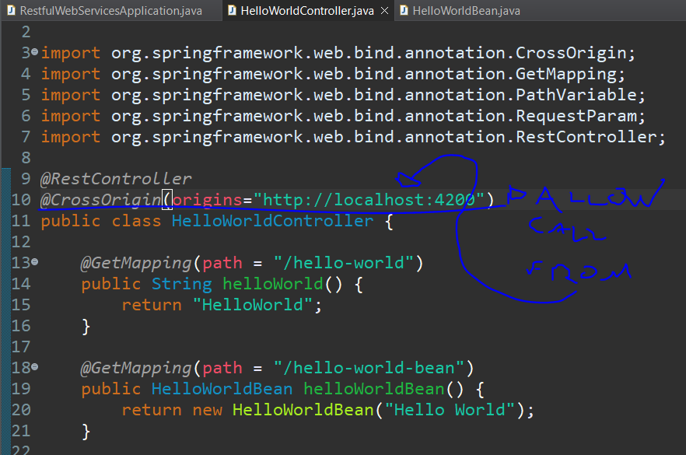

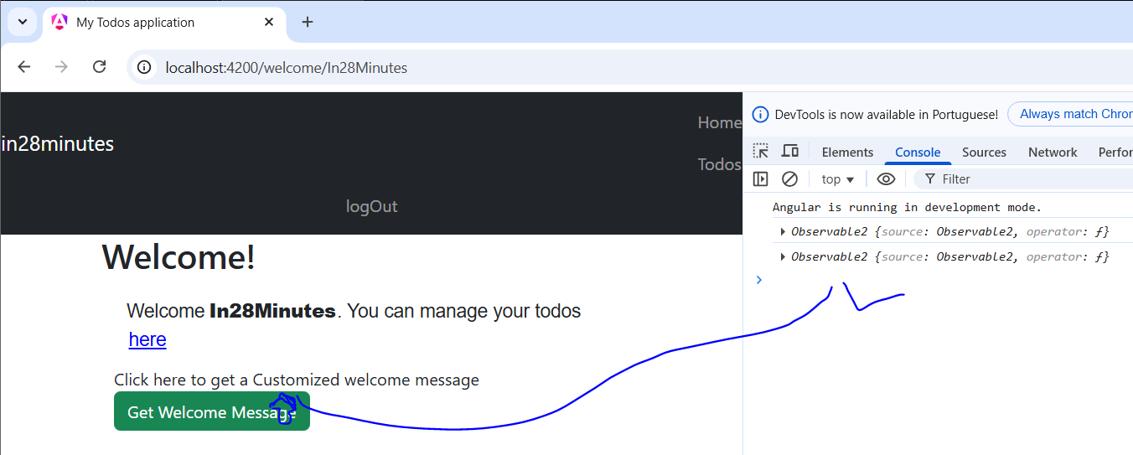

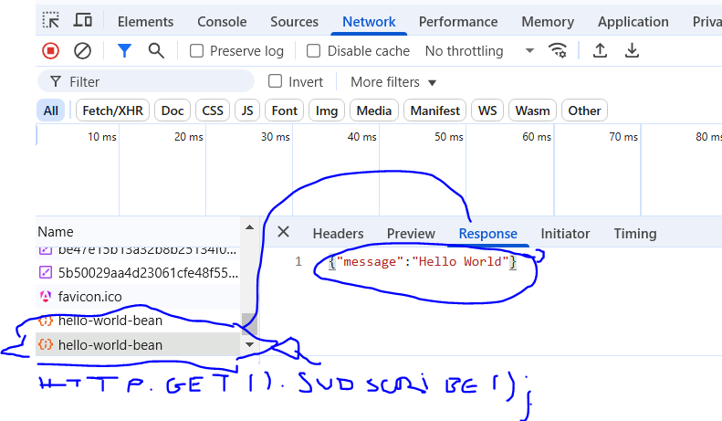

But as security feature, the spring boot apps are configured to **block any external call**, this is called **CORS policy**, to allow this connection, it is needed to include on the controller class the annotation @CrossOrigin(origins=”specific front-end allowed to make call to this back-end server”).

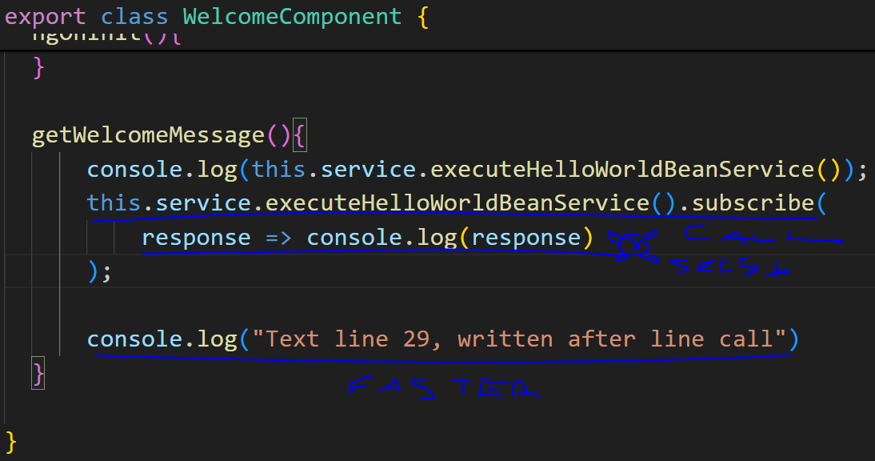

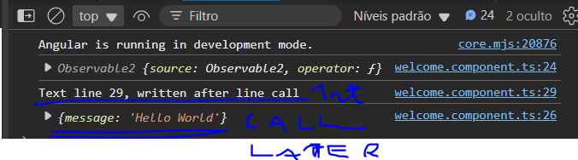

The call made by subscribe method is **asynchronous**, as in, while the call doesn’t receive the response the rest of the lines can be executed (faster).

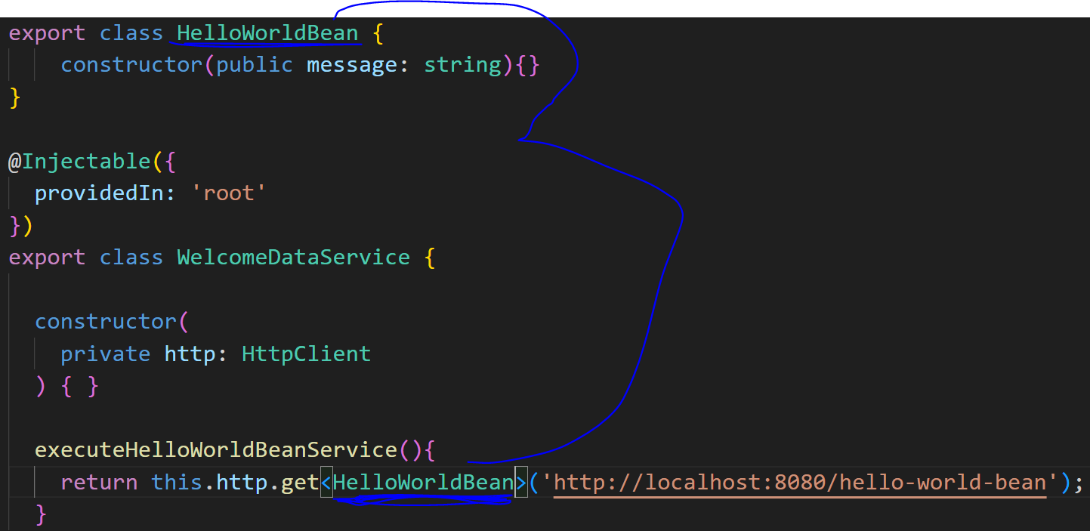

For casting the response object into a new object on angular, it is needed to create a class containing the message attribute and pass it as a generic type<>, for that the object be displayed and usable on angular.

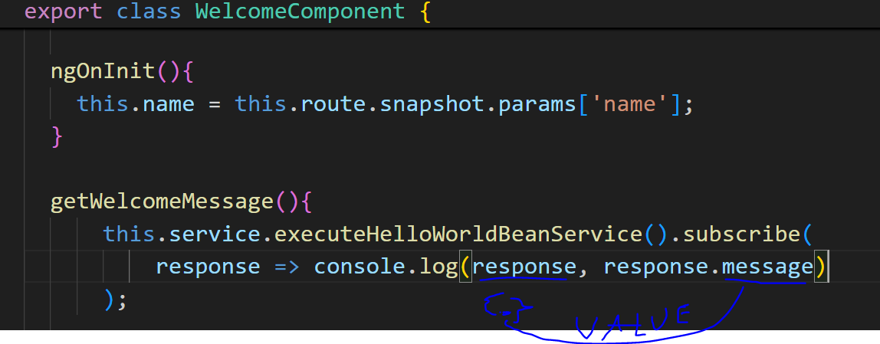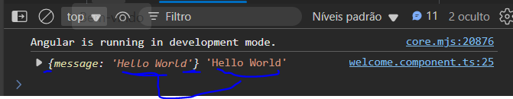

Having the shell object, its content can be usable and manipulated, for instance, the whole object, value of its attributes and so on.

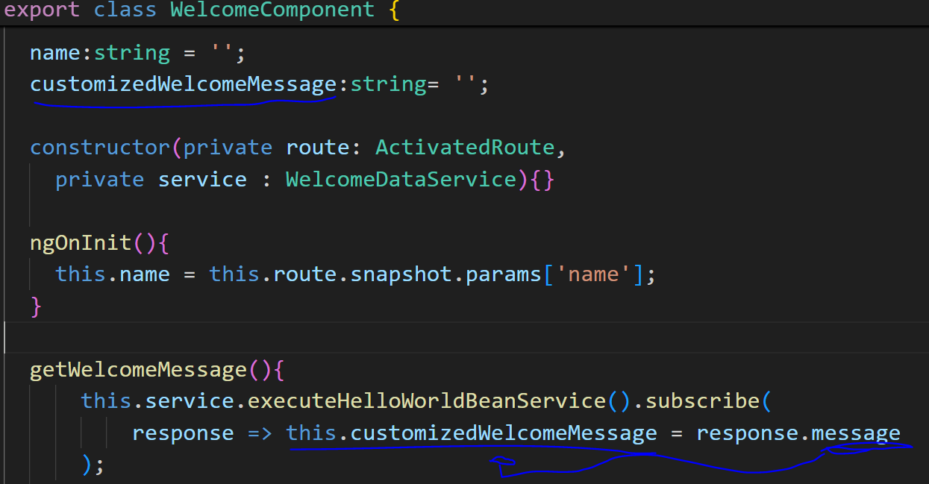

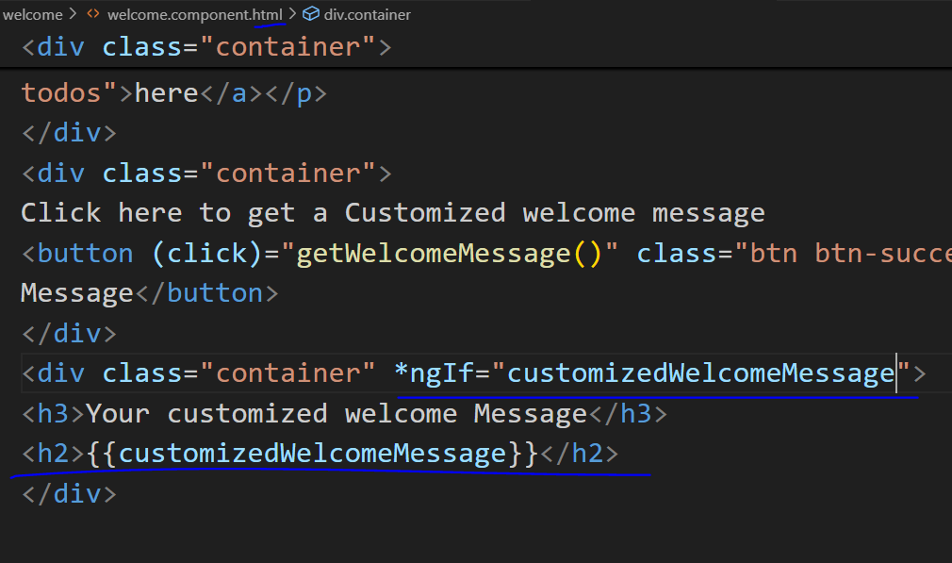

With this object in hands, it is interesting to show it inside the welcome template. It is needed to use the new customized message property, on the lambda back-end response to receive the message from the object response and display it through {{interpolation}} since it is filled in(*ngIf).

(back-end)

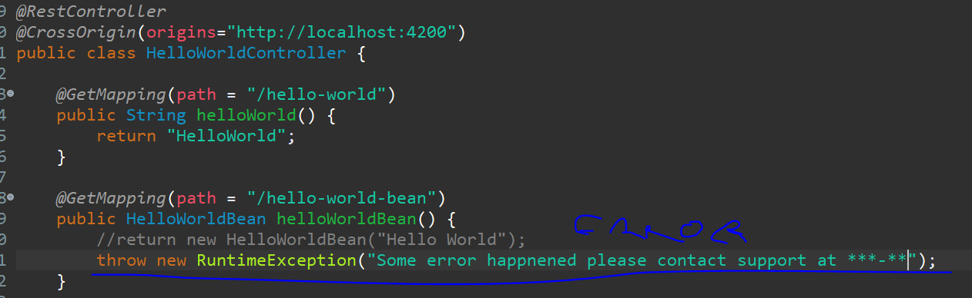

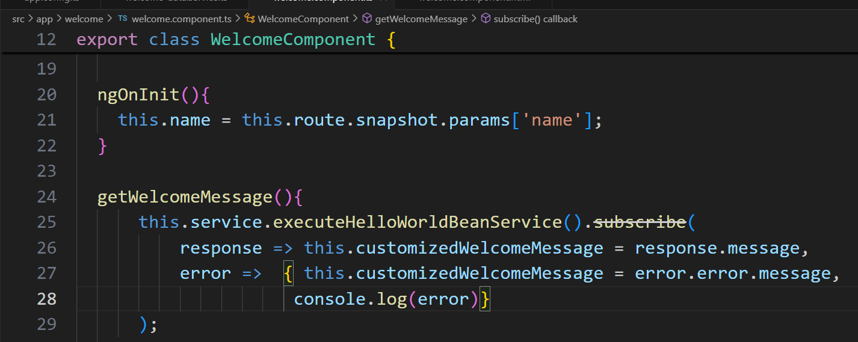

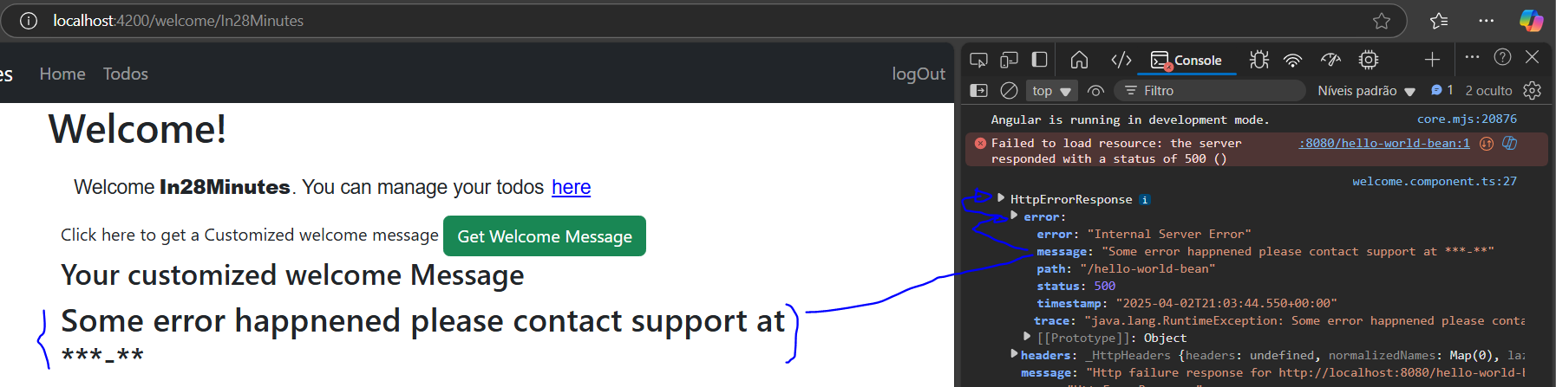

The same way that there is a response object for success, there is an **error object** for failure on angular. In this case, it’s possible to reuse the same customizedWelcomeMessage property to receive the message from back-end and display it on the {{template}}. On the back-end side, it is needed to **throw** this error (new RuntimeException(“”)).

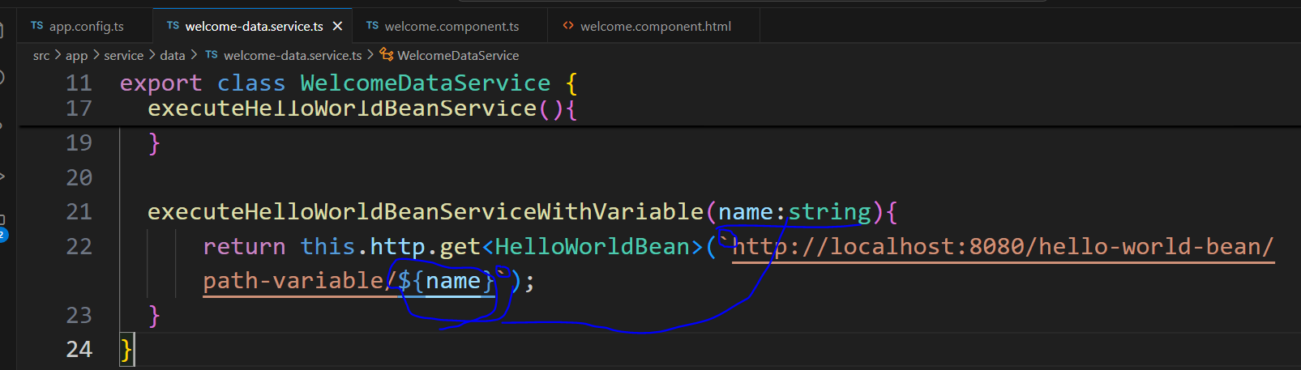

Going to the next call, on the service is created one more method that will receive a parameter on the signature to include it inside the url(`using a backtick instead of quotes`) of the call (${name}).

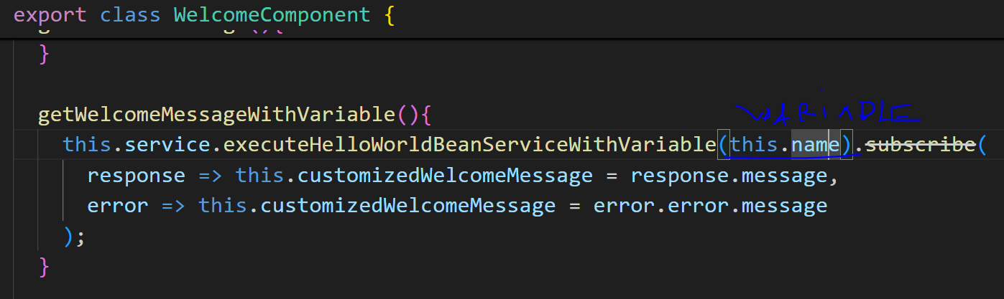

On the component.ts, the property name is passed **as a variable** on the service call new method.

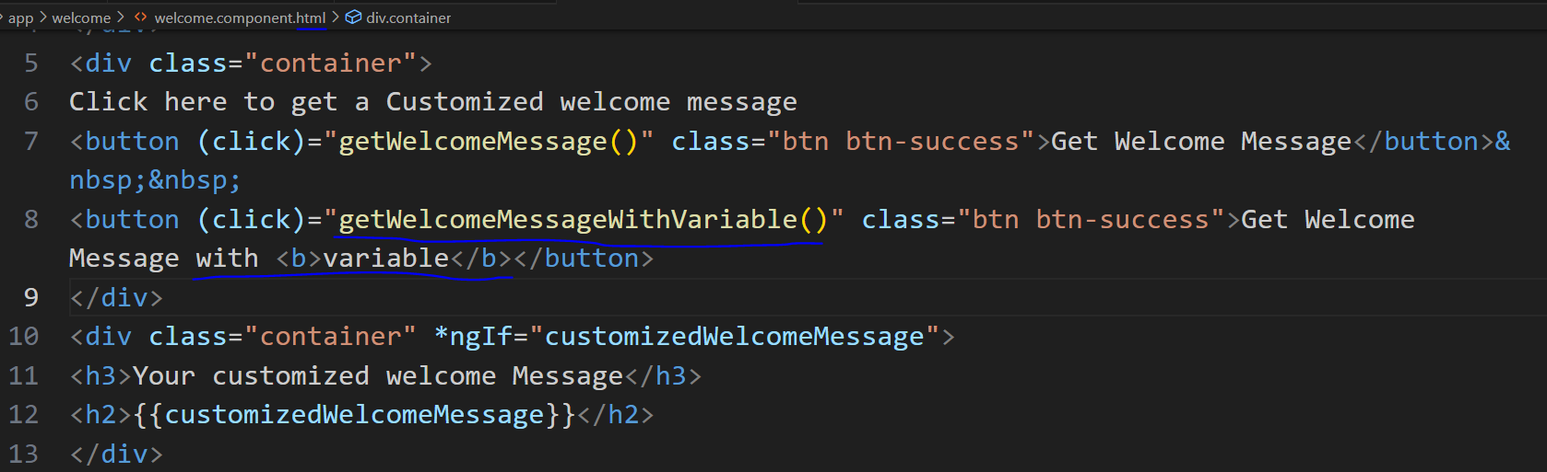

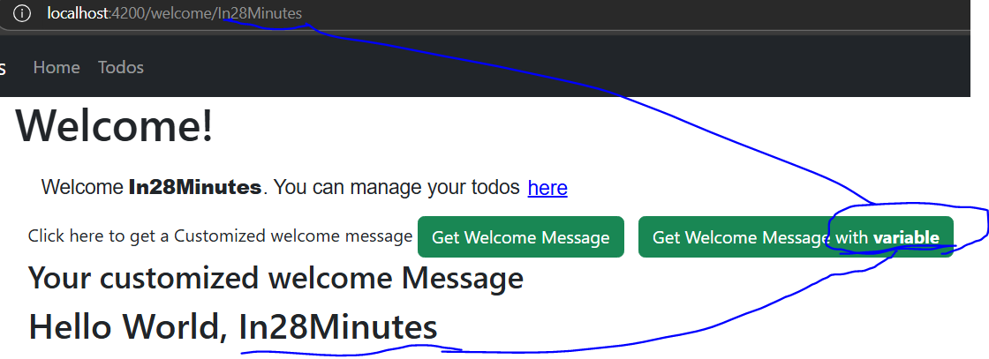

On the template, one more button is created calling this new method.

With this structure on hands, the **to do** operations can be done following the below idea for the controller:

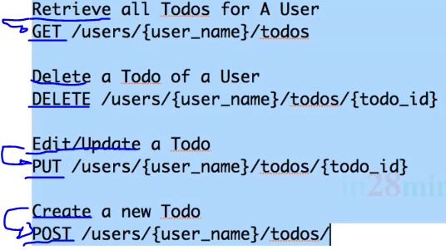

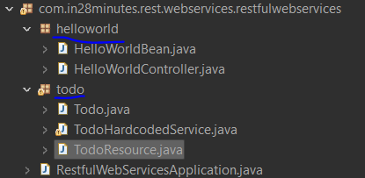

Separate the HelloWorld content in a new package, create another one for the todo content.

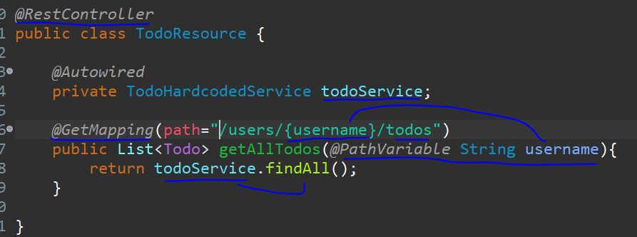

On the todo package, create a controller that will return a list<Todo> in a method as a @GetMapping request containing the path variable, using the service to be created later to return it.

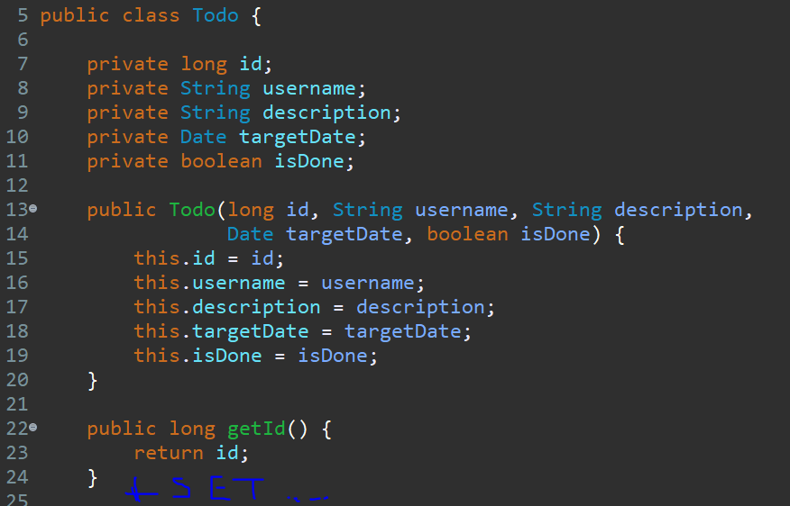

Then, create the relational object Todo with id,username,description,targetDate and isDone as a boolean state with getters,setters and constructor.

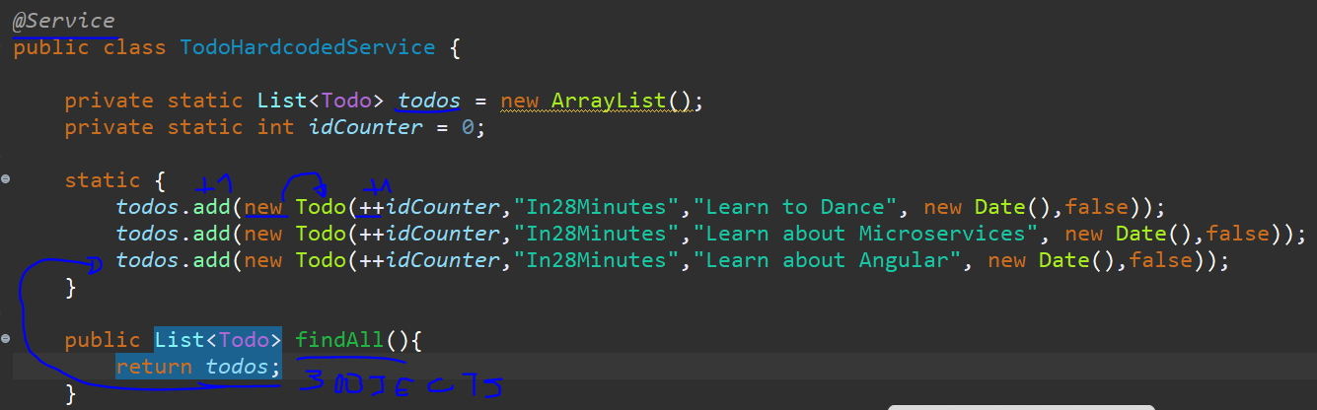

The business rule is focused on a new hardcoded service with the list<todo> as static, an idCounter. Create the static declaring and put on the {} the addition of three todos, pre-implementing the idCounter in all, learning to dance, learn about microservices, learn about Angular, and return this filled in list in a findAll method.

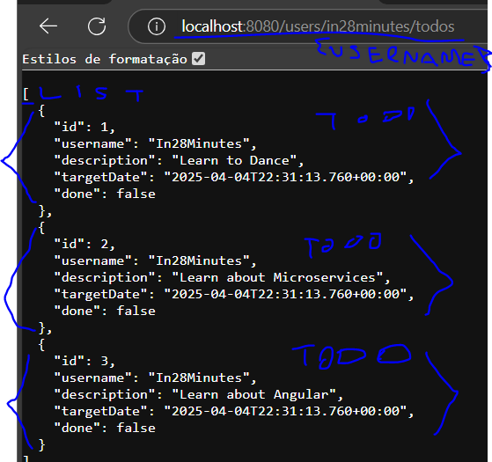

This is the result from the backend, a list of objects of the kind Todo.

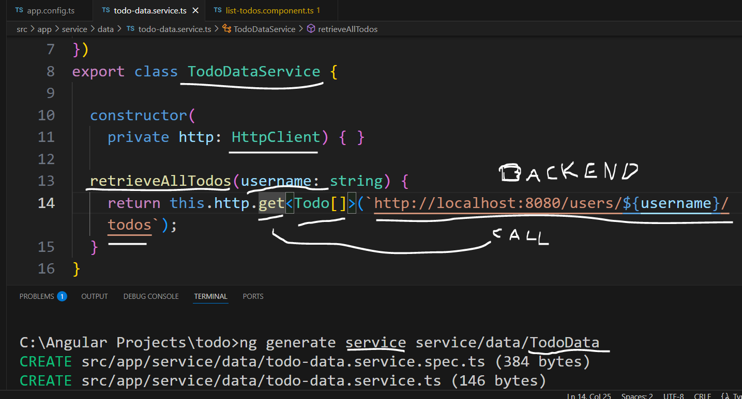

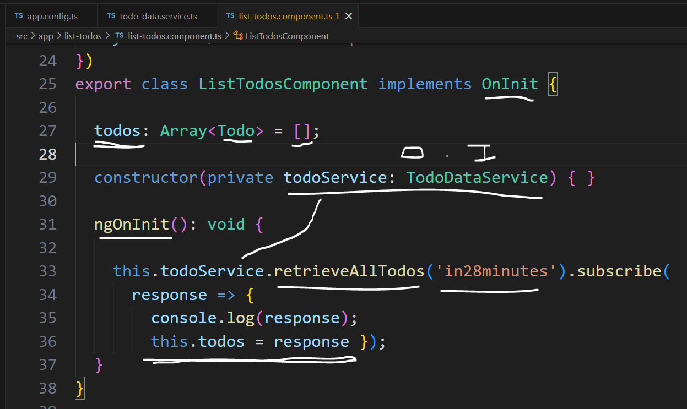

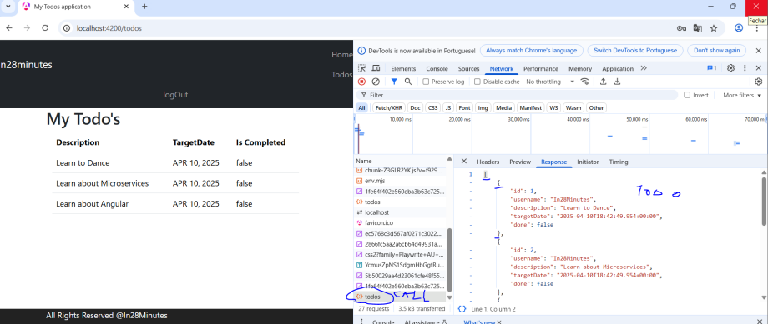

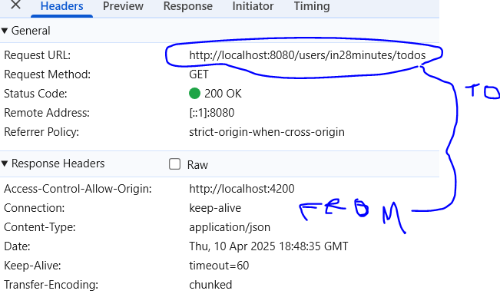

With the back-end prepared to **retrieve a list of todos**, now it’s time to prepare the front-end, for that, it is generated one more service for making the todo data calls and for the list-todos.component using it, initializing the todo’s list as empty, making the dependency injection of the service to call the method to fill in the list . As a reminder, the todoResource class also needs to have the @CrossOrigin to allow the call from the front-end.

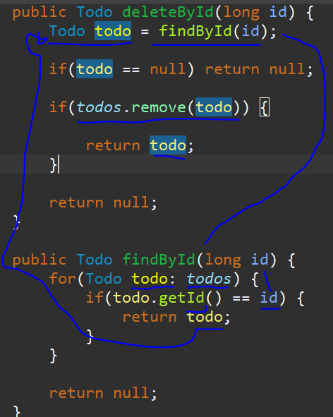

The next step is to simulate the deletion of a todo, for that, on the service back-end it is needed to create a method for deletion by Id, inside it create a reference of a todo that will receive the return of another method for finding the todo by id that will sweep the list to check a compatible id for it, then once returned verify if it is null, if yes, return null else verify if the todo found have been removed from the list, if true return this todo object removed else return null.

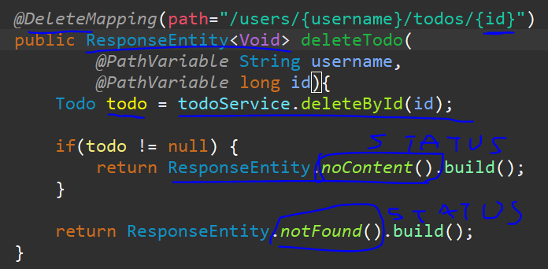

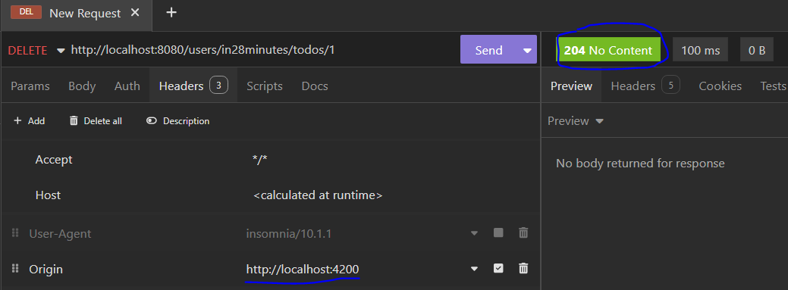

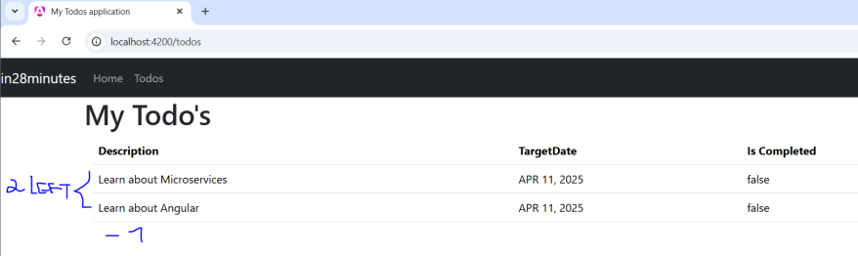

Then, for using this service, on the todoResource, create a @DeleteMapping request including the username and the id, under it, create the method with a **Response Entity<void>** response, inside it, create the reference that will receive the removed todo and call the deletion method passing the id, verify if this todo is not null to return **the status no content** from Response Entity object else return **the status not found**.

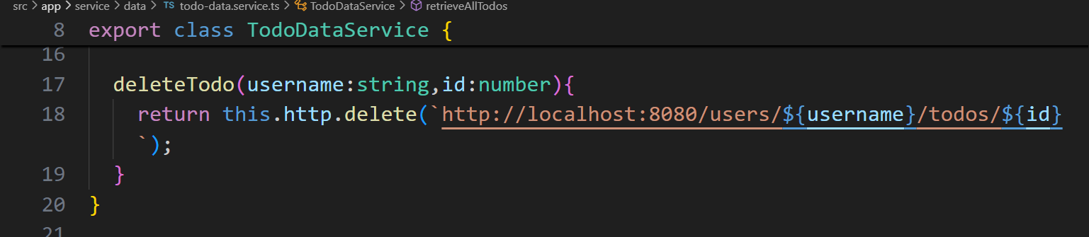

The back-end part is prepared, now on the front-end, it is needed to create the method deleteTodo receiving the username and id to make the delete request to the back-end passing the variables.

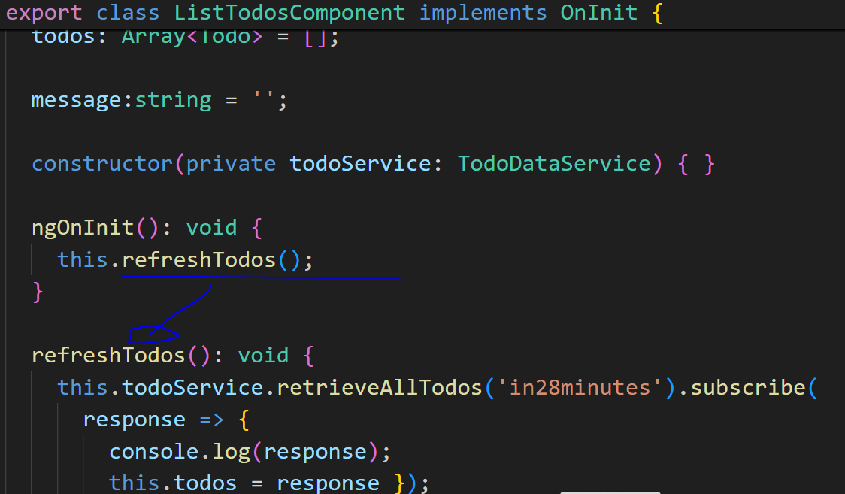

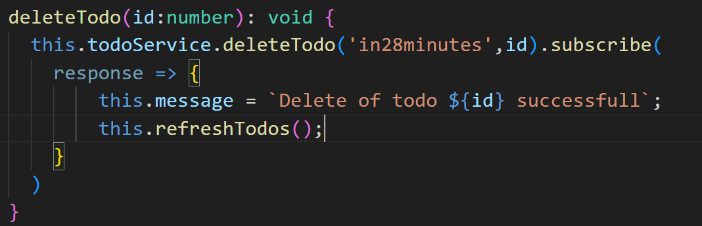

On the list todo component, a method of the same name is created receiving the id to call the delete request. On the success response, use the property message to receive the sentence, inform that the todo with the id passed was removed and update the list of todos without the removed one.

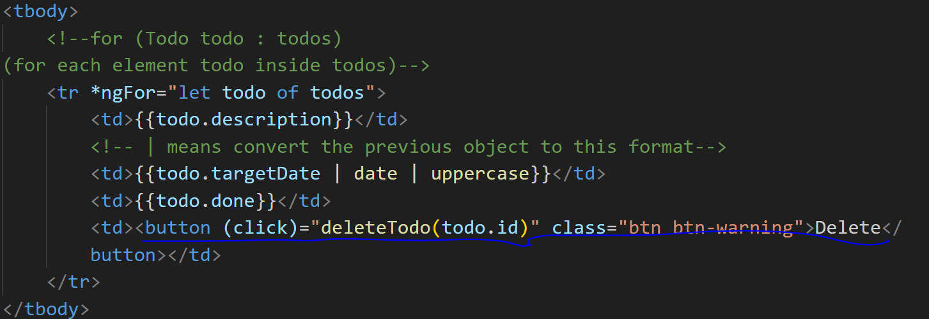



On the template, it is needed to create the button inside a new <td> with the click event calling the new function passing the id of the current todo of todos. On the top of the page, it is created a div to exposure the message if it is filled in.

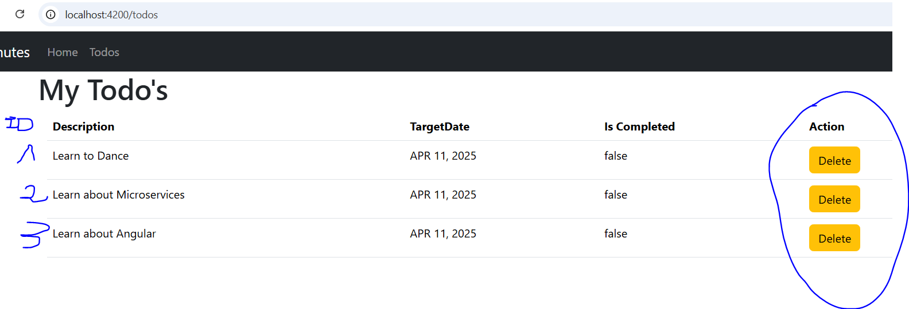

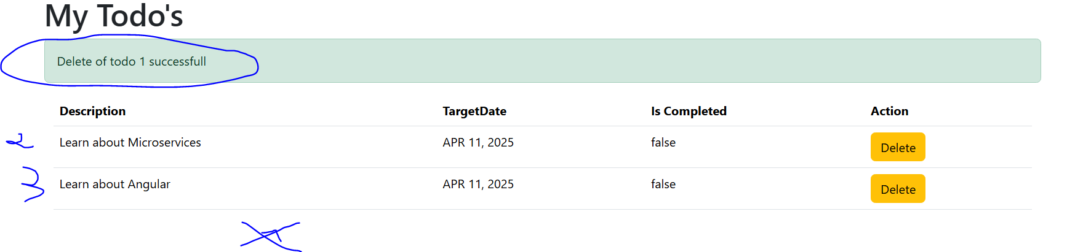

This way, all the functionality is accessible through the button delete.

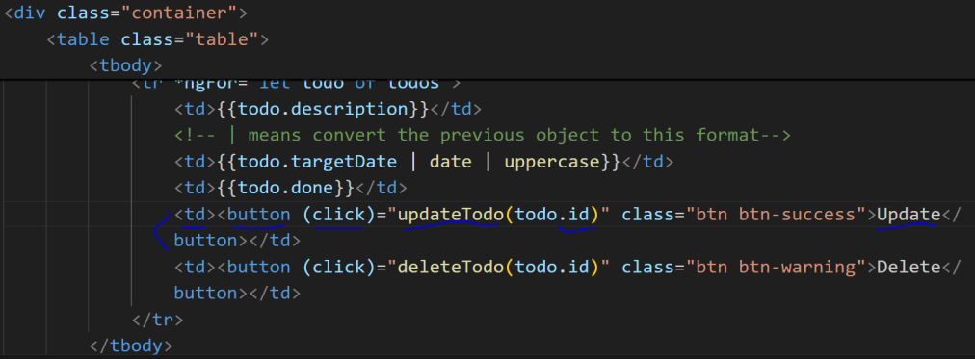

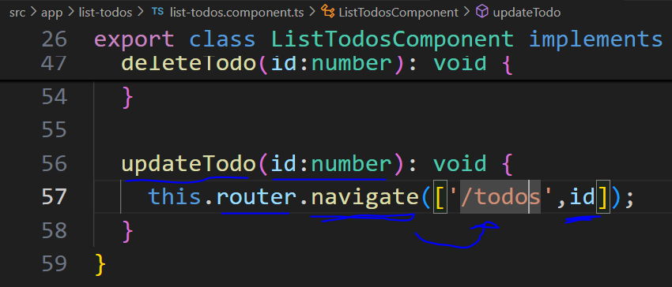

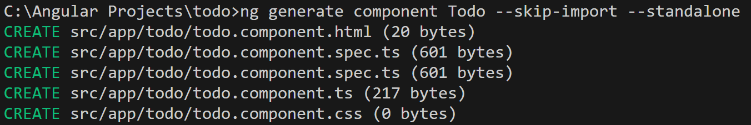

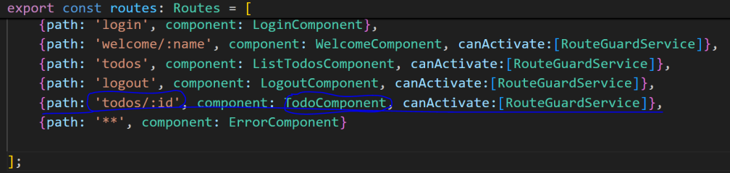

Going ahead, it’s time of updating the todo, for that one more button is created to redirect the user to a new component called Todo passing the id of the selected todo. In summary, create this button (template) with the click event calling the method to redirect to this new component passing the id (.ts). This way, the component is inserted in the route list.

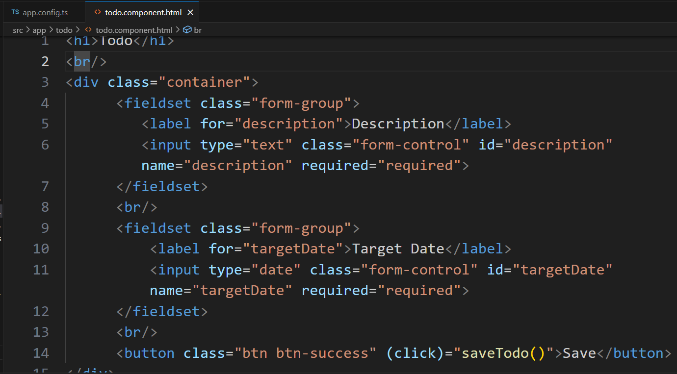

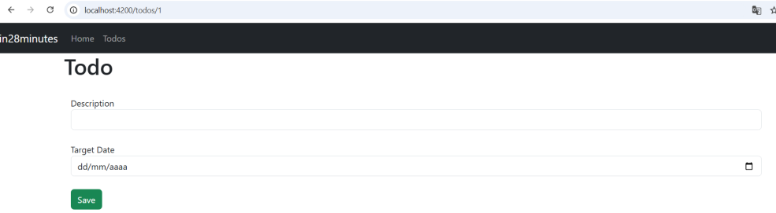

On the todo template, create the title todo, fieldsets, labels, required inputs for text and date, and a button to trigger the method to call the back-end service.

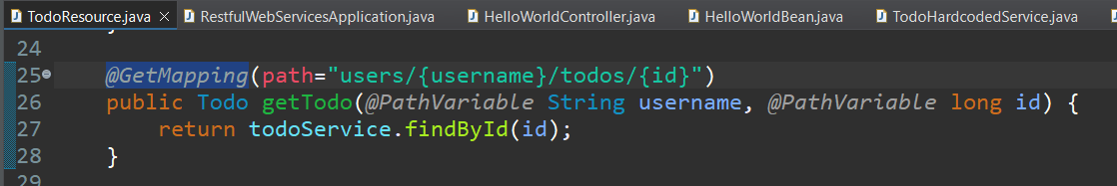

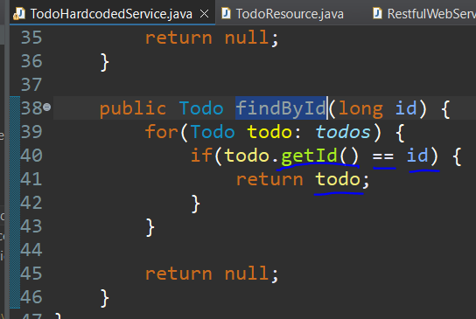

On the back-end, it is created one route to retrieve **one** todo receiving the username and id as variables on the path and method. The search is done sweeping the todos list and checking if the current id is equal to the one sent by parameter, once found, it is returned to the front-end.

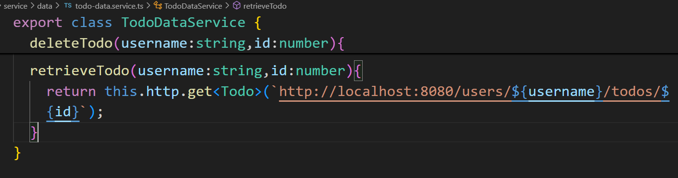

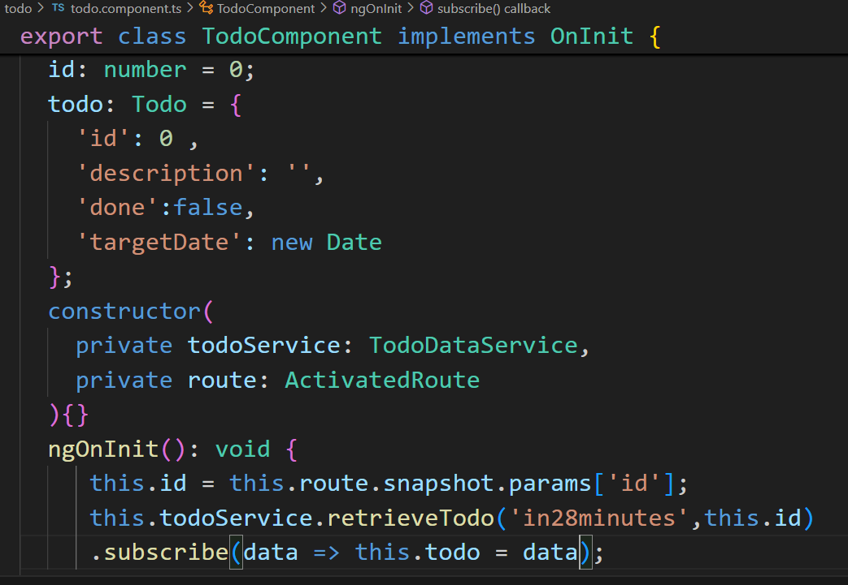

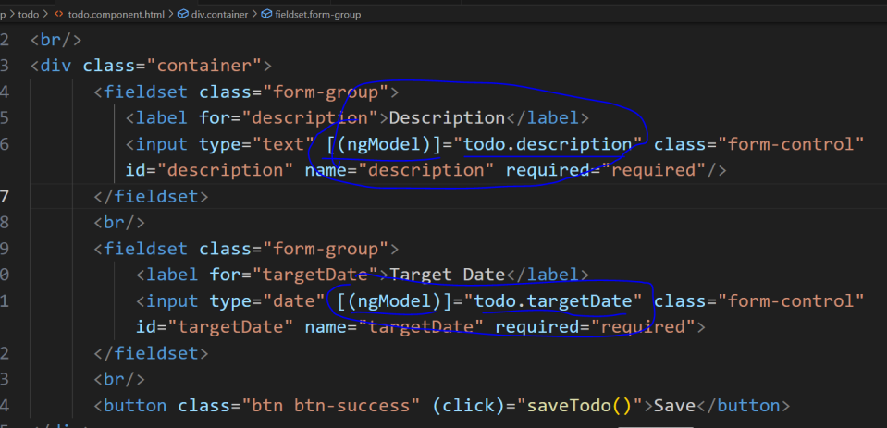

On the front-end side, it is needed to create the call in the service receiving **a** <Todo> as type, on the todo component .ts is created the id and todo properties to store the same ones by route parameter and data obtained by the service call and finally on the template is used the directive [(ngModel)] to retrieve and update the fields description and date of the property todo.

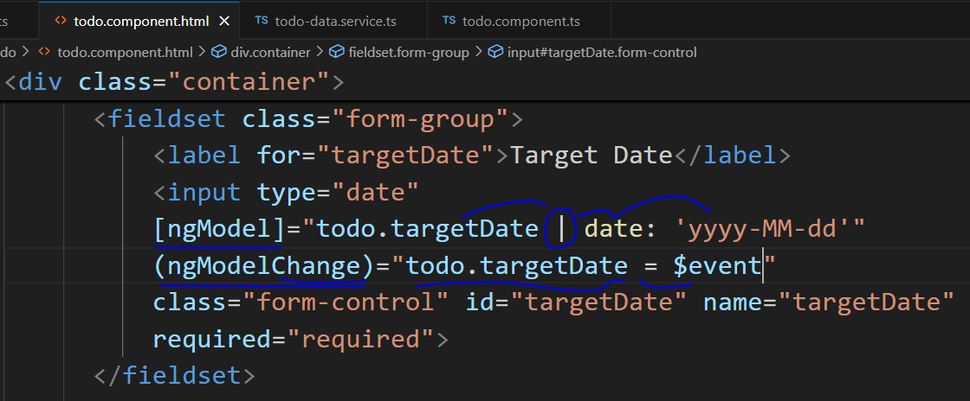

But the date was not being formatted as year,month and day only, to fix the problem of the date to be in another format, it is needed to segregate the ngModel in two:

[ngModel] = ”property | date: ‘date format wished for’ ”

| means is formatted to

(event binding for every change of value defined by the user) = “property = $newValue”

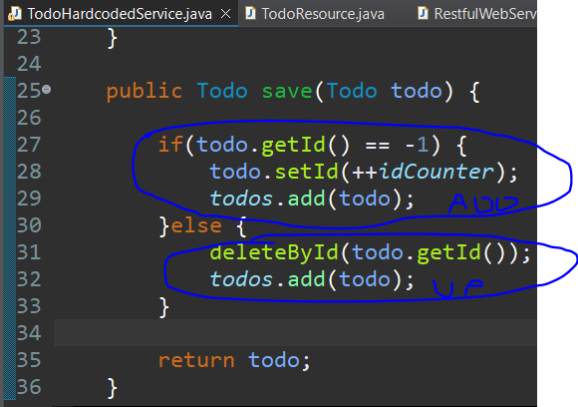

As in the database, the method save is used for insert / update some object, in the simulation with a static list for adding a new todo, it is verified if the id of the todo object is - 1 || 0, then replace the id by last position more one and actually insert it (.add(todo)). Otherwise, for updating the existing one, this one is deleted by its Id and a new todo is inserted with the same id but with different values.

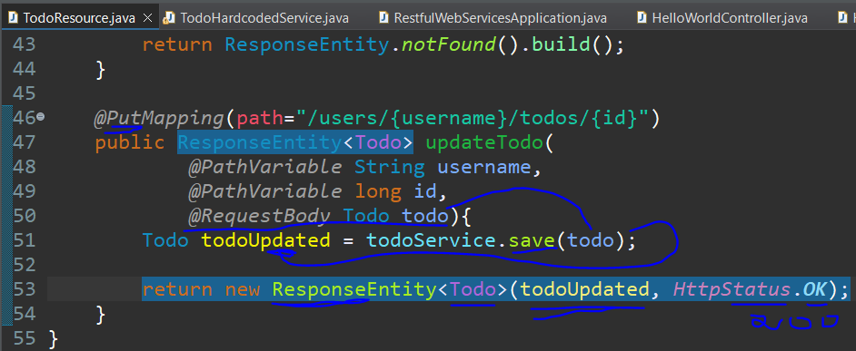

Now, it is needed to map the request to update the todo(@PutMapping), receiving the variables through the path, as return include the Response Entity<Todo> object, add the todo object as a @RequestBody, use the service to make the call and inside the return make the instantiation passing the updated todo and the status of the response.

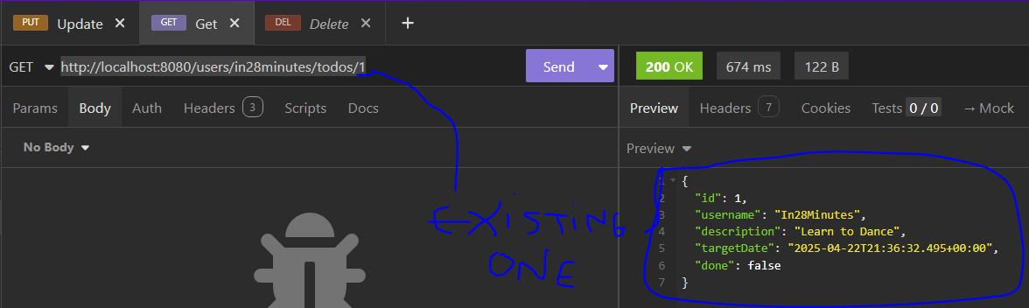

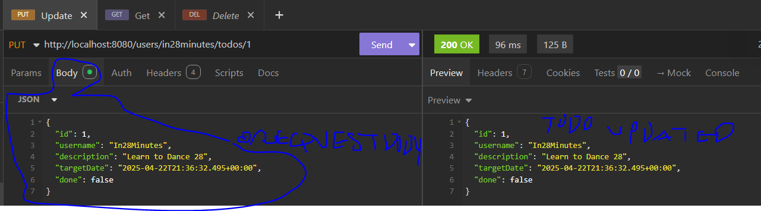

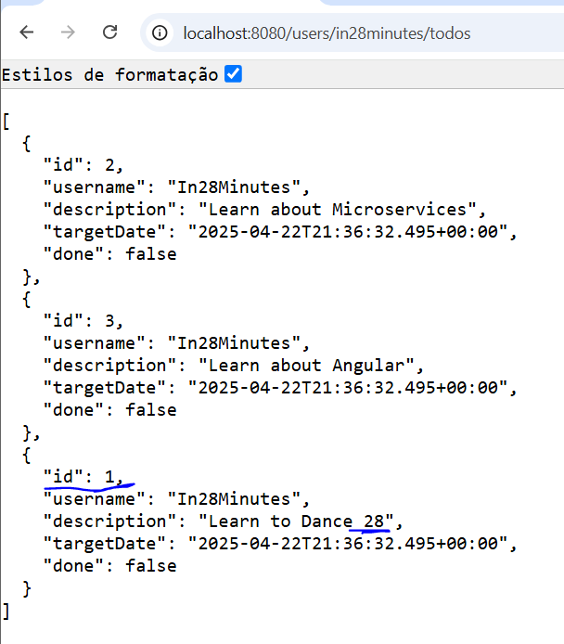

As a test without the front-end, it is made a get request to return the todo with id 1, copying this content, and on the put request paste the content as **the body of the request** for really updating the list and finally checking the whole list to see that the object is with the same id but with a different description.

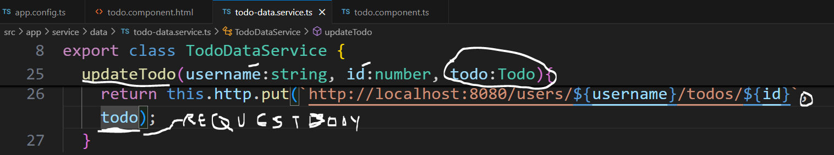

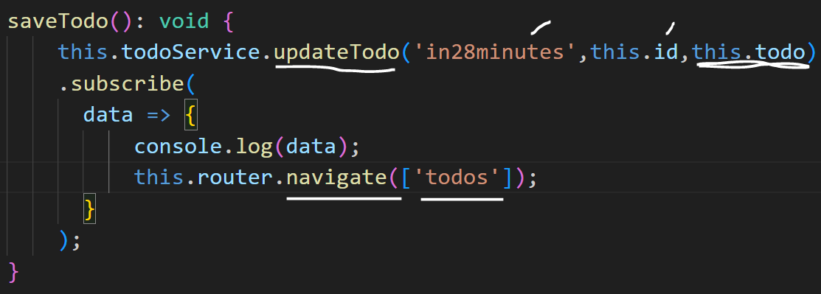

Once the back-end is ready for updating, the front-end can make the call passing the variables and **the todo as a request body** on the put signature. When the user to click on the save button, this event will trigger the method saveTodo to make the call and navigate back to the todos component to see the todo already updated.

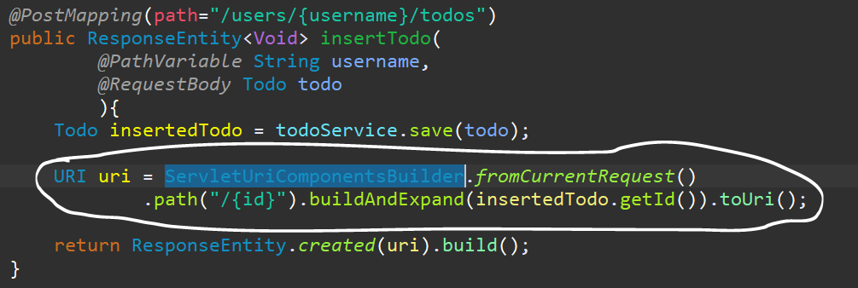

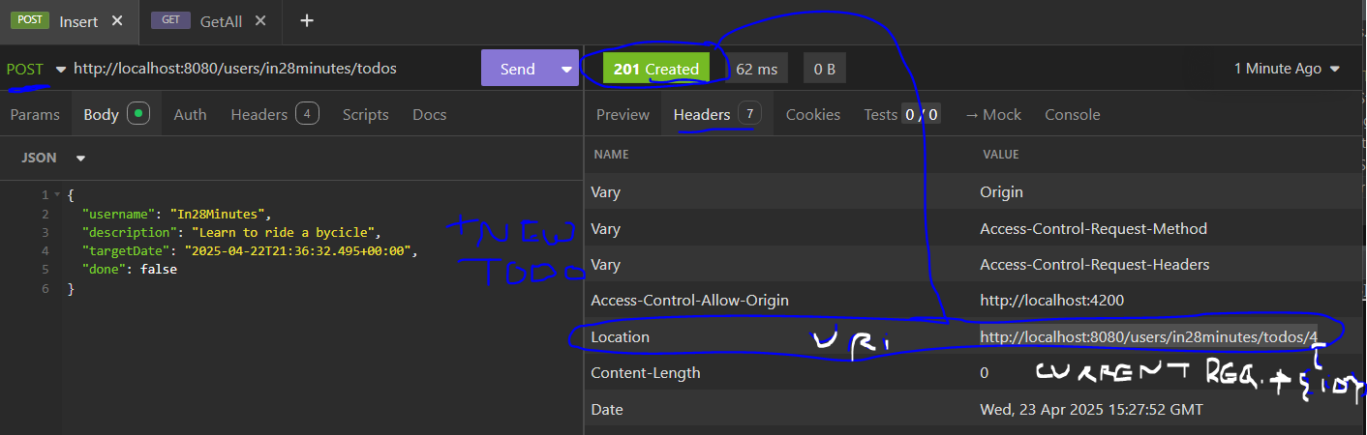

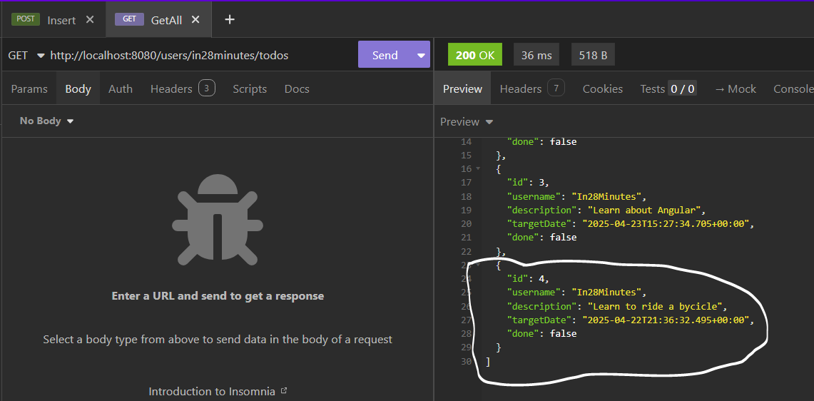

For inserting a new todo, it is mapped a new post request receiving the username as a variable and the todo object as a **@RequestBody**, then storing the inserted todo calling the save method from the service and return the status of created with the whole url including the new id. For building this uri object is used the class **ServletUriComponentsBuilder**  to obtain the current path, include the {id} variable , replace it by the id from the todo object and convert the result as an URI value.

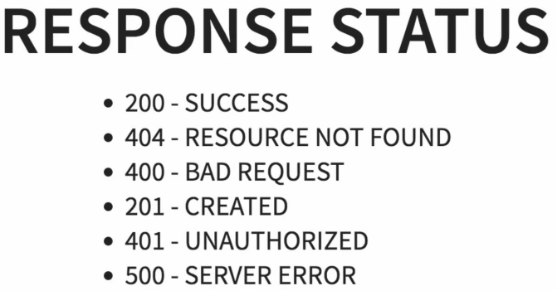

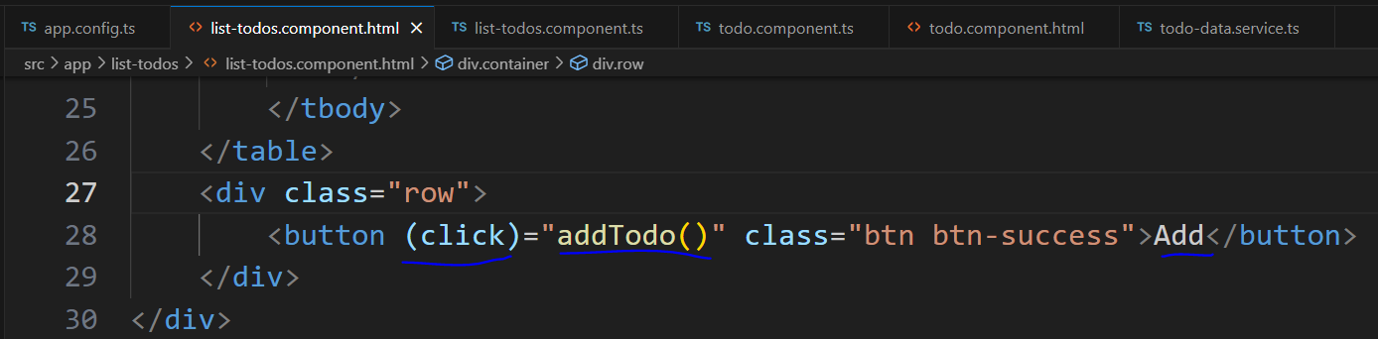

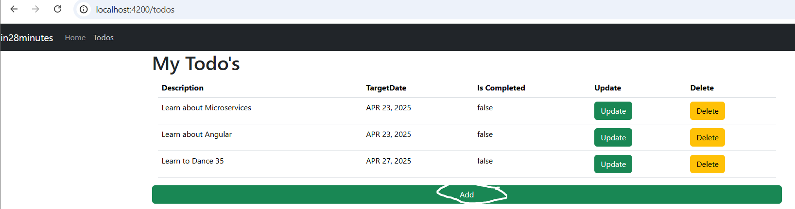

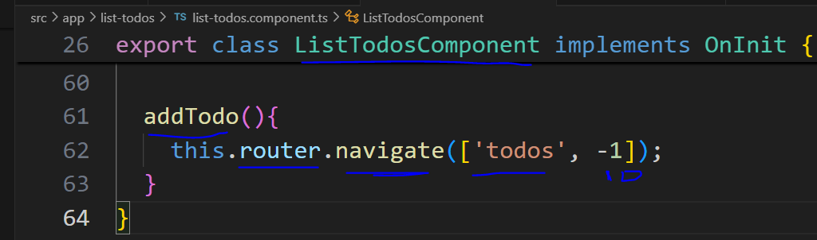

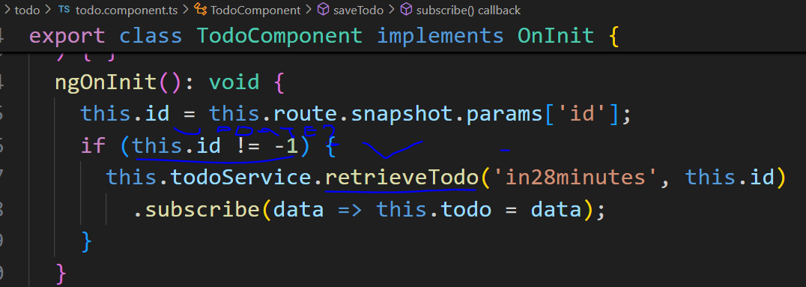

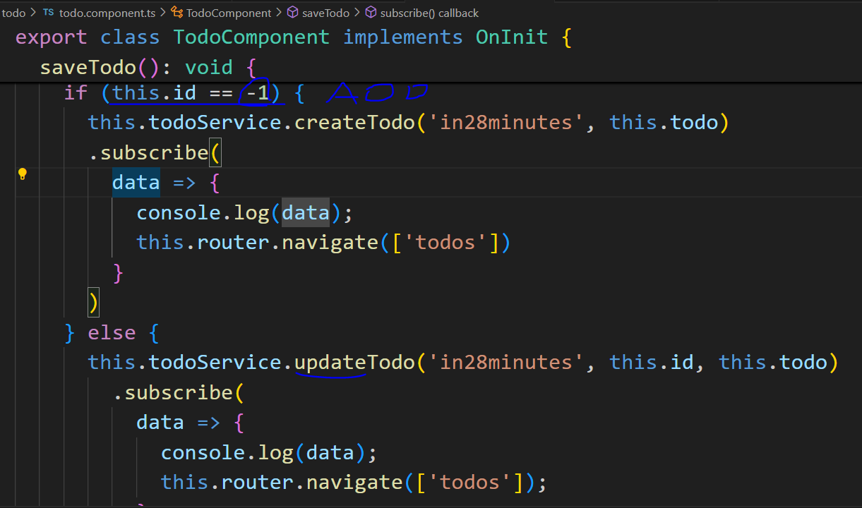

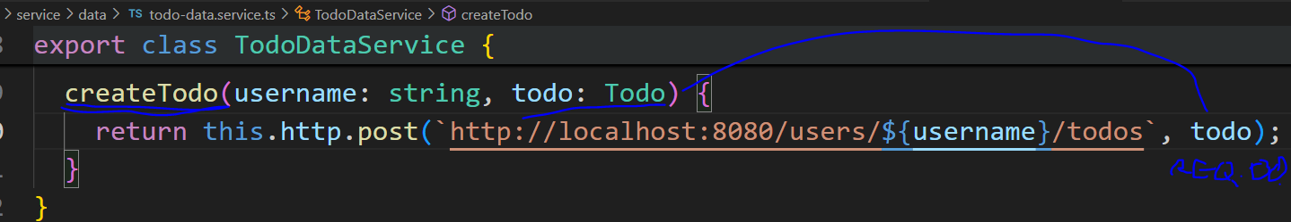

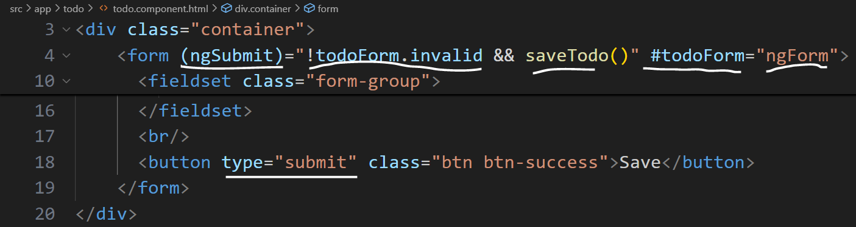

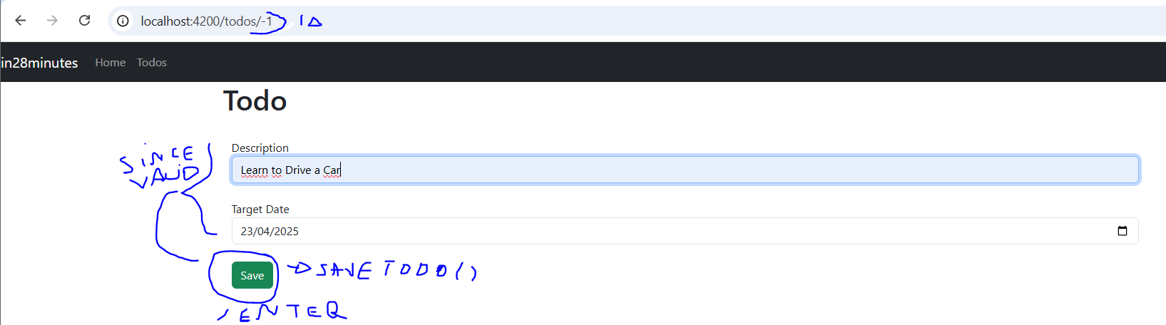

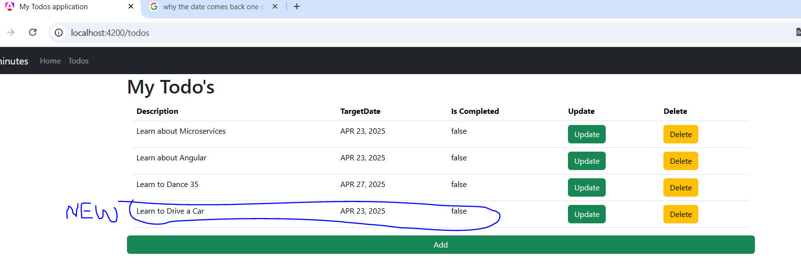

On the front-end, it is included the button add triggering the method addTodo to navigate to the todo component **sending the id as -1.** On the todo component, the id is retrieved by the reference router of ActivatedRoute and verified before retrieving any data, because it’s a new todo, then on the saveTodo method is verified if the id is -1 to call the service for adding a new one else call the update service for after doing the operation come back to the todo list to retrieve the new or updated todo.

An important validation is to check if the fields are valid(not empty for instance) and be possible pressing the button Enter to send the form, for that is needed to include the tag form to make both fieldsets to be part it, the save button becomes a submit button (type), the tag form has an submit event **(ngSubmit)** since this form **is not invalid** for then triggering the method **saveTodo** using the id **#nameOfTheForm=”ngForm”** to identify the form as an angular form.

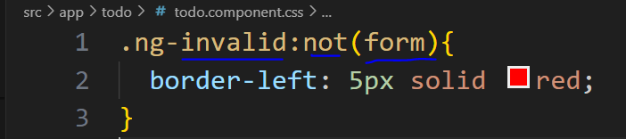

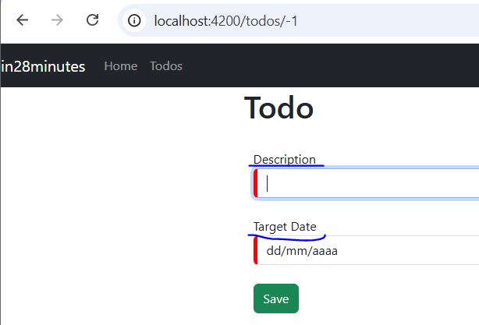

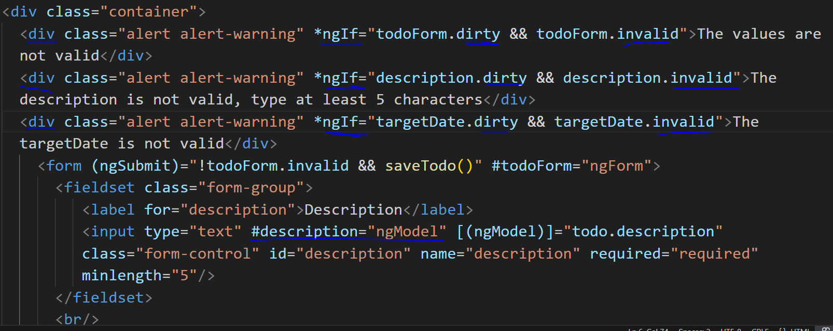

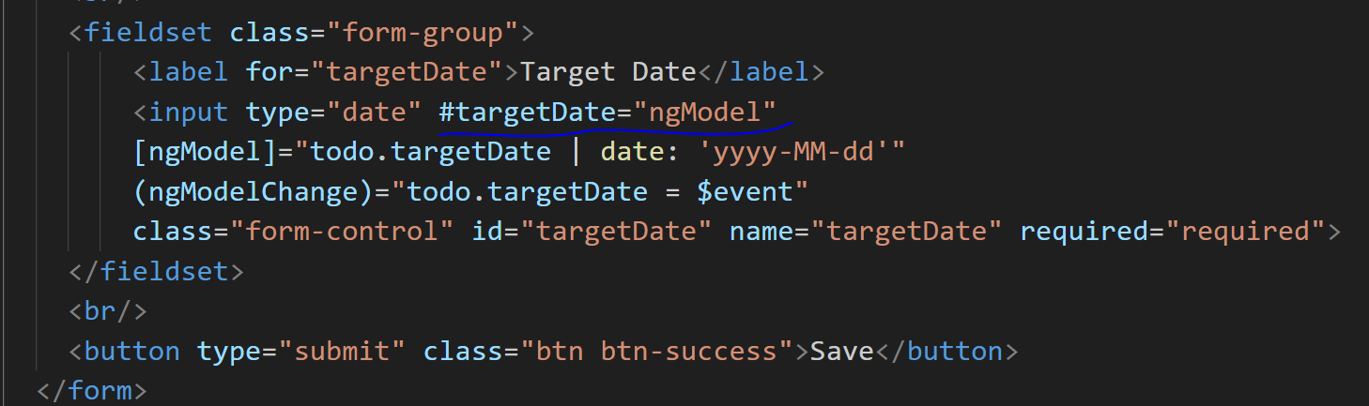

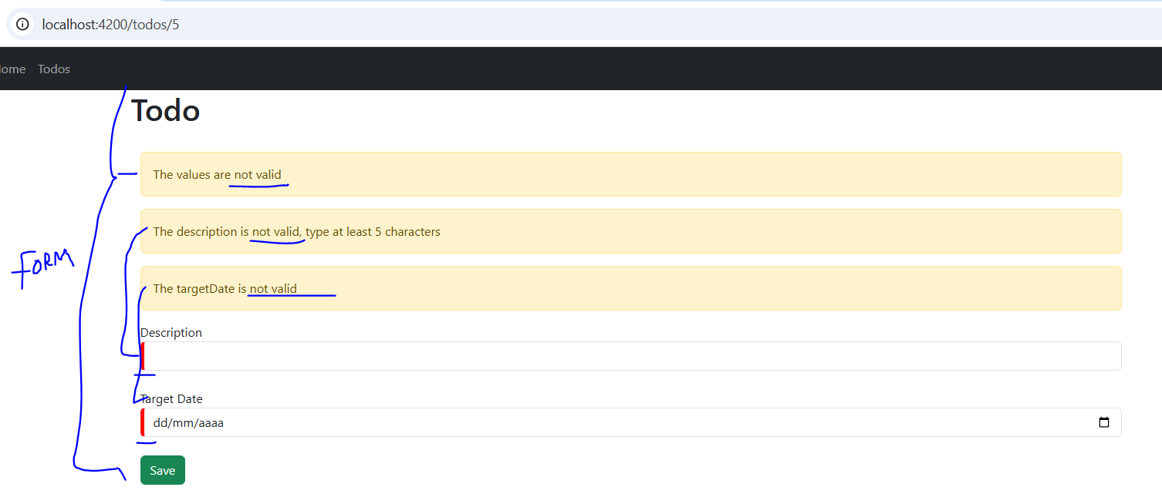

*dirty means is edited

Once the form is being validated it is important to display to the user why the form is not being sent, for that, every input needs to be **id**entified by a reference(#name=”directive”) and on a separated div use the *ngIf directive to check if is invalid “reference.invalid” >the message< is displayed. As a style, on the css, it is possible to individually catch each input by the class .ng-invalid:not(form){ adding a left border as solid and red with 5 pixels}.

The section now is about security , because all the services exposed by the controller at the back-end is free without any authentication, thinking about it on SpringBoot there’s the dependency **spring security** and as feature to use the **J**ava **W**eb **T**oken that will serve as a session control besides username and password.

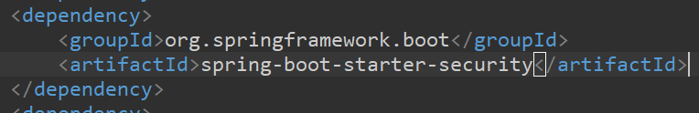

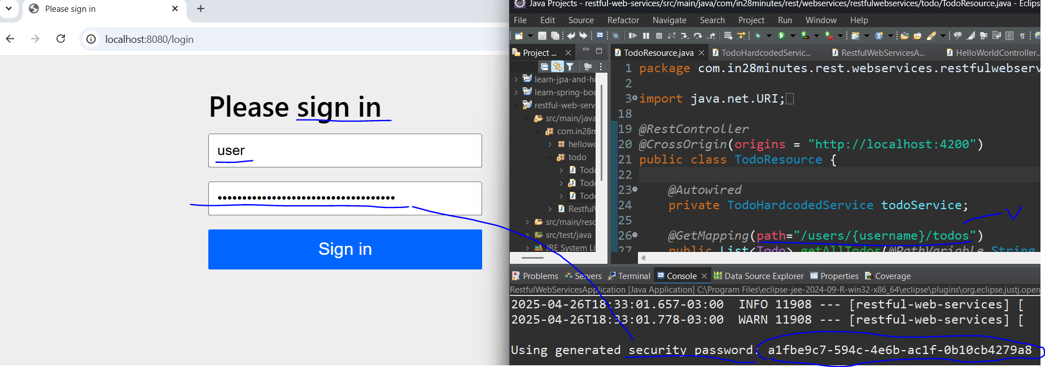

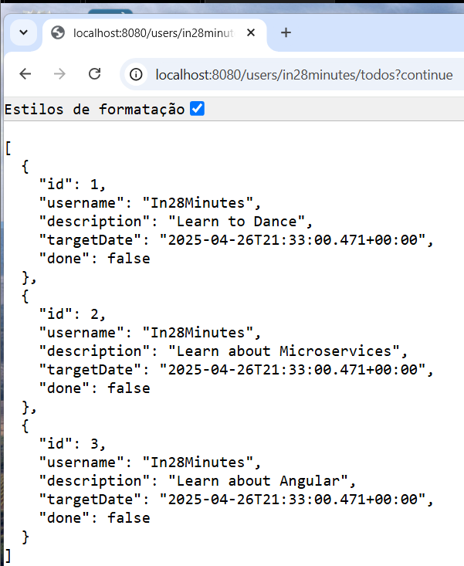

Just importing the spring security dependency (pom.xml), every first time accessing some service it is requested a **form based authentication** **with user and password** provided by spring boot and these are automatically sent encrypted in every request and connected to a cookie **session** until the browser closes.

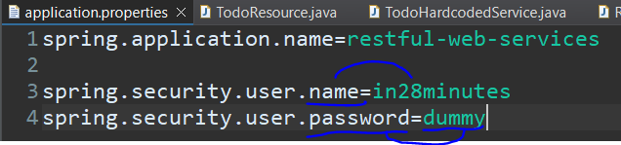

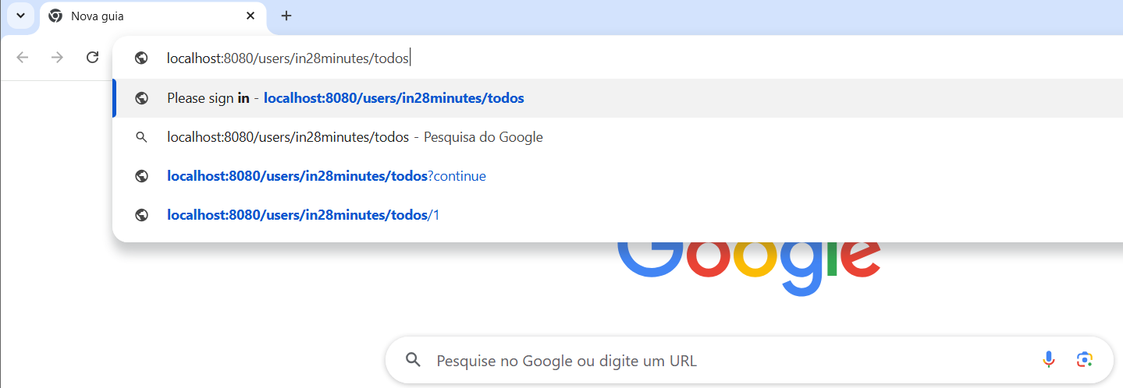

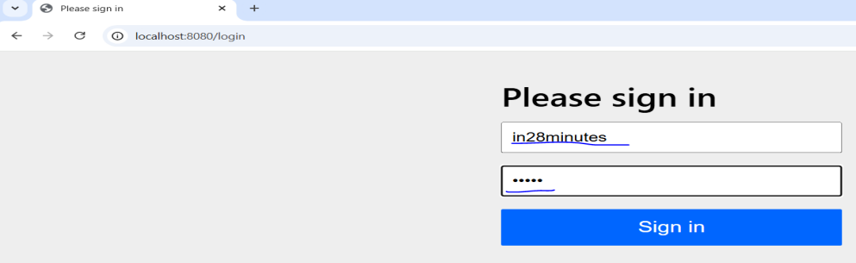



Editing the app.properties file it is possible to include a configuration to customize the username and password with the following ones: spring.security.user.name=”anything I want” and spring.security.user.password=”anything I want”.

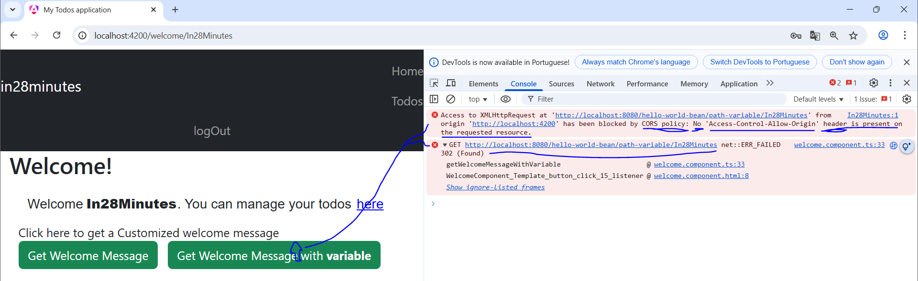

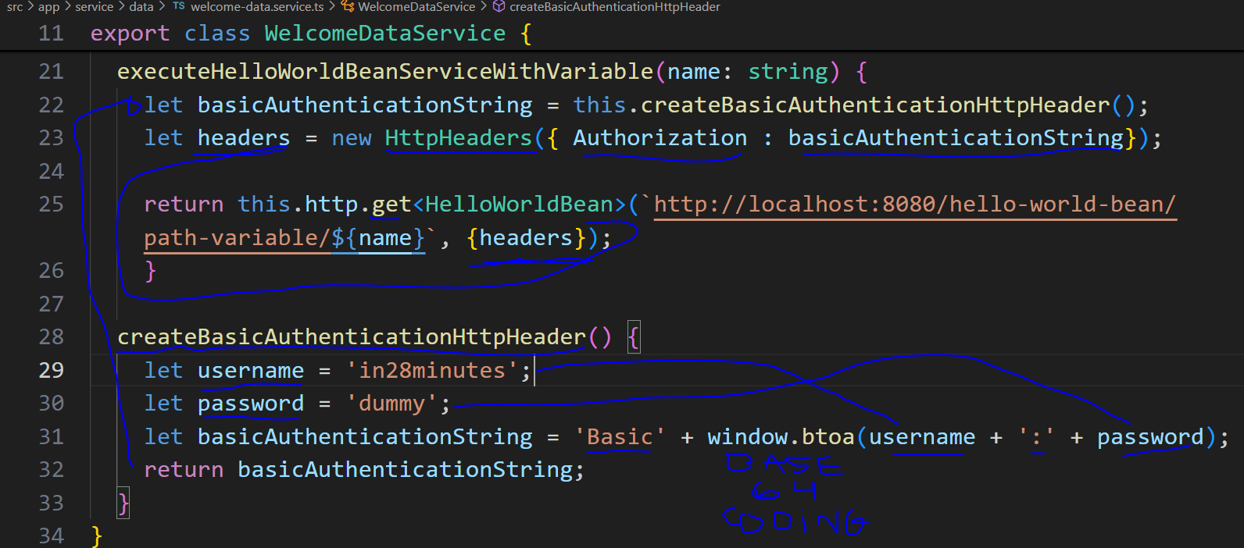

*the ‘Basic’ without space is wrong replace by adding space ‘Basic ’

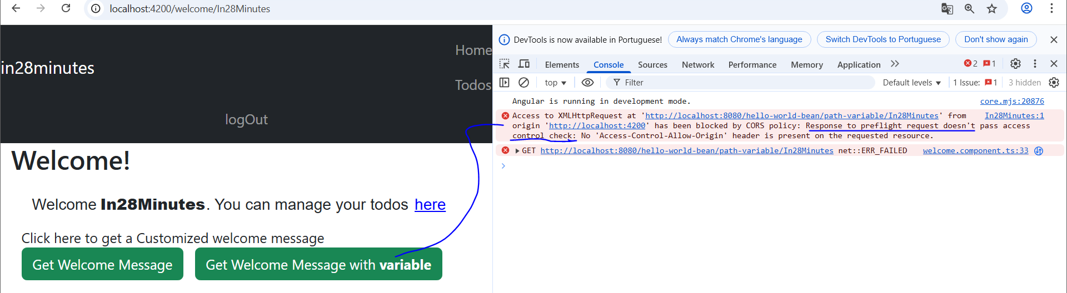

Now that the back-side is using the security dependency, there are some configurations that needed to be done, first send username and password in the request but encrypted joining the text ‘Basic ’ and the username and password coded in base 64 as parameter using the method window.btoa, then instantiate a new httpHeaders object receiving in the constructor the authorization property with the encrypted one to finally make the call using this httpHeaders object. With that the header is created, but still needs a few settings to allow the connection.

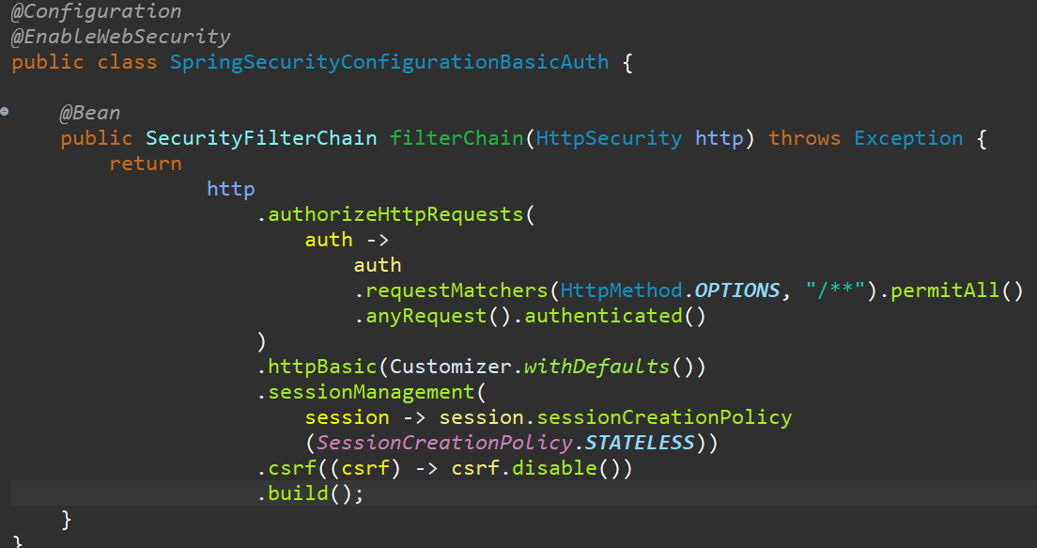

As resolution for ‘ preflight request doesn't pass access control check’, is created a class responsible for setting the web security through a method that will return httpSecurity reference as an implementation of SecurityFilterChain interface to authorize the OPTIONS requests for any service to be attended and setting the basic authentication to disable the csrf protection without any session policy.



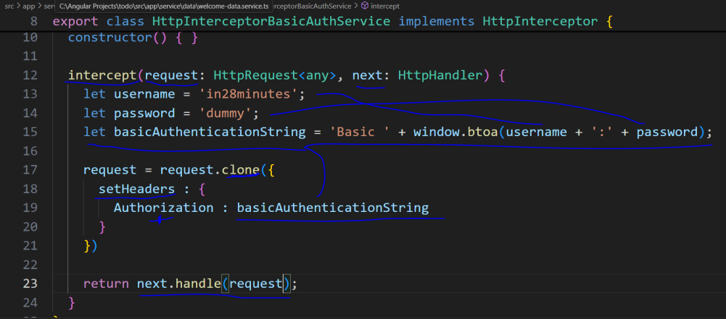

For not having to add manual header for each call, this logic can be reused and focused on a service called HttpInterceptorBasicAuth. This service will be responsible for implementing the HttpInterceptor interface and override the method intercept with the original parameters, pasting the username, password and the basicAuthenticationString properties. Then updating the request parameter with a clone of the original request and updating the headers with the property Authorization containing the basicAuthenticationString as value, the next parameter to handle **the new request**. In this way, any request will be intercepted and added with basic authentication.

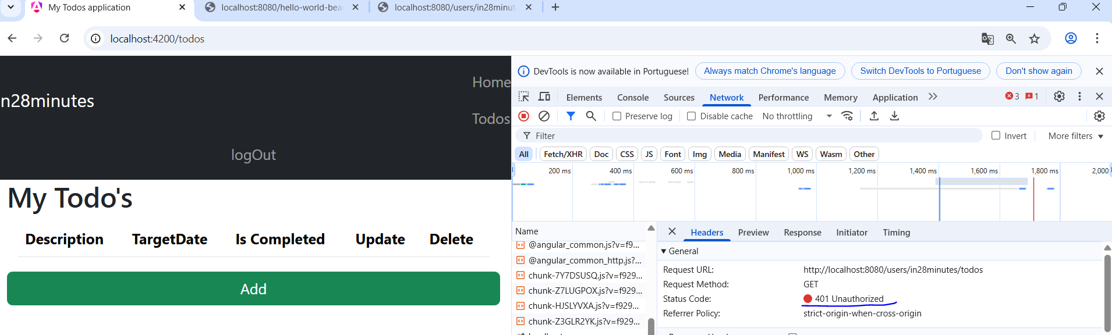

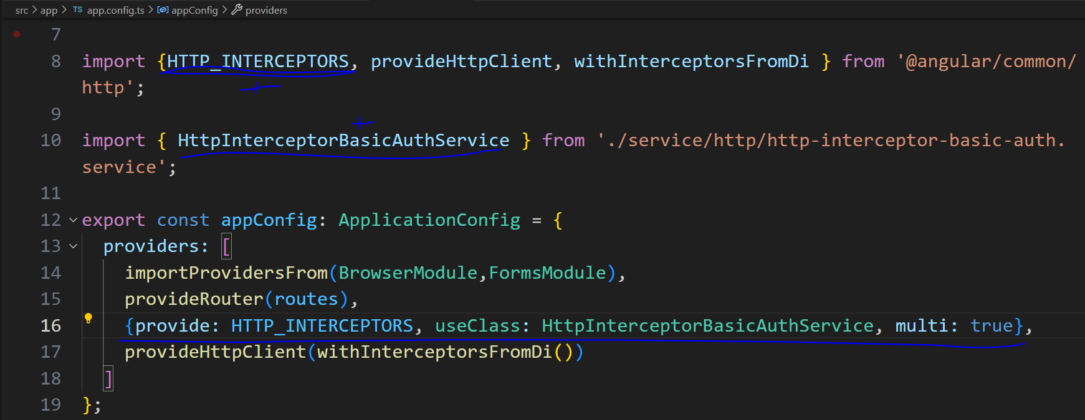

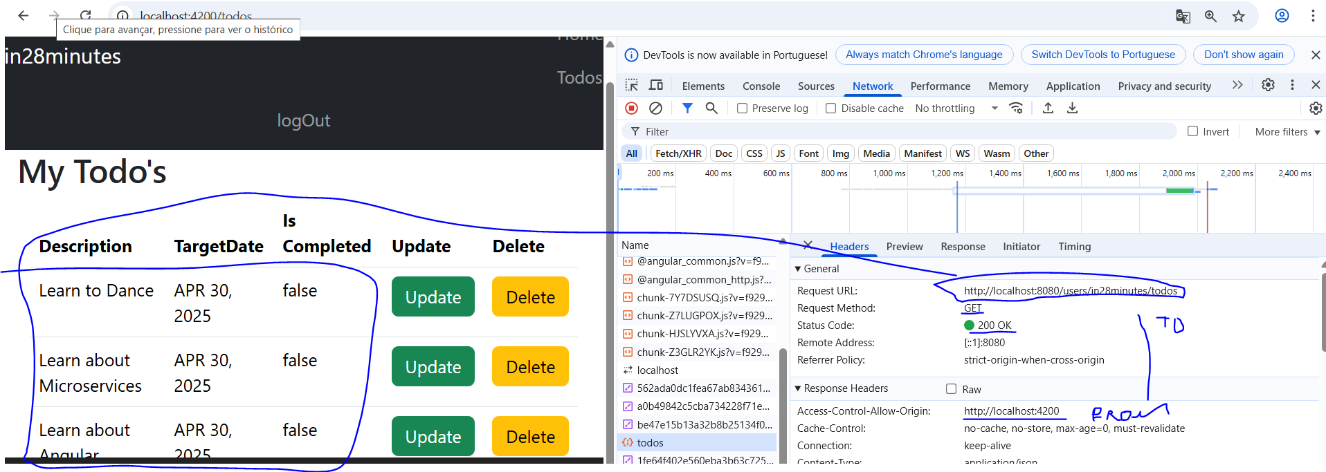

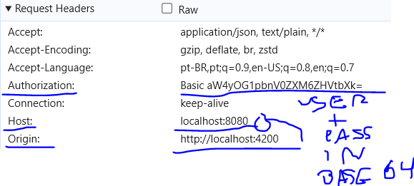

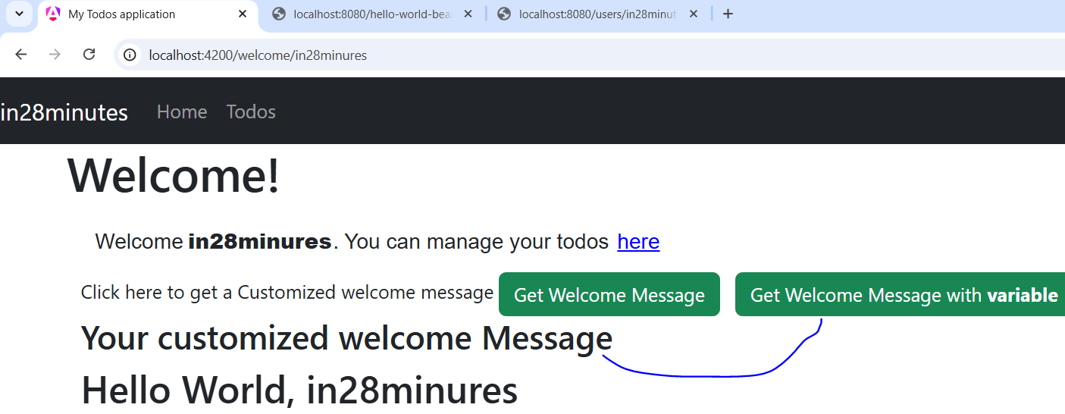

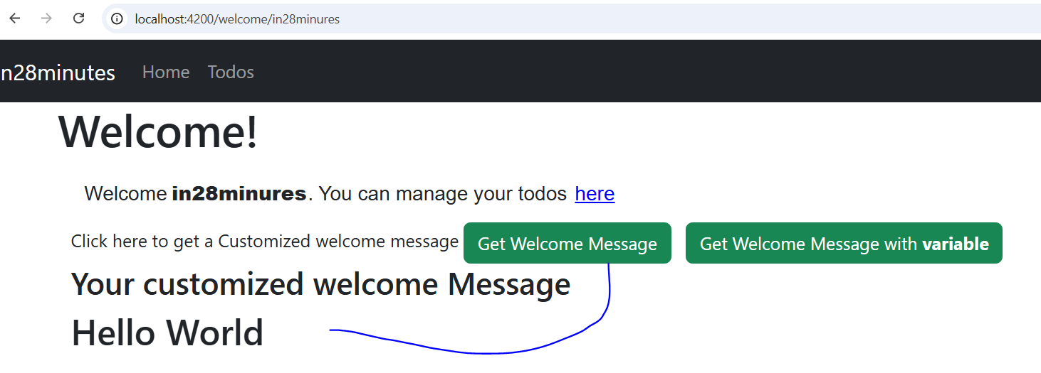

Now that it is configured, it is needed to include this interceptor on the app configuration in general way, **the field ‘multi: true’** is important to add other interceptors in the future for not overriding the current one. Being possible to intercept every request and add the correct authorization with username and password, because without this basic authentication the request will be denied.

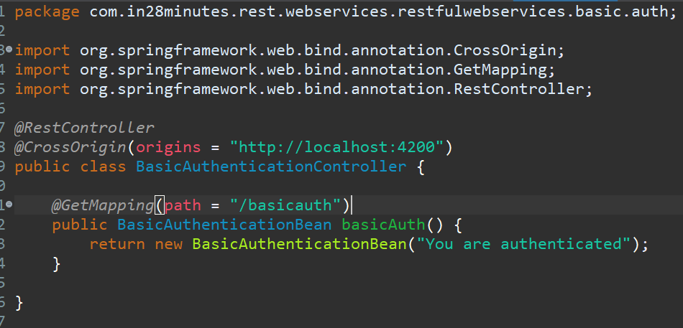

For reformulating the hard-corded authentication on login through front-end, it is created one more controller accepting the front-end call and contemplating the mapping of a new get request called basicauth to return the message “you’re authenticated”.

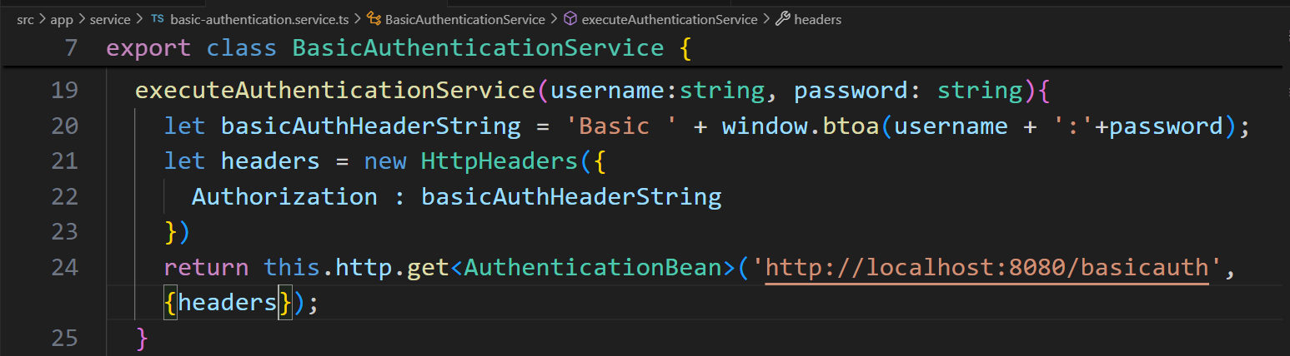

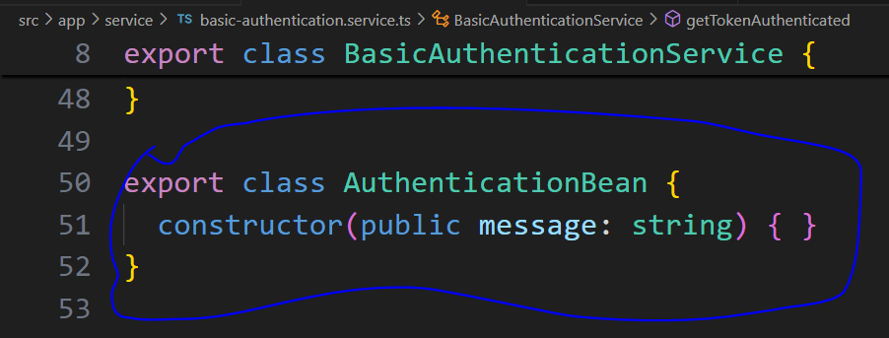

The same service is created on the front-end receiving the username and password through parameter, coding them in base 64 joining with a ‘Basic ’, creating the HttpHeaders instance including the Authorization property with the coded one. Finally, returning the result of the get request having AuthenticationBean as a type and including the headers to it.

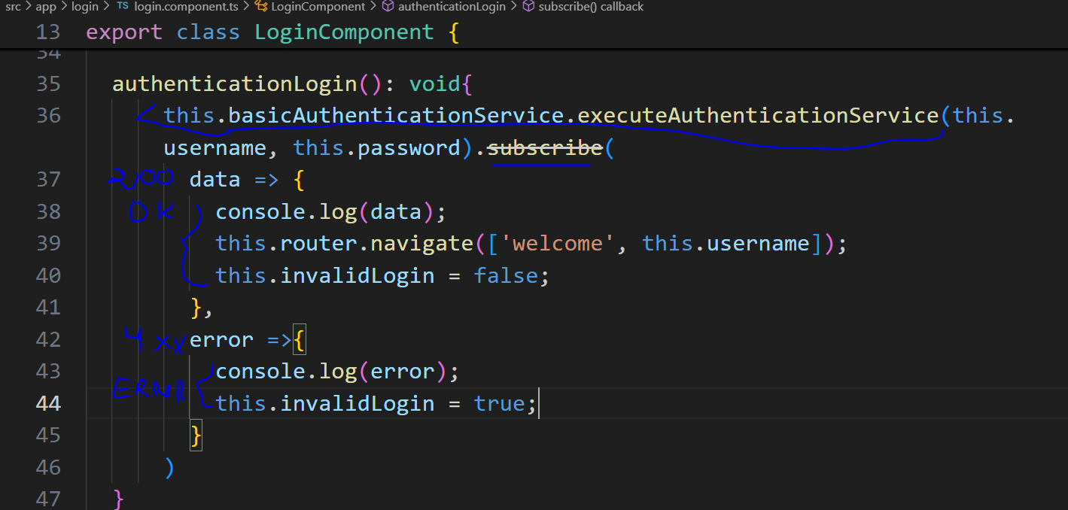

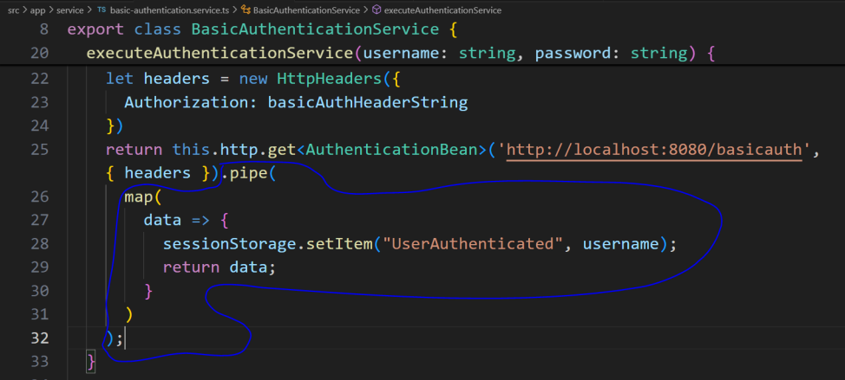

On the login component (.ts), it is included the method authenticationLogin to call the basicAuthService method for making the request in fact passing the username and password as parameters, subscribing it,in case of success retrieve the data, redirect the user to the welcome page and make the login valid the other way around retrieve the error data and invalid the login.

On the service, at the end of the get call method, **improve the observable object(plus)** with the method **pipe**, map the success data, include the username on the sessionStorage as user authenticated.

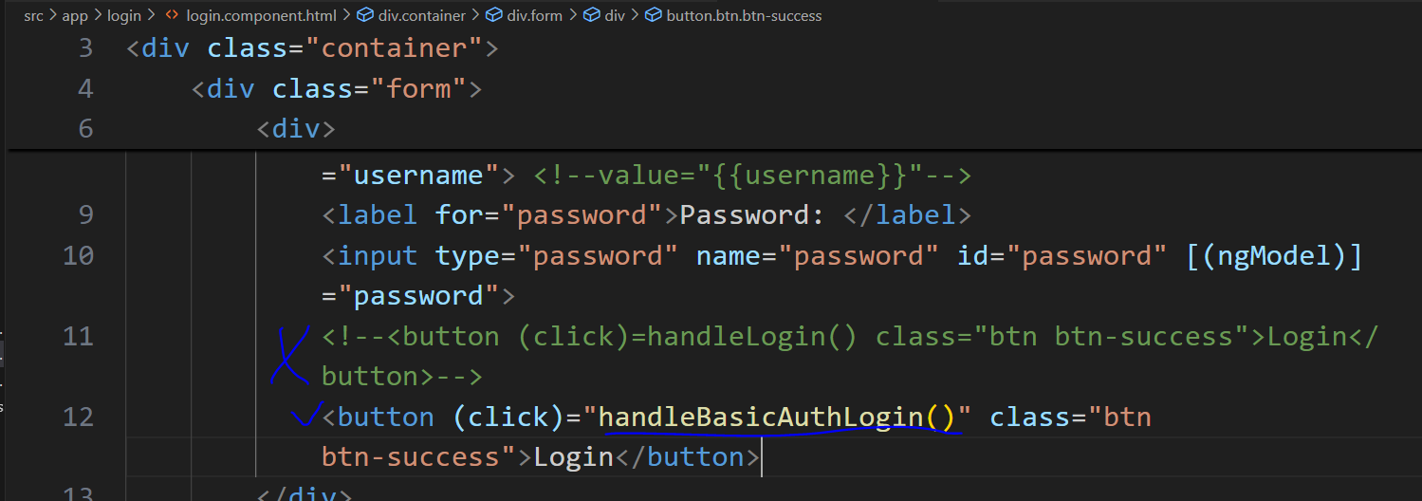

On the login template, create one more button to call this new authentication to successfully make the login or not, because the username and password sent will be compared with the ones on the properties file in the back-end side when the request is done. Just a point, the http interceptor was commented out(appConfig.ts).

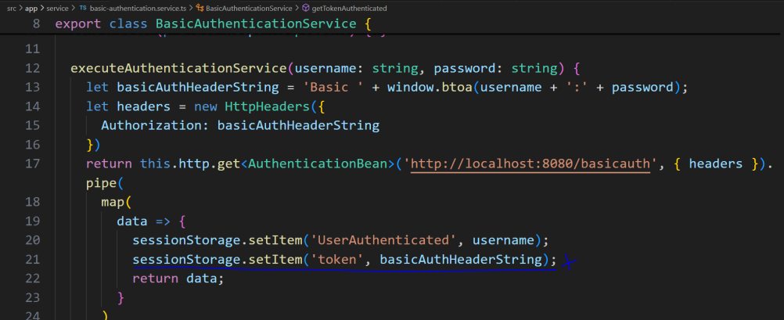

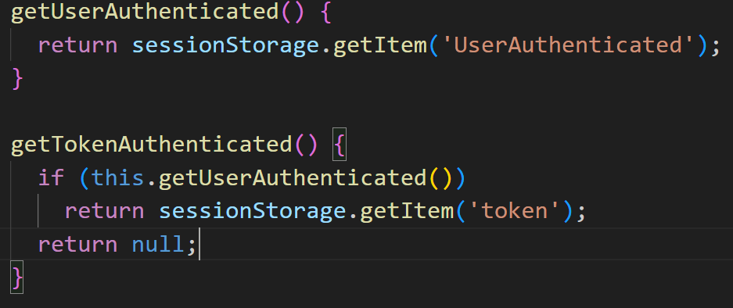

As a refactoring of basicAuthenticationService, include the basicAuthHeaderString as a token in the session, also create the get methods for both items, but to recover the token the user needs to be authenticated.

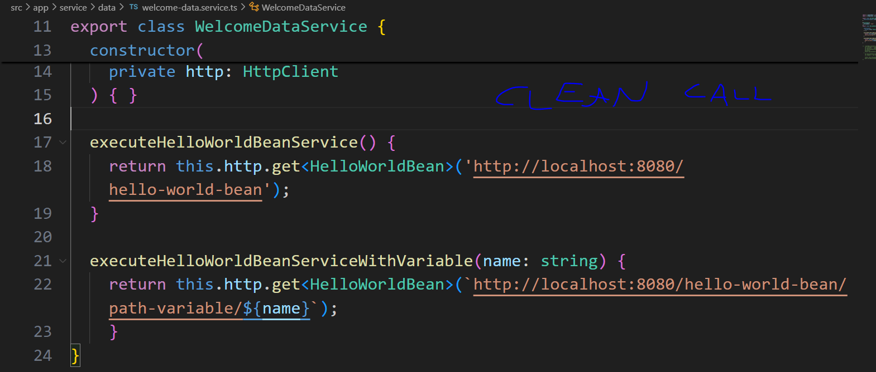

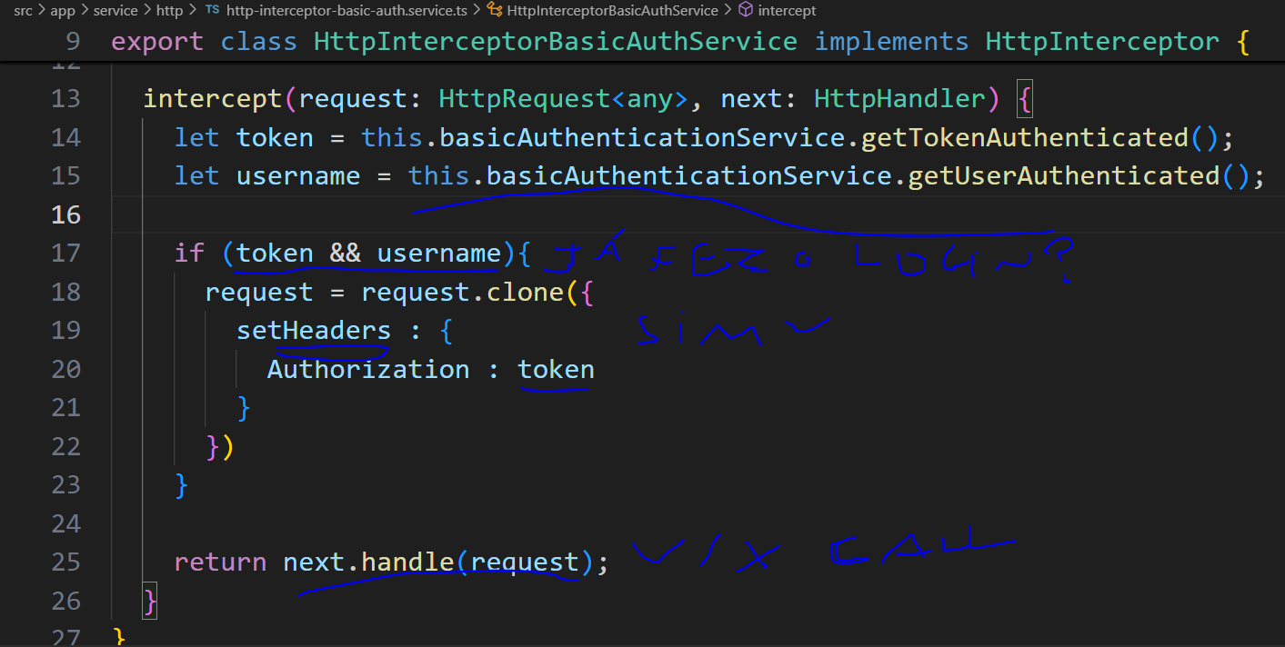

Having the token and the username saved in the session storage and recoverable by it, the interceptor needs to recover them and save on variables to check if the login have already been done, if true, capture the original request then update the headers to include an object with the authorization attribute with the token else the request goes on without it. This way, the requests in general won’t have to worry about authentication.



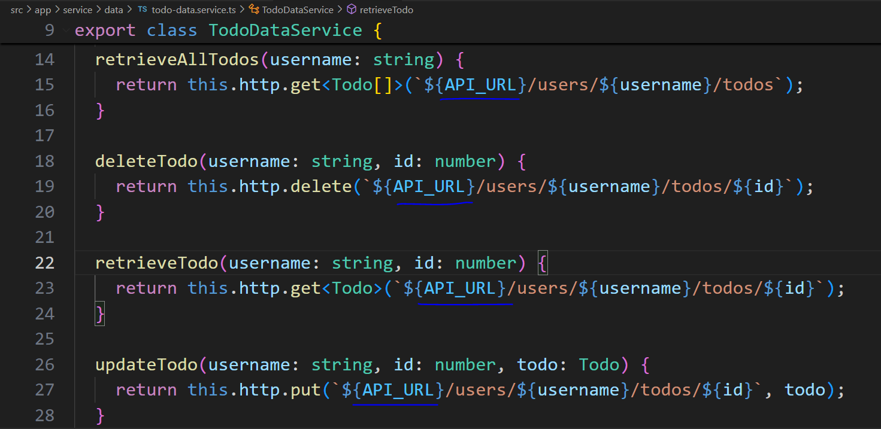

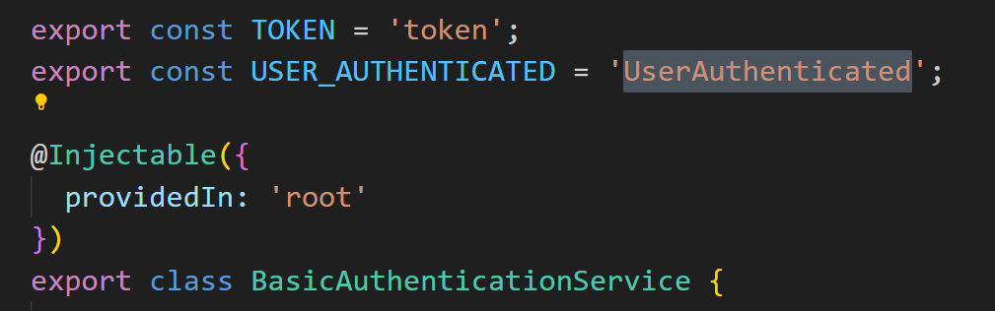

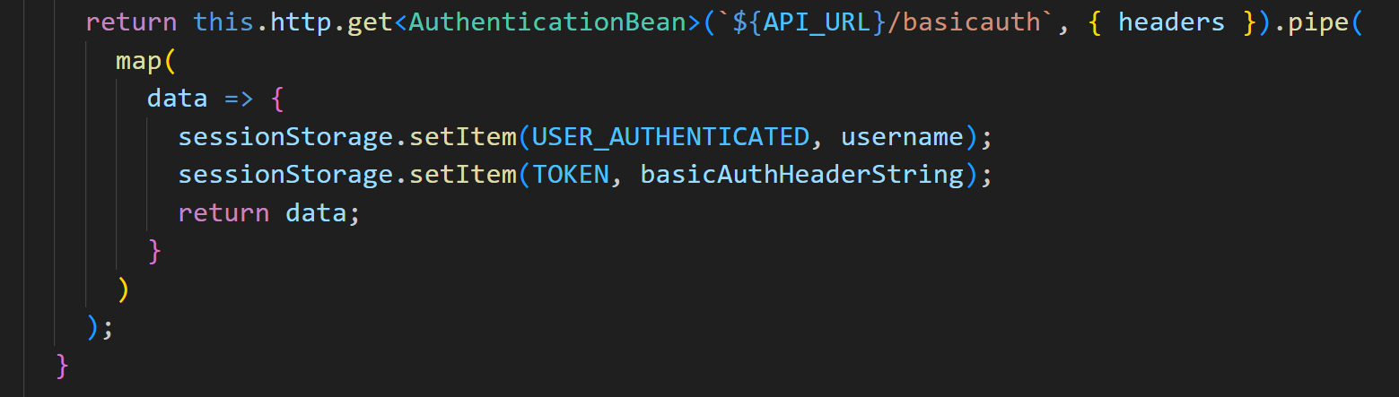

A good practice is to use constants for values that are **frequently used and don’t change**, avoiding misspelling when editing different files.

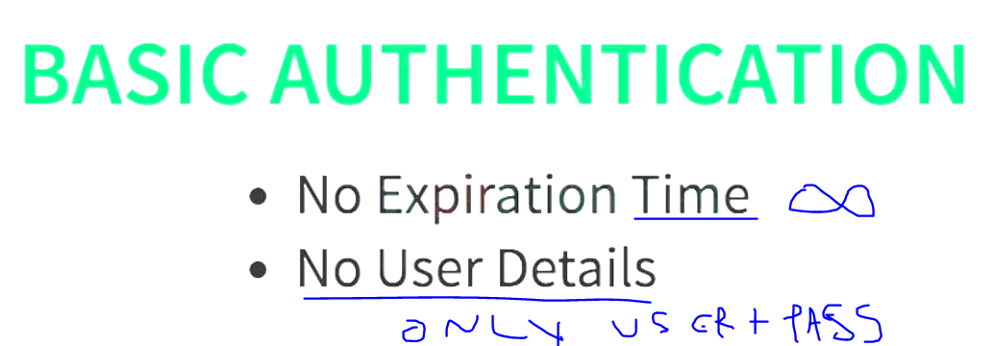

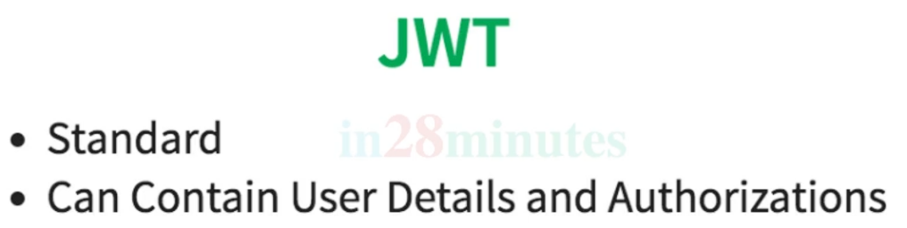

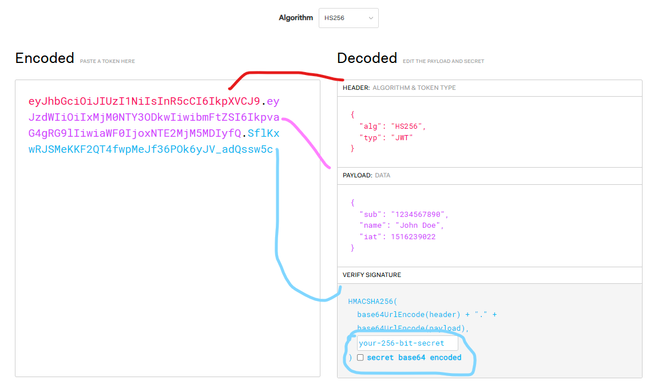

JWT (**J**ava **W**eb **T**oken) is a **security standard** with expiration time like a clock session that brings up one more security measure on the **user authentication** having user data, authorization data using an algorithm to encode the information in a non-understandable sequence of numbers and letters. As a key to protect the data, the field ‘your-256-bit-secret’ is open to insert a **customized riddle** that only the **authorized** systems & people must know to get access to the token.

*IAT-> token creation time

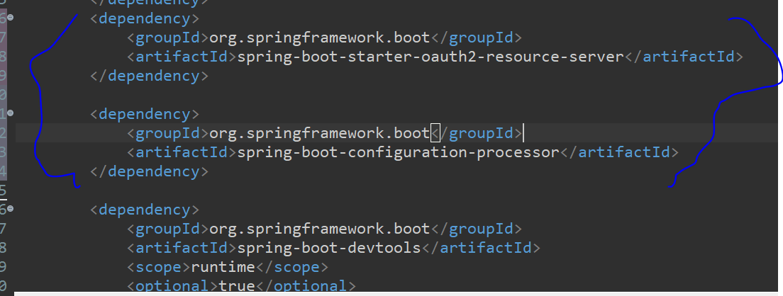

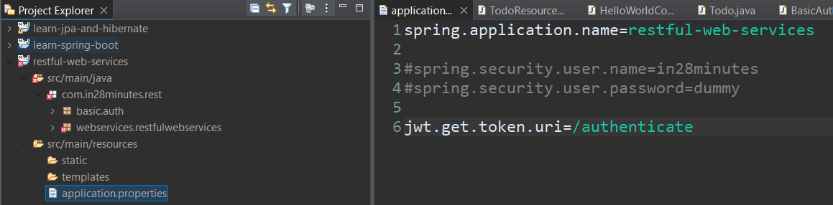

For Implementing the JWT, the dependencies oauth-2-resource-server and configuration-processor are needed on pom.xml. Secondly, on application.properties include the new route for authenticating the user using **jwt**.get.token.uri=/authenticate. As part of the classes structure to create the unique token to be used in every request, it is needed to include the following ones:

package com.in28minutes.rest.webservices.restfulwebservices.jwt;

public record JwtTokenRequest(String username, String password) {}

package com.in28minutes.rest.webservices.restfulwebservices.jwt;

public record JwtTokenResponse(String token) {}

package com.in28minutes.rest.webservices.restfulwebservices.jwt;

import java.time.Instant;

import java.time.temporal.ChronoUnit;

import java.util.stream.Collectors;

import org.springframework.security.core.Authentication;

import org.springframework.security.core.GrantedAuthority;

import org.springframework.security.oauth2.jwt.JwtClaimsSet;

import org.springframework.security.oauth2.jwt.JwtEncoder;

import org.springframework.security.oauth2.jwt.JwtEncoderParameters;

import org.springframework.stereotype.Service;

@Service

public class JwtTokenService {

private final JwtEncoder jwtEncoder;

public JwtTokenService(JwtEncoder jwtEncoder) {

this.jwtEncoder = jwtEncoder;

}

public String generateToken(Authentication authentication) {

var scope = authentication

.getAuthorities()

.stream()

.map(GrantedAuthority::getAuthority)

.collect(Collectors.joining(" "));

var claims = JwtClaimsSet.builder()

.issuer("self")

.issuedAt(Instant.now())

.expiresAt(Instant.now().plus(90, ChronoUnit.MINUTES))

.subject(authentication.getName())

.claim("scope", scope)

.build();

return this.jwtEncoder

.encode(JwtEncoderParameters.from(claims))

.getTokenValue();

}

}

package com.in28minutes.rest.webservices.restfulwebservices.jwt;

import org.springframework.http.ResponseEntity;

import org.springframework.security.authentication.AuthenticationManager;

import org.springframework.security.authentication.UsernamePasswordAuthenticationToken;

import org.springframework.web.bind.annotation.CrossOrigin;

import org.springframework.web.bind.annotation.PostMapping;

import org.springframework.web.bind.annotation.RequestBody;

import org.springframework.web.bind.annotation.RestController;

@RestController

@CrossOrigin(origins="http://localhost:4200")

public class JwtAuthenticationController {

private final JwtTokenService tokenService;

private final AuthenticationManager authenticationManager;

public JwtAuthenticationController(JwtTokenService tokenService,

AuthenticationManager authenticationManager) {

this.tokenService = tokenService;

this.authenticationManager = authenticationManager;

}

@PostMapping("/authenticate")

public ResponseEntity<JwtTokenResponse> generateToken(

@RequestBody JwtTokenRequest jwtTokenRequest) {

var authenticationToken =

new UsernamePasswordAuthenticationToken(

jwtTokenRequest.username(),

jwtTokenRequest.password());

var authentication =

authenticationManager.authenticate(authenticationToken);

var token = tokenService.generateToken(authentication);

return ResponseEntity.ok(new JwtTokenResponse(token));

}

}

package com.in28minutes.rest.webservices.restfulwebservices.jwt;

import java.security.KeyPair;

import java.security.KeyPairGenerator;

import java.security.interfaces.RSAPrivateKey;

import java.security.interfaces.RSAPublicKey;

import java.util.UUID;

import org.springframework.boot.autoconfigure.security.servlet.PathRequest;

import org.springframework.context.annotation.Bean;

import org.springframework.context.annotation.Configuration;

import org.springframework.http.HttpMethod;

import org.springframework.security.authentication.AuthenticationManager;

import org.springframework.security.authentication.ProviderManager;

import org.springframework.security.authentication.dao.DaoAuthenticationProvider;

import org.springframework.security.config.Customizer;

import org.springframework.security.config.annotation.method.configuration.EnableMethodSecurity;

import org.springframework.security.config.annotation.web.builders.HttpSecurity;

import org.springframework.security.config.annotation.web.configuration.EnableWebSecurity;

import org.springframework.security.config.annotation.web.configurers.AbstractHttpConfigurer;

import org.springframework.security.config.annotation.web.configurers.oauth2.server.resource.OAuth2ResourceServerConfigurer;

import org.springframework.security.config.http.SessionCreationPolicy;

import org.springframework.security.core.userdetails.User;

import org.springframework.security.core.userdetails.UserDetails;

import org.springframework.security.core.userdetails.UserDetailsService;

import org.springframework.security.oauth2.jwt.JwtDecoder;

import org.springframework.security.oauth2.jwt.JwtEncoder;

import org.springframework.security.oauth2.jwt.NimbusJwtDecoder;

import org.springframework.security.oauth2.jwt.NimbusJwtEncoder;

import org.springframework.security.provisioning.InMemoryUserDetailsManager;

import org.springframework.security.web.SecurityFilterChain;

import org.springframework.web.servlet.handler.HandlerMappingIntrospector;

import com.nimbusds.jose.JOSEException;

import com.nimbusds.jose.jwk.JWKSet;

import com.nimbusds.jose.jwk.RSAKey;

import com.nimbusds.jose.jwk.source.JWKSource;

import com.nimbusds.jose.proc.SecurityContext;

import static org.springframework.security.config.Customizer.withDefaults;

@Configuration

@EnableWebSecurity

@EnableMethodSecurity

public class JwtSecurityConfig {

@Bean

public SecurityFilterChain securityFilterChain(HttpSecurity httpSecurity, HandlerMappingIntrospector introspector) throws Exception {

// h2-console is a servlet

// https://github.com/spring-projects/spring-security/issues/12310

return httpSecurity

.authorizeHttpRequests(auth -> auth

.requestMatchers("/authenticate").permitAll()

.requestMatchers(PathRequest.toH2Console()).permitAll() // h2-console is a servlet and NOT recommended for a production

.requestMatchers(HttpMethod.OPTIONS,"/**")

.permitAll()

.anyRequest()

.authenticated())

.csrf(AbstractHttpConfigurer::disable)

.sessionManagement(session -> session.

sessionCreationPolicy(SessionCreationPolicy.STATELESS))

.oauth2ResourceServer(

(oauth2) -> oauth2.jwt(withDefaults()))

.httpBasic(

Customizer.withDefaults())

.headers(headers -> headers.frameOptions(frameOptionsConfig-> frameOptionsConfig.disable()))

.build();

}

@Bean

public AuthenticationManager authenticationManager(

UserDetailsService userDetailsService) {

var authenticationProvider = new DaoAuthenticationProvider();

authenticationProvider.setUserDetailsService(userDetailsService);

return new ProviderManager(authenticationProvider);

}

@Bean

public UserDetailsService userDetailsService() {

UserDetails user = User.withUsername("in28minutes")

.password("{noop}dummy")

.authorities("read")

.roles("USER")

.build();

return new InMemoryUserDetailsManager(user);

}

@Bean

public JWKSource<SecurityContext> jwkSource() {

JWKSet jwkSet = new JWKSet(rsaKey());

return (((jwkSelector, securityContext)

-> jwkSelector.select(jwkSet)));

}

@Bean

JwtEncoder jwtEncoder(JWKSource<SecurityContext> jwkSource) {

return new NimbusJwtEncoder(jwkSource);

}

@Bean

JwtDecoder jwtDecoder() throws JOSEException {

return NimbusJwtDecoder

.withPublicKey(rsaKey().toRSAPublicKey())

.build();

}

@Bean

public RSAKey rsaKey() {

KeyPair keyPair = keyPair();

return new RSAKey

.Builder((RSAPublicKey) keyPair.getPublic())

.privateKey((RSAPrivateKey) keyPair.getPrivate())

.keyID(UUID.randomUUID().toString())

.build();

}

@Bean

public KeyPair keyPair() {

try {

var keyPairGenerator = KeyPairGenerator.getInstance("RSA");

keyPairGenerator.initialize(2048);

return keyPairGenerator.generateKeyPair();

} catch (Exception e) {

throw new IllegalStateException(

"Unable to generate an RSA Key Pair", e);

}

}

}

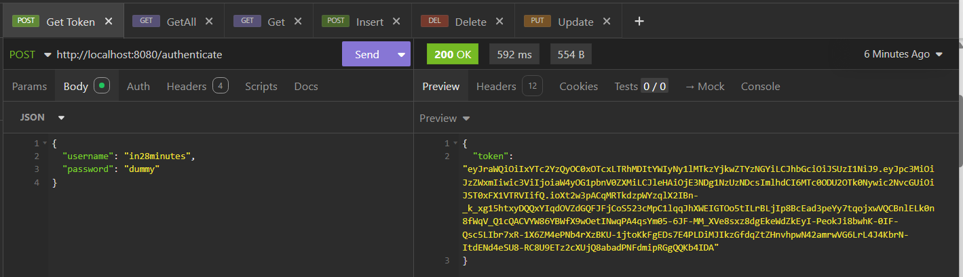

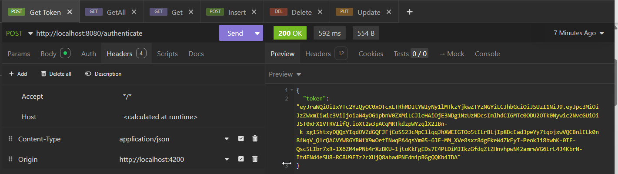

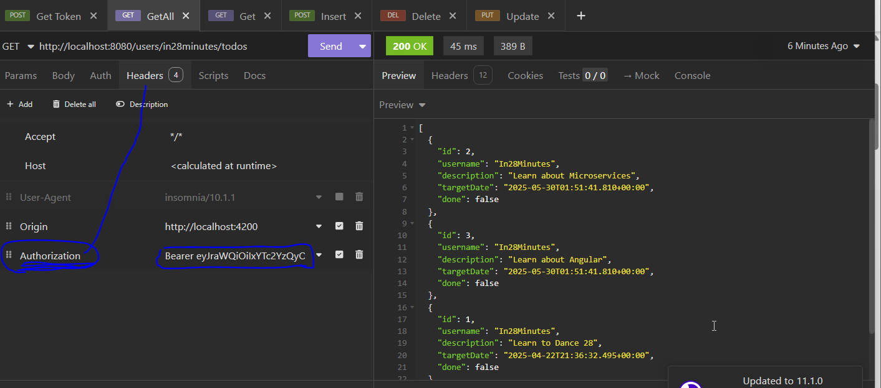

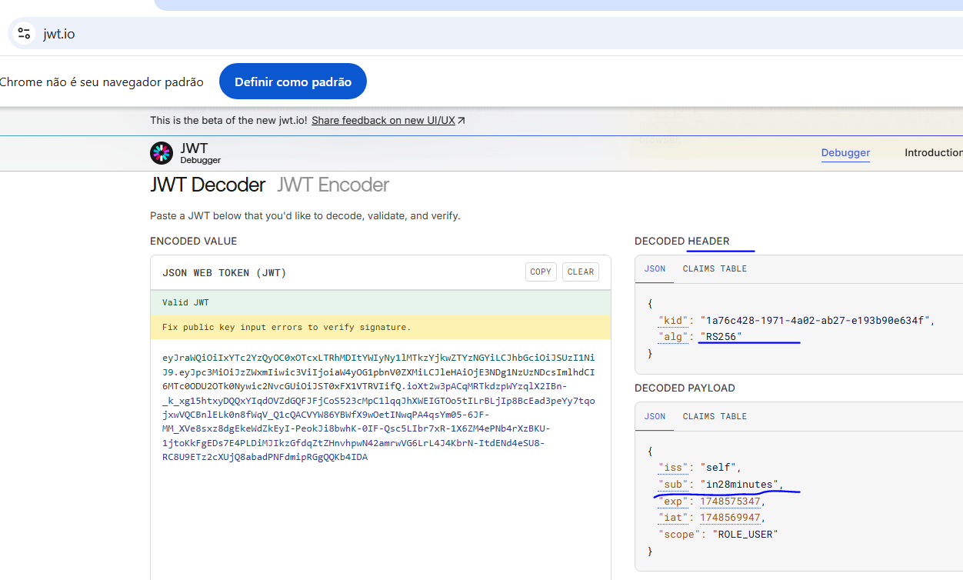

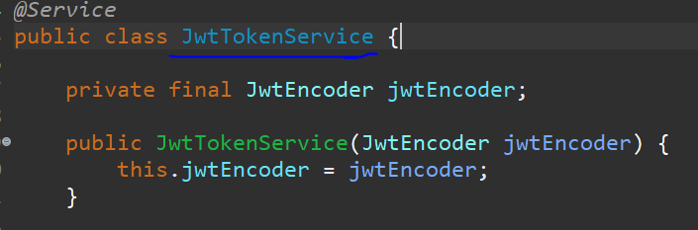

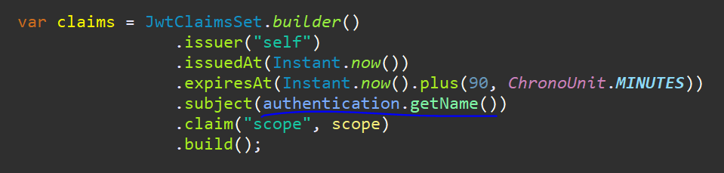

Run it on insomnia on post /authenticate route to obtain the token then make a request to obtain the list of todos of the user using the field Authorization with the **obtained token** as Bearer token value. Checking it on jwt.io, the token is validated.

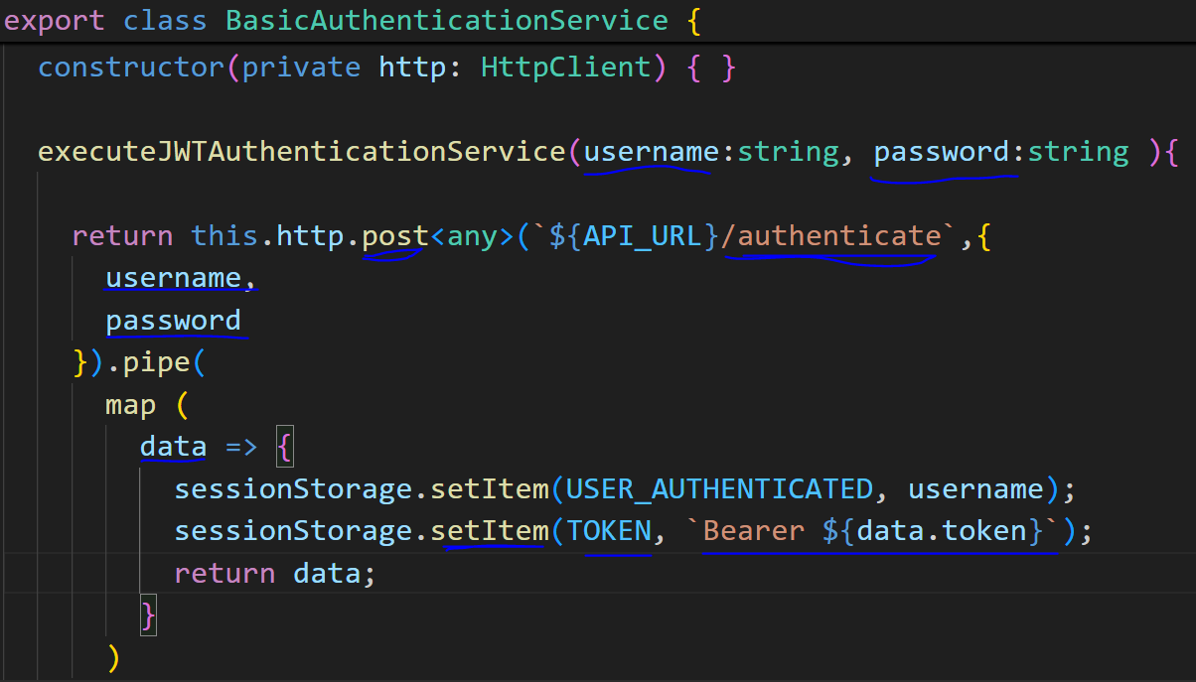

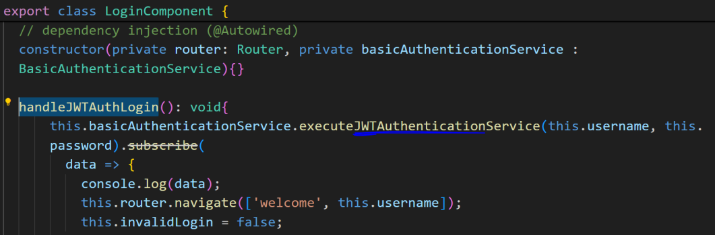

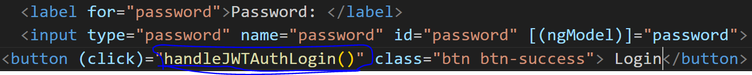

Applying this call to the front-end, it is needed in a new method to make a post request to /authenticate route, passing the requestBody with username and password, retrieve the successful response data, use the data to store the token on the sessionStorage as an item as ‘Bearer ${data.token} and the username. Then, update the method called by the login button to use the JWT authentication and the button itself to call the updated method. This way, every time the interceptor class include the authorization, it will contain the updated token.

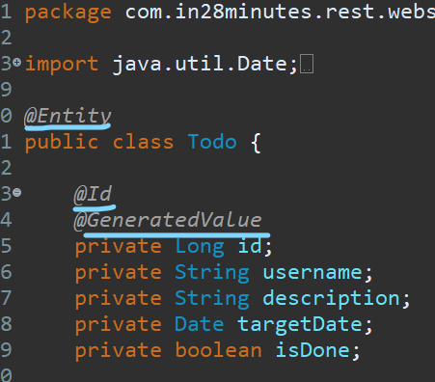

Applying the JPA mapping for defining the table of the database, it is needed to use the @annotations over the table class to identify the class and its fields.

Description:

@Entity-> Relational Object Mapping (class to table)

@Table(name=”customized table name”)

@Id-> primary key

@GeneratedValue-> auto increment from 1 and plus 1

@Column(name=”customized field name”)

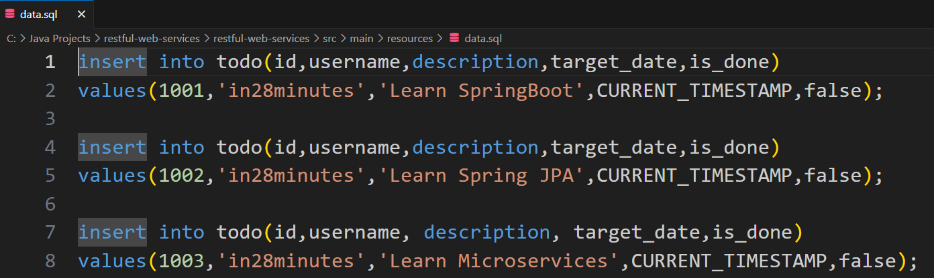

On the data.sql inside resources, it is possible to pre-populate the data todos using the SQL commands.

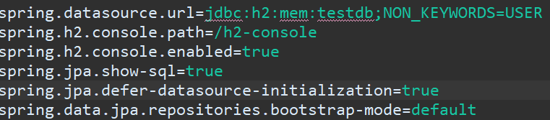

Also important, define the url of the database, enable the h2 on the browser and its uri, show the sql used to see the database and tables creation in terminal.

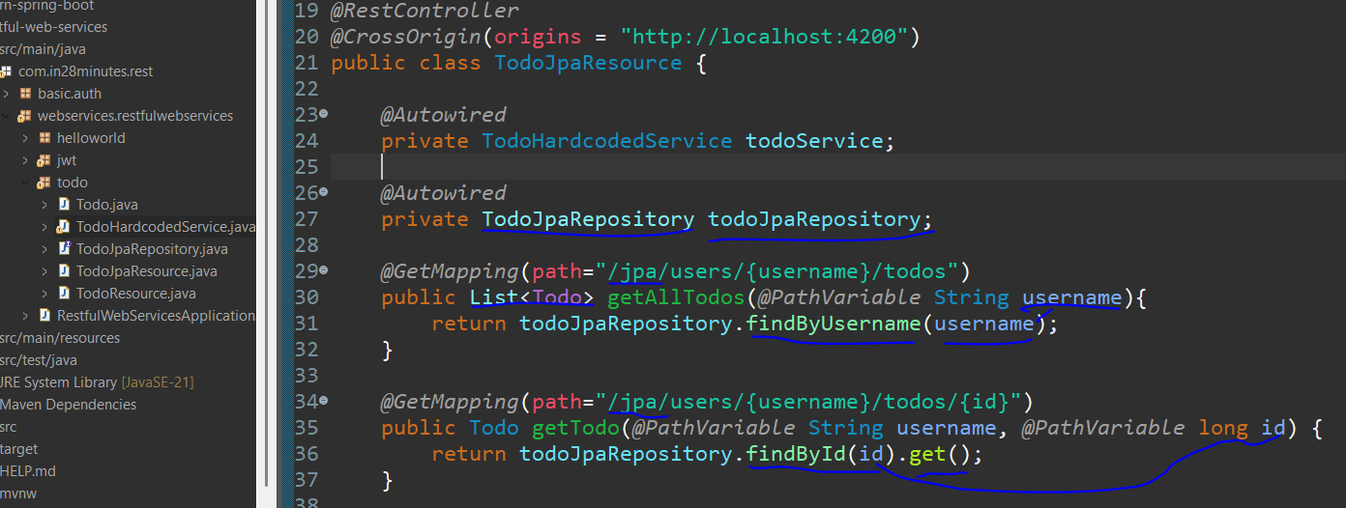

Once the table is mapped, it is needed to make a new controller to service these calls to the database then the TodoJpaResource is created as a copy of the TodoResource class, just putting ‘/jpa’ at the beginning of each request mapping uri.

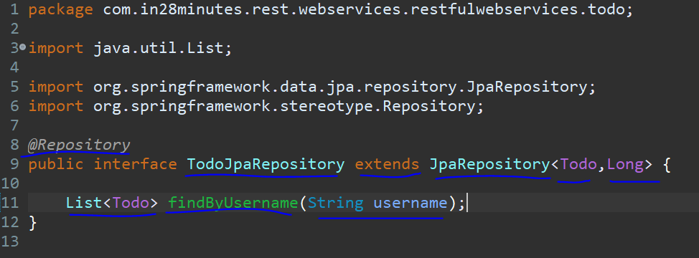

The interfaceTodoJpaRepository is created to manipulate the operations related to the Todo table, adding the annotation @Repository to identify it as a data access layer. Then, it extends from JpaRepository passing the entity Todo and the Id type as generic type, also create the method findByUsername receiving the username as parameter and returning a List of todos as answer.

Still on TodoJpaResource, create the instance of the interface with the annotation @Autowired, inside of getTodo method use this instance to return one Todo by Id and how the return is an Optional, it is needed to use the method .get() to obtain the original object (Todo) and inside of getAllTodos method use this interface to return the list of todos according to the username.

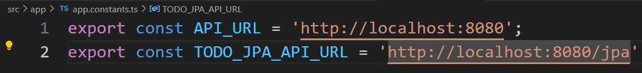

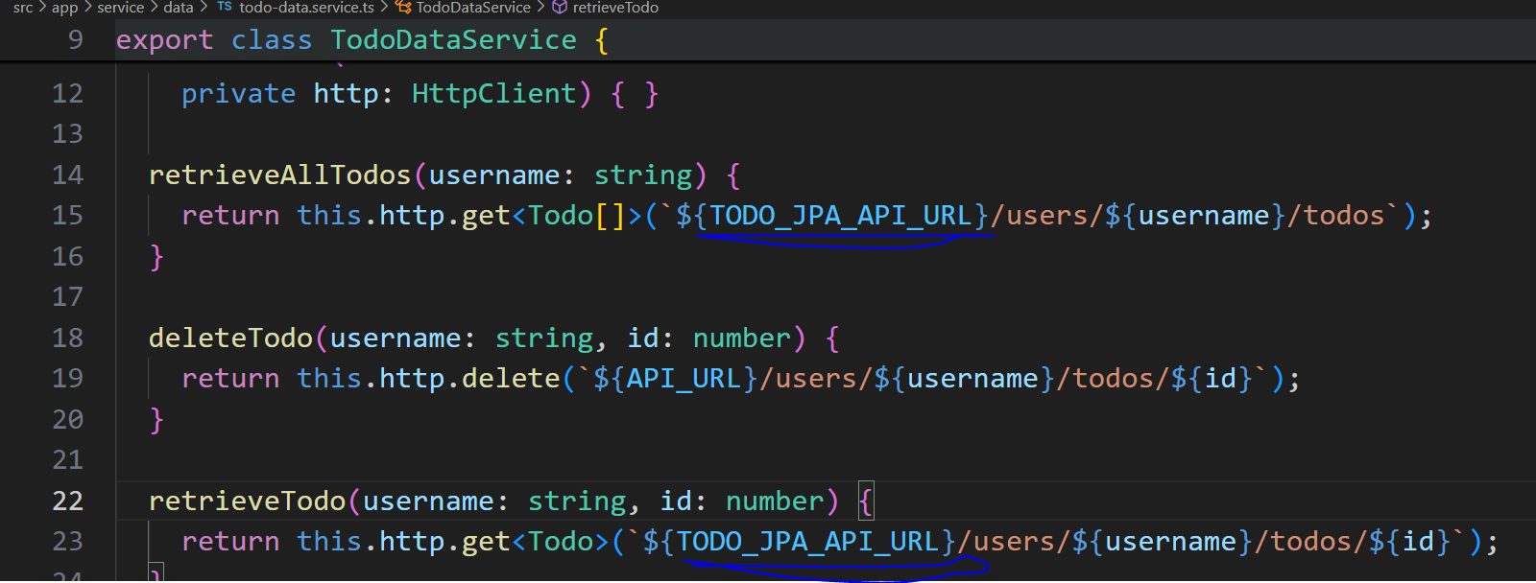

On the front-end, update the TodoDataService class using a new constant to include the ‘/jpa’ at the beginning of the http call.

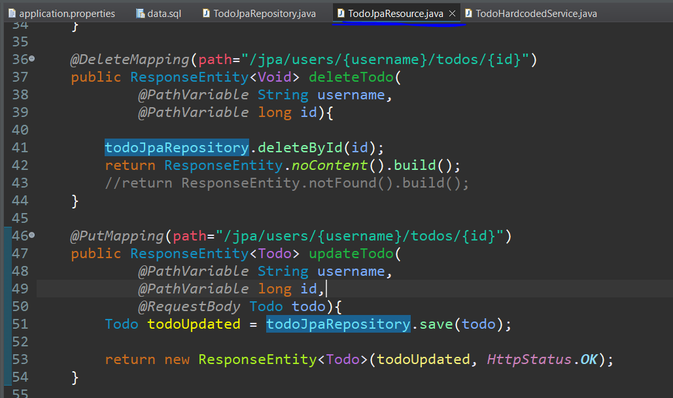

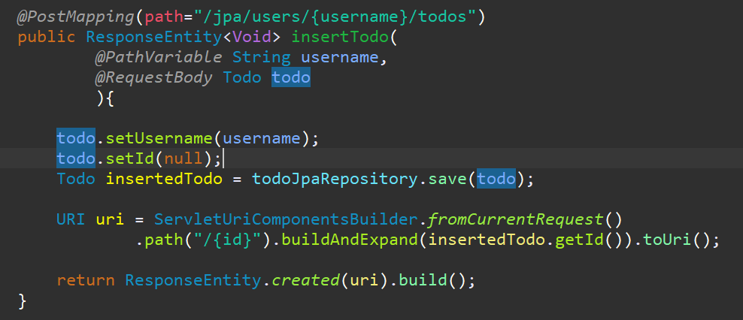

For finishing the application as a whole, it is needed to update the rest of the request mappings on back-end side, replacing the call from todoService to todoJpaRepository. Just two observations: the not found content was commented because if the one is not found, an exception is thrown, the username had to be overridden for not being null at database and the id had to be overridden because it can’t be 0 or -1 given that this field is auto incremented, so it has to be null before inserting in fact by the interface for that hibernate can fulfil it as the last inserted plus 1.

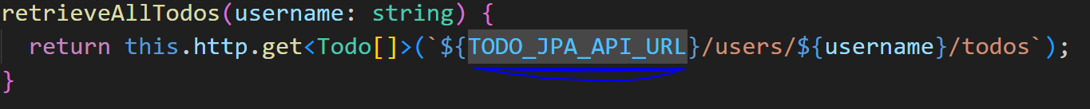

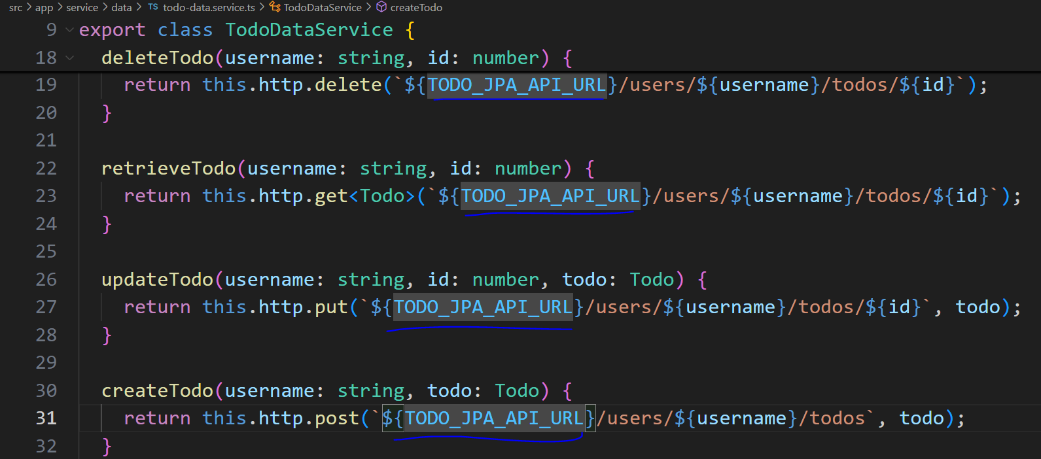

The same on the front-end, putting all the constants considering the ‘/jpa’. At this point the application is done.

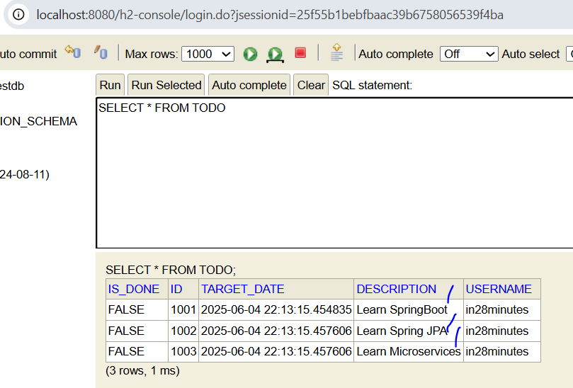

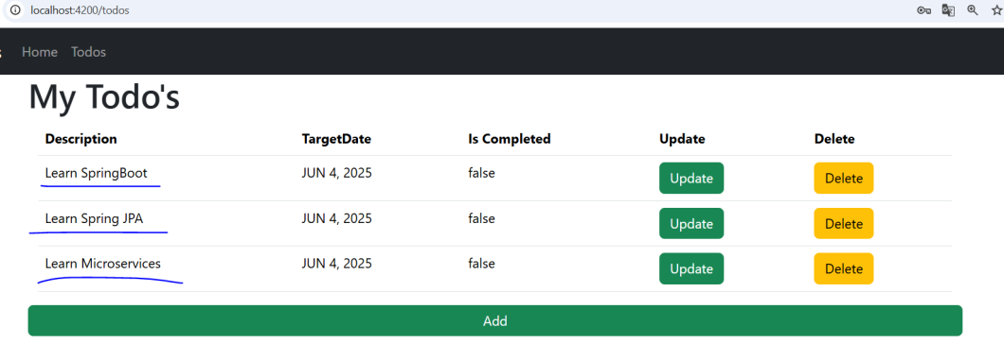

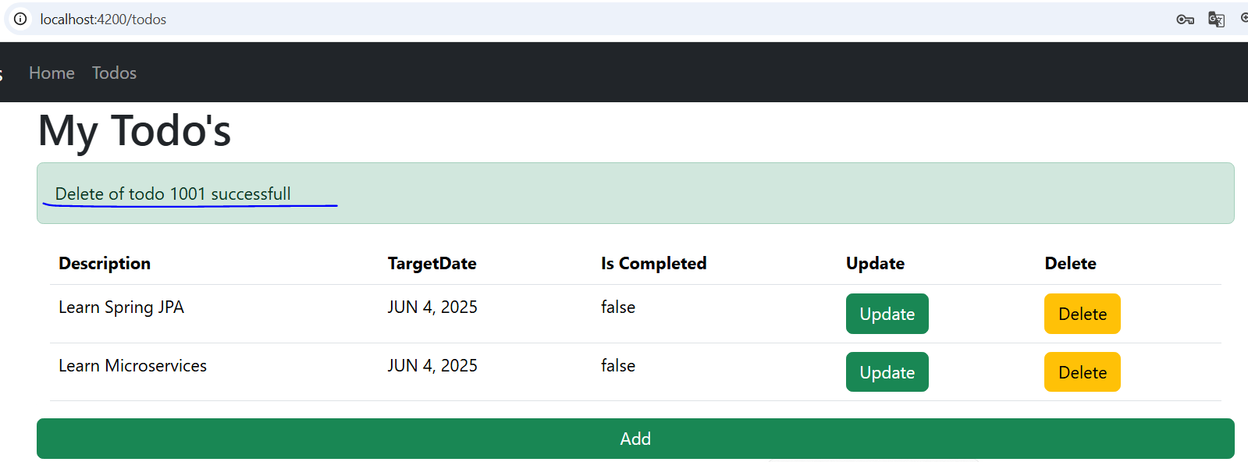

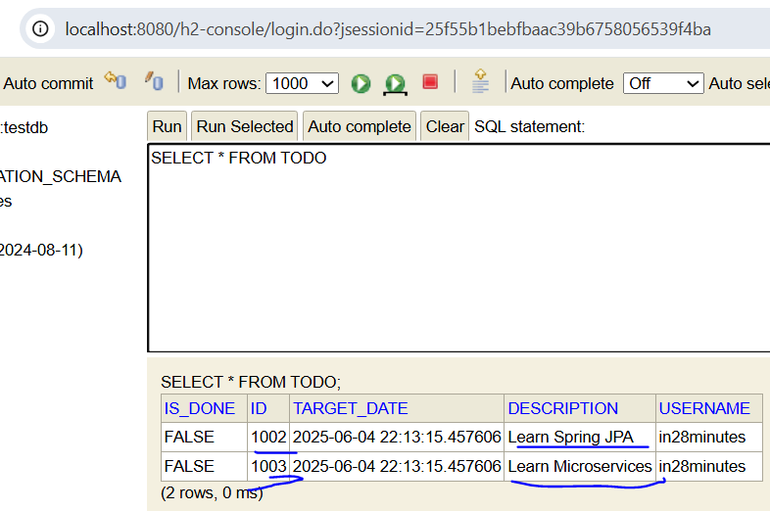

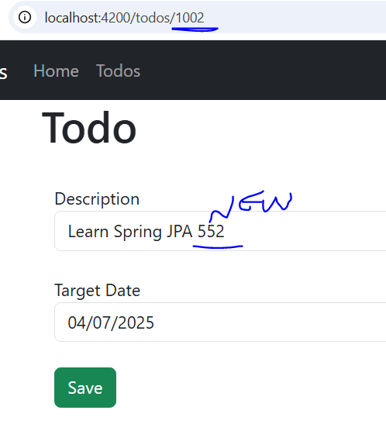

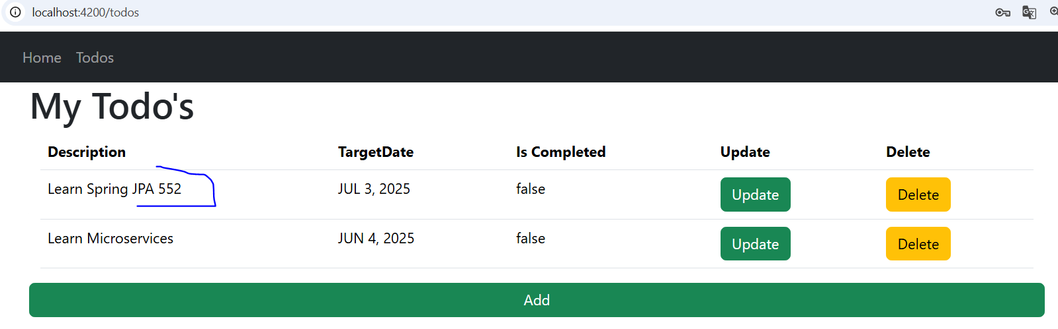

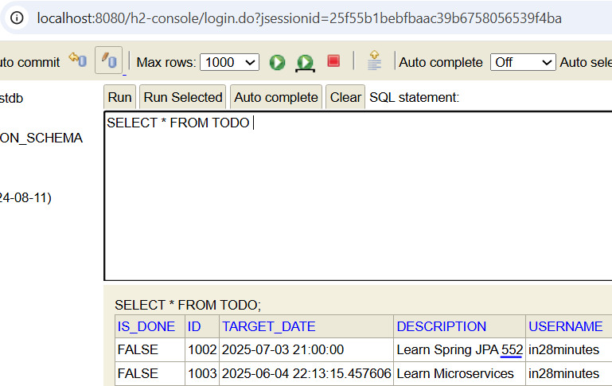

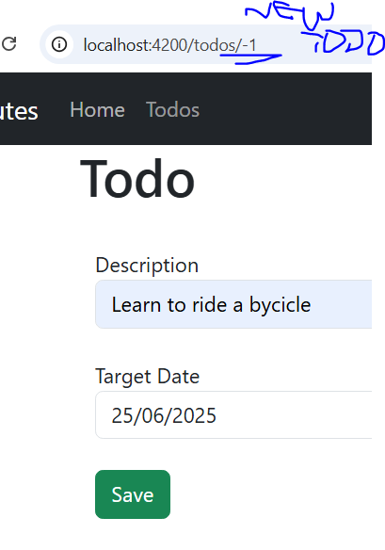

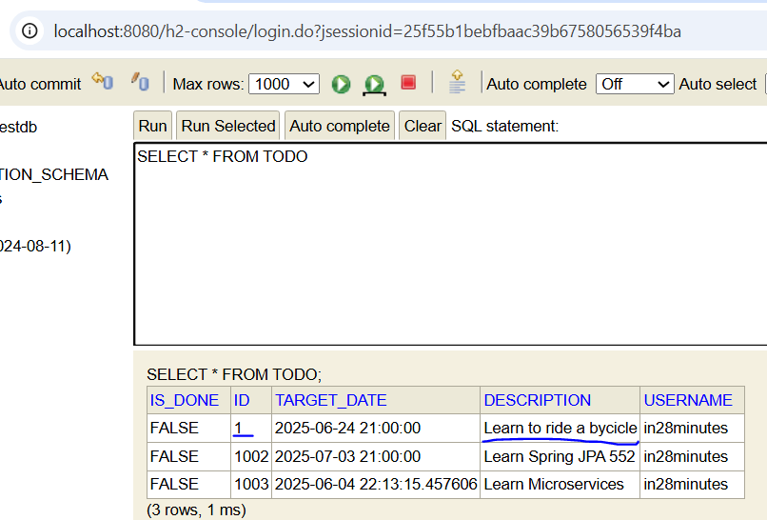

Now it is taking all of the todos, deleting, updating from database and inserting too.

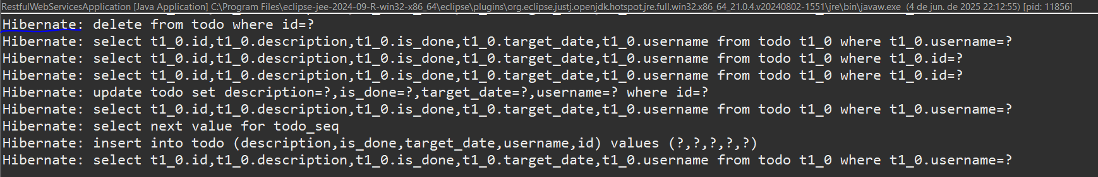

Checking the terminal at the back-end side, it is possible to check the sql operations done by hibernate as a proof that the controller uris are being requested, processed and answered back.

From this point ahead is to depth the knowledge in JWT to explain about the spring security working, in the following steps:

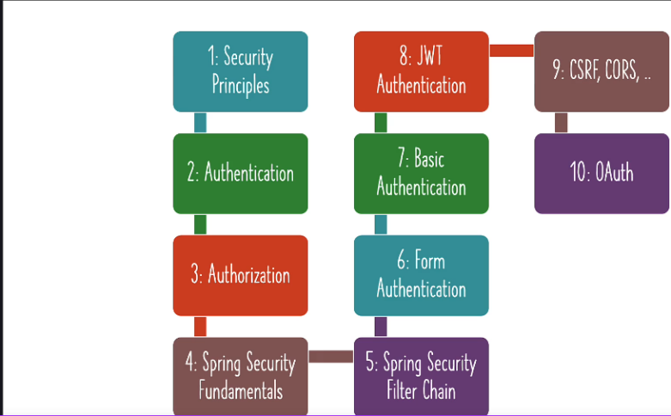

The security fundamentals are applied in any system, because it will guide the system working during the development.

Identifying the **resources** that the system will offer, a set of rest API services to be exposed, application (site) to consume the services, the database to store the client data (tables and relationships), a virtual machine on the cloud to run the app server.

Identifying the **identities / entities / actors** will access and manipulate the system using calls to modify the data and to set the allowed actions according to the profile..

Using the **authentication** to say who is the role / profile which is accessing the system by username and password that only the real user should remember and the ways to prove his identity (sms, email, key-pass).

Using the **authorization** to determine the level of hierarchy the user is subdue, for controlling the actions allowed to the type of user, for instance, the Adm can update and delete data while the common user can only retrieve the data.

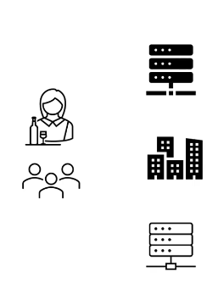

Every small flaw counts, so these principles will help to think in security:

1st Validate any request and its incoming content;

2nd Think about security requirements at beginning of the project considering which roles and privileges will be granted for each user as filters to be tested;

3rd Security since transport, network, infra, O.S and app built in a simpler way to be open to changes when needed;

Real life example: Get onboard in a plane, trust nothing, identify and check the **passenger** by **passport, id and the ticket,** the same way the **crew**, the **pilots**, the **check-in** team, **baggage inspection** team, **passengers** do not do **anything beyond** its limitations in every movement.

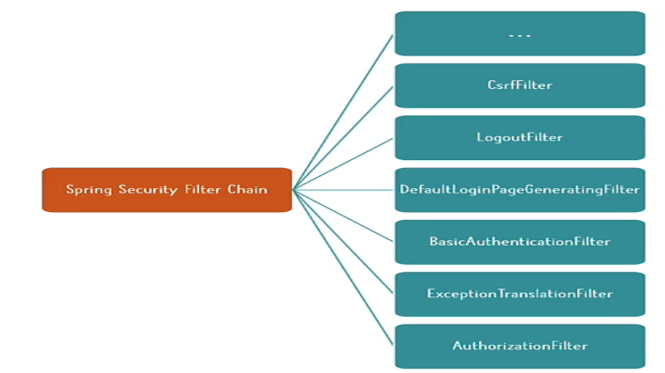

In Java, the spring security is the dependency focused in the protection of applications (rest API, Web apps, micro-services) covering a lot of points including authentication and authorization.

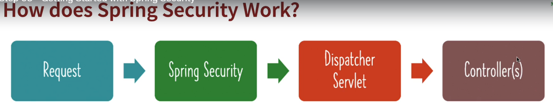

Obeying the principles, every each request and its data is intercepted by the spring security for applying a filter chain to allow or denying the continuation of process to reach a general controller (dispatcher Servlet) to analyze the request verb and url to specify which controller will be responsible for servicing the request.

Detailing the filters:

Authentication: is this user valid? -> AuthenticationFilter

Authorization: which right access does this user have? -> AuthorizationFilter

**C**ross-**O**rigin **R**esource **S**haring (CORS): Should a call from other domains be accepted?-> CorsFilter

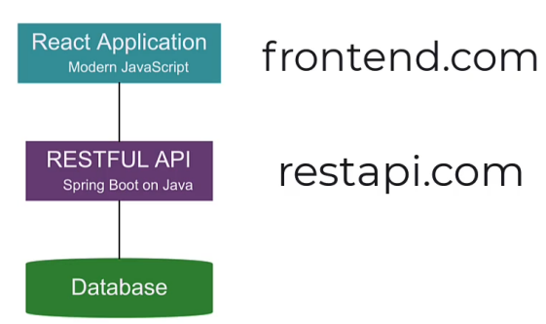

Similarly, **C**ross-**S**ite **R**equest **F**orgery (CSRF): is the domain is legit? Or is it reusing some stolen client cookie?->csrfFilter

*Forgery -> fake

AutoGenerated Login&Logout page ->LogoutFilter,DefaultLoginPageGenerationFilter,

DefaultLogoutPageGenerationFilter

In case of problems, exceptions, it’s not cool to return the error as it happens on the back-end, it is needed to translate it to a language that the common user can understand->HTTP responses->ExceptionTranslationFilter (Entity Response -> 404 not found)

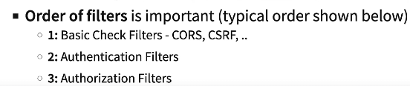

From this moment ahead, lets focusing on the hands on, open spring intlzr with these configs:

Dependency manager Maven, Java language, spring boot latest version, java latest version and **dependecies as spring web and security**.

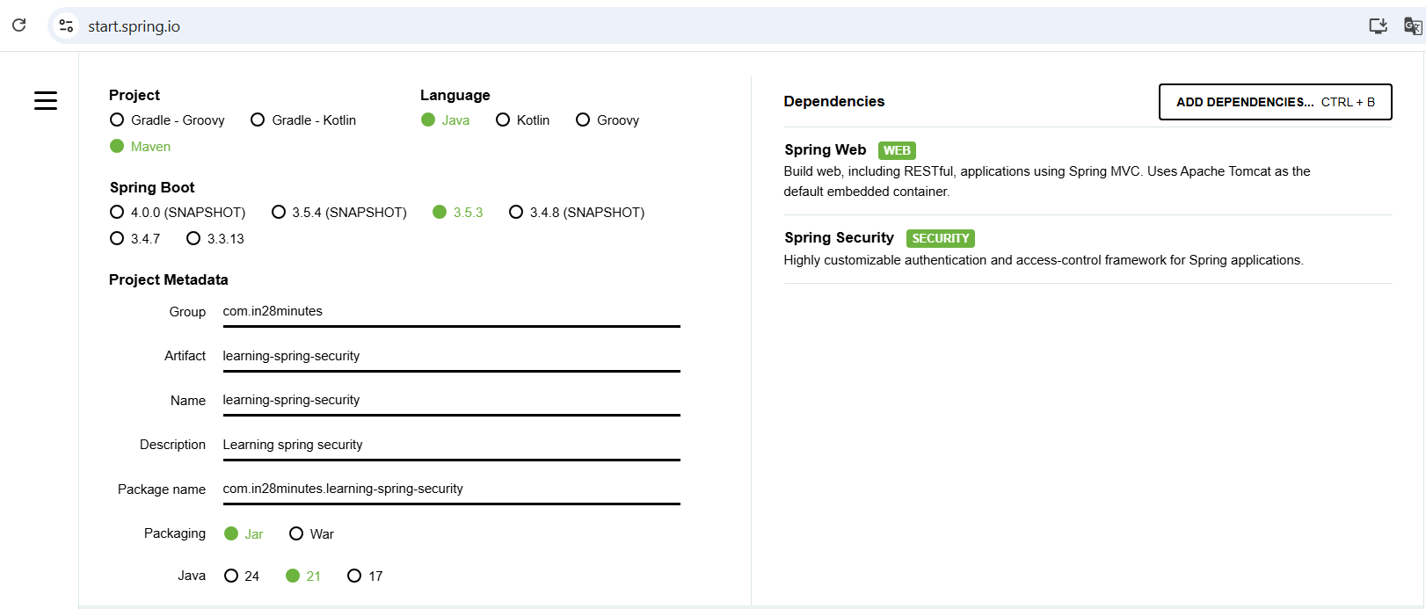

After importing the project and running on eclipse these info appear on the terminal showing the use of the dependencies:

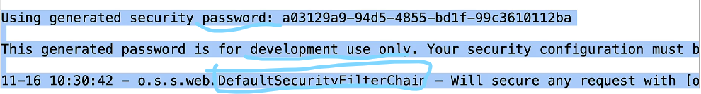

Using the spring security, when a service is available or not, the dependency protects the application from **every request** by default requiring the user is **authenticated** by **form** authentication (user+password ) providing a login & logout page, once logged in, it is created a cookie property that contains a session Id that is sent in **every request** **to identify** the **authenticated** **user**. Then, when the user accesses the /logout route, a logout page is rendered asking if you really want to log out, confirming it, the user is redirected to the log in page with a reminder saying that the user has been logged out.

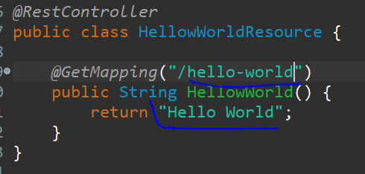

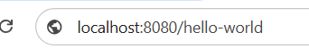



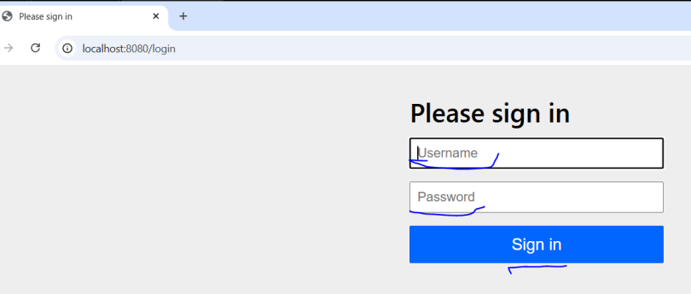

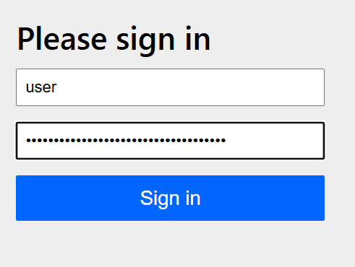



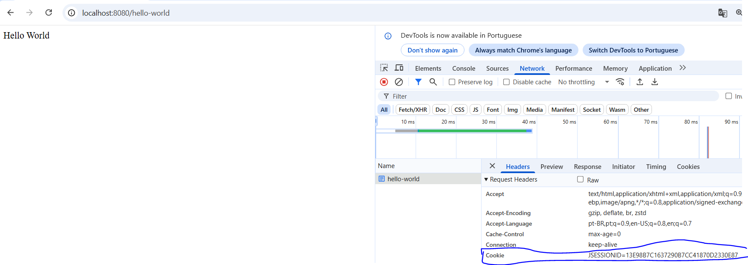

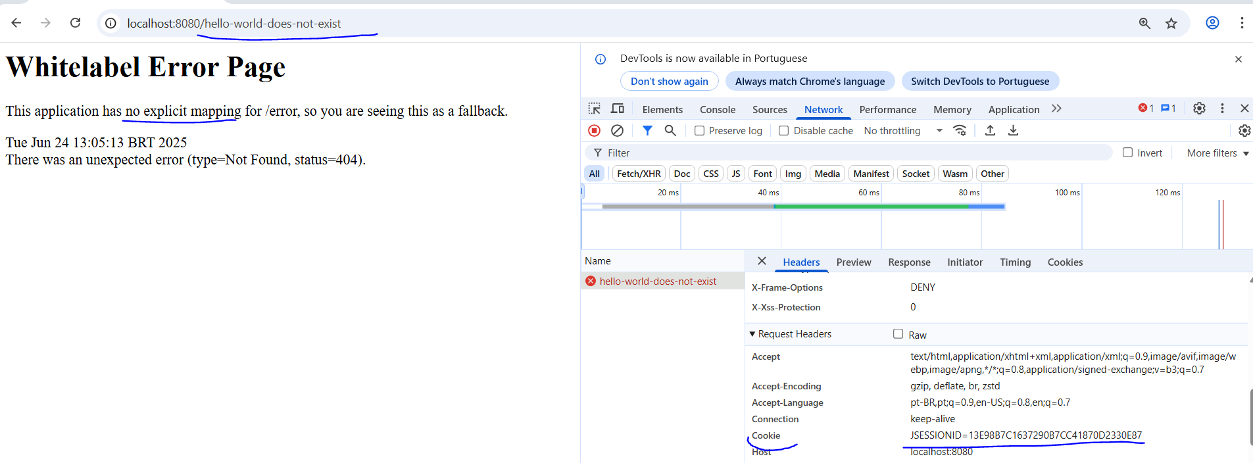

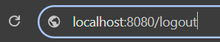

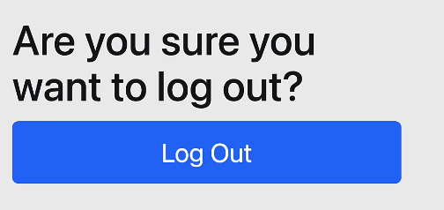

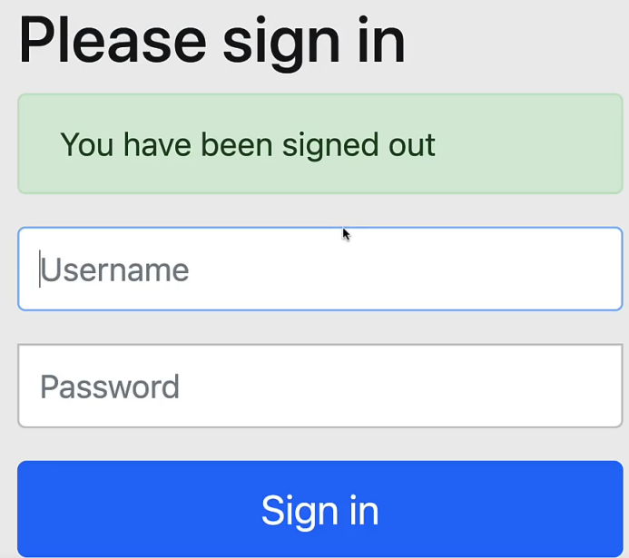

Another authentication way that is accepted by the spring security by default is the **basic** authentication as the most simple option that combines the username : password **encoded into base 64 along with ‘Basic ‘** as a request header property called **authorization** in every request. But it is recommended for development purpose only, because it is constant if the user or password doesn’t change and doesn’t expire being easily decoded and not contains authorization data like privileges, roles, etc. . Anyway, the user needs to be authenticated for accessing the services.

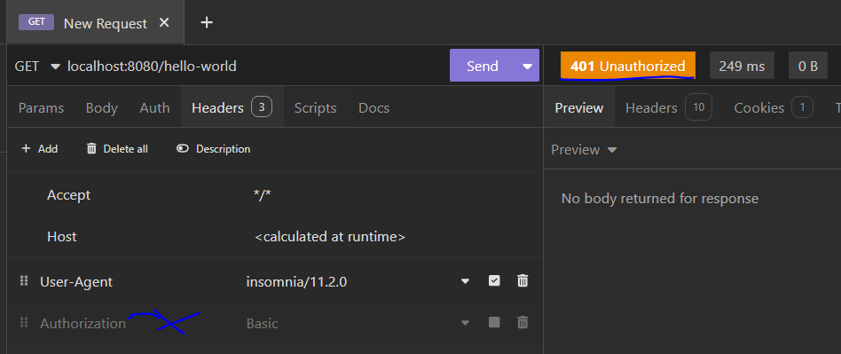

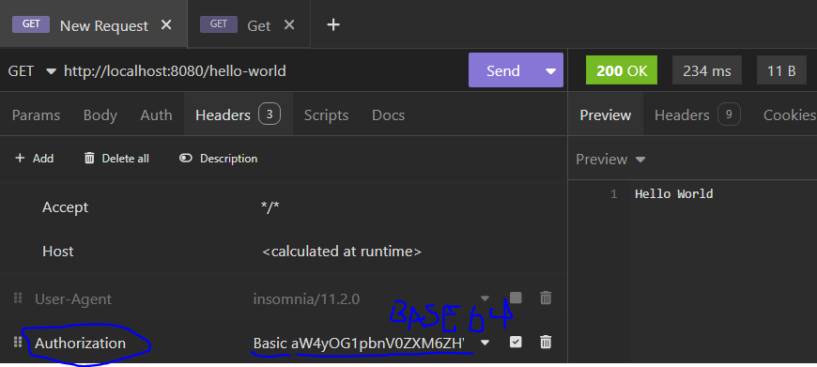

To make the username and password static, on application.properties include the lines:

Spring.security.user.name=in28minutes

Spring.security.user.password=dummy

The next protection used by default in spring security is the **C**ross-**S**ite **R**equest **F**orgery (CSRF), if the cookie was not erased because the user didn’t logged out, it will prevent the client cookie to be stolen and used in fraud actions by a malicious site.

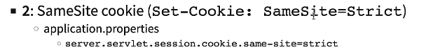

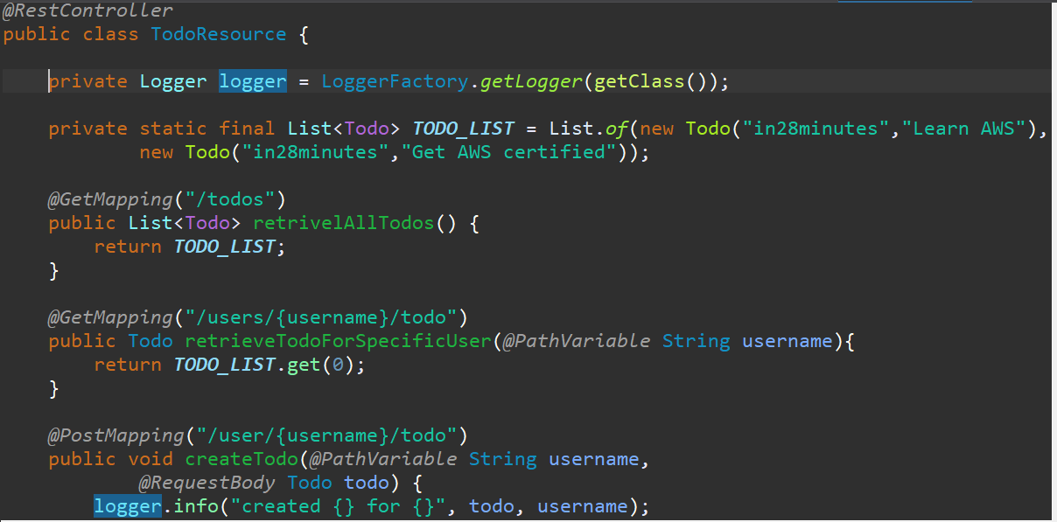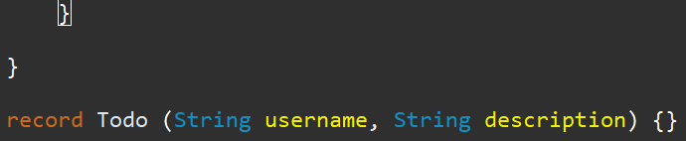

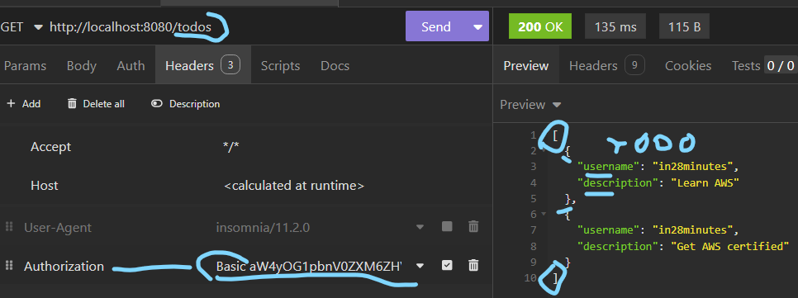

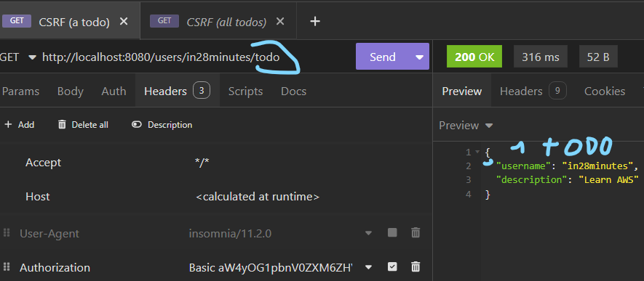

Without doing any configuration, the practice is to create one more controller for retrieving todos from a static list containing two todos from a record, creating get routes to retrieve all of them, one of them for a specific username and simulate an update operation with a post route receiving a todo.

* record: it is a special type of class responsible for carrying a **plain** set immutable data. Being a functional way to create **plain** data classes without worrying with manual creation of constructors, getters,setters,equals,hashcode and to string (compiler is responsible for it).

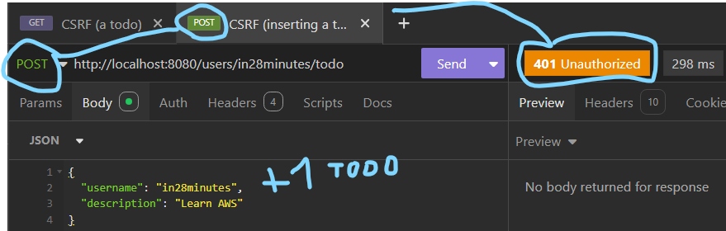

The solution provided is:

Creating a token for each request;

**For updating data**, CSRF token is needed from the previous request

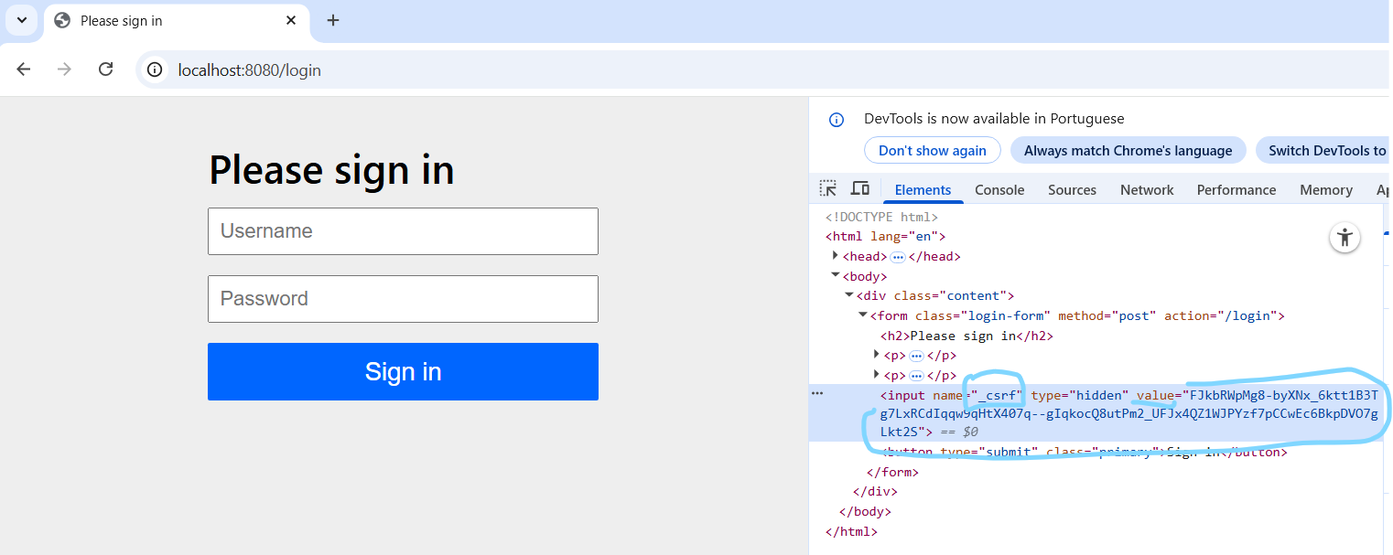

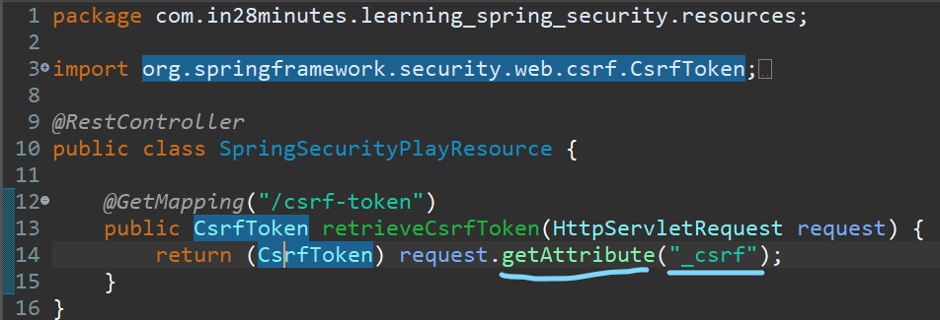

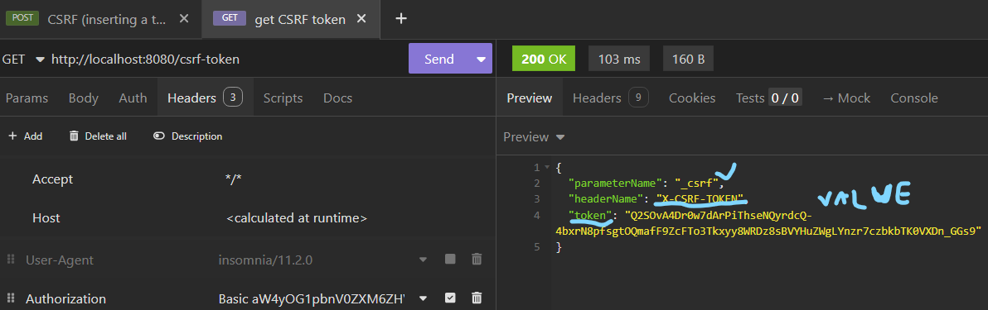

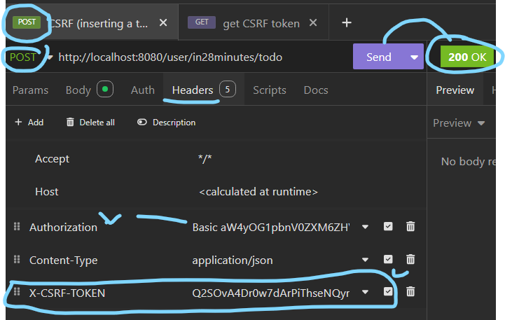



CSRF token is obtained by the request object from the attribute “_csrf” and cast it to a CSRF token interface. Then on insomnia, make the call to obtain the data: parameter name; headerName, token. With it on hands, it’s possible to make a post/put call.

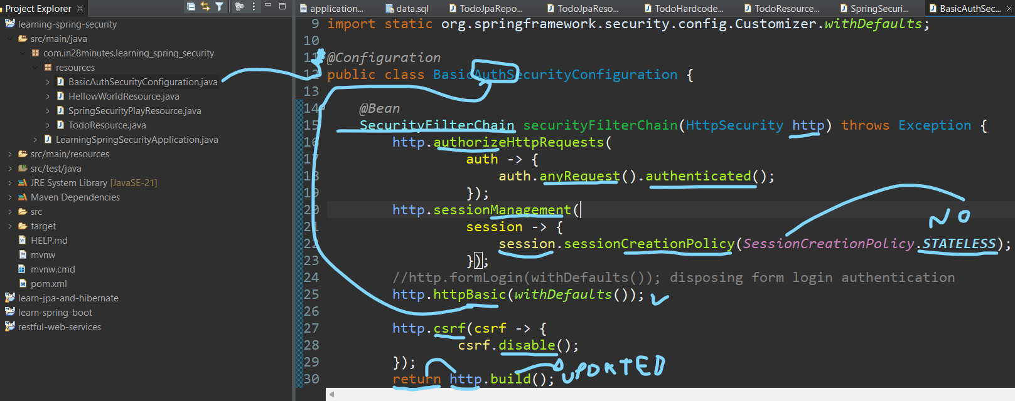

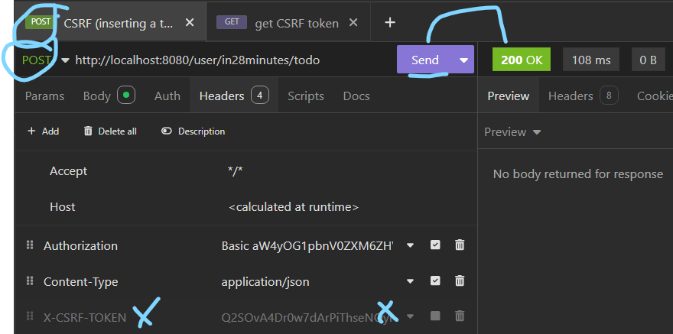



To disable the csrf, it is needed to create a new configuration class like BasicAuthSecurityConfiguration with the annotation @Configuration, practically copying a pre-exist method from a class of security configuration in the spring boot dependencies, just commenting the formLogin that is the form authentication with login&logout pages, passing a customizer called withDefaults() as parameter on httpBasic that is the basic authentication and mainly including csrf disabling code, using the same http object calling the csrf method and call the disable method as parameter, as in, http.csrf( csrf-> csrf.disable()). This way, is possible to make a post call without using the recovered csrf token.

When a full-stack app is built, the back-end needs to be prepared to deal with front-end (outside) requests, thinking about it, the **C**ross-**O**rigin **R**esource **S**haring(CORS) allows to set which domains are allowed to make requests to the resources, that by default is blocked.

For specifying the domains, there are two ways:

Global:

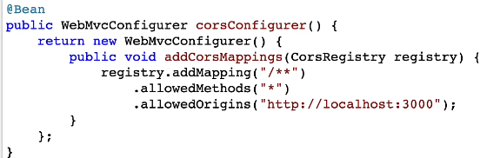

The registry object can set free all the routes and http verbs to specific domains, having access to **all the controllers**.

Local: On the specific controller or method use the @annotation @CrossOrigin without specifying which domain or @CrossOrigin(origins=”http://www.frontend.com”).

Focusing on managing the users of the app instead of only one, there are 3 ways to do this:

**In memory**  for development purpose only;

**Database** using JDBC/JPA to access the credentials;

**LDAP** - **L**ightweight **D**irectory **A**ccess **P**rotocol for accessing directory services and authentication.

Inside basicAuthSecurityConfiguration:

@Bean

Public UserDetailsService userDetailsService (){

Var user = User.withUsername(“in28minutes”)

.password(“{noop}dummy”)

.roles(“USER”)

.build();

Var admin = User.withUsername(“admin”)

.password(“{noop}admin”)

.roles(“ADMIN”);// I can include multiple roles, as in, 1 or +

.build();

Return new **InMemory**UserDetailsManager(user,admin);

}

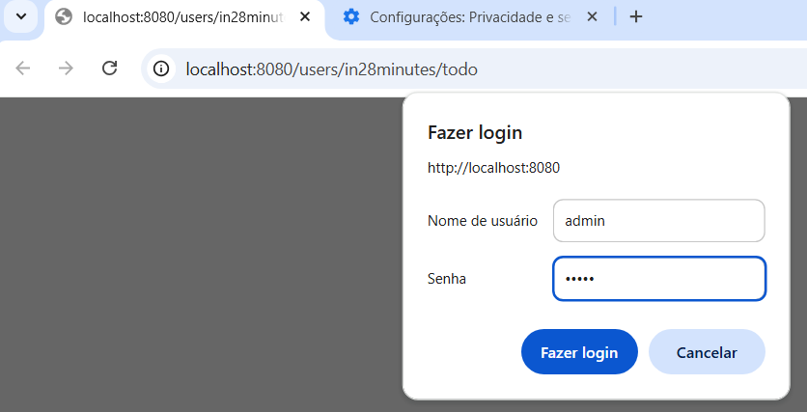

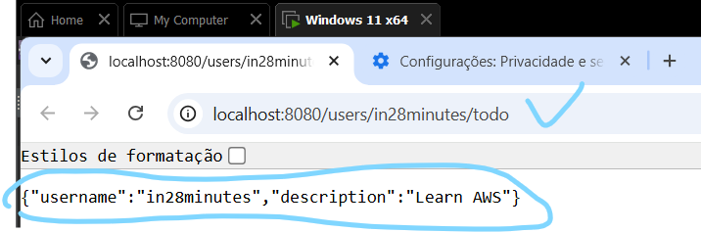

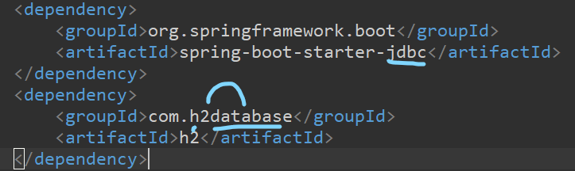



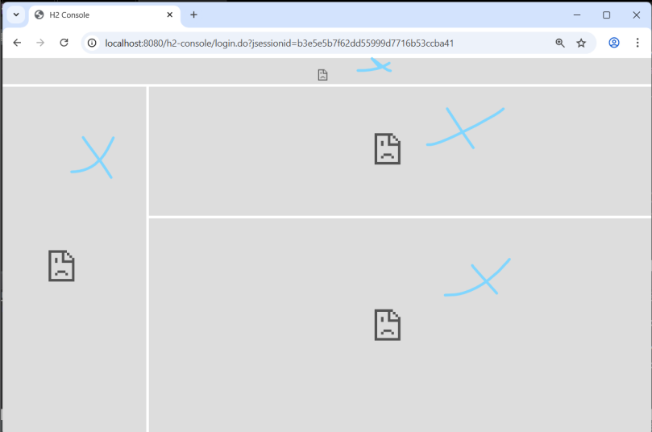



The second experiment is to use a **database** called h2 to store the **user credentials.** Getting started by the dependency importing and the fixed url on app.properties. When we try to open it after connecting, a lot of frames are blocked by spring security, for sorting this out the frame option must disabled from the header.

@Bean

public DataSource dataSource() {

return new EmbeddedDatabaseBuilder()

.setType(EmbeddedDatabaseType.H2) .addScript(JdbcDaoImpl.DEFAULT_USER_SCHEMA_DDL_LOCATION)

.build();

}

Now that everything is configured, still on the configuration class, define which database is being used, in this case the embedded H2, so a new method called dataSource is created to be responsible for using the embedded database, choosing H2 as type, **and executing the sql file responsible for creating the users and authorities table.**

@Bean

public UserDetailsService userDetailsService(**DataSource dataSource**) {

var user = User.withUsername("in28minutes")

.password("{noop}dummy")

.roles("USER")

.build();

var admin = User.withUsername("admin")

.password("{noop}dummy")

.roles("ADMIN")

.build();

var **jdbcUserDetailsManager** = new JdbcUserDetailsManager(**dataSource**);

jdbcUserDetailsManager.createUser(user);

jdbcUserDetailsManager.createUser(admin);

return jdbcUserDetailsManager;

}

Therefore, with the data source in hands, on the userDetailsService method make it as a parameter (dependency injection) for that after the **User** variables are created, instantiate the **jdbcUserDetailsManager** passing the data source as parameter to call the method **createUser** carrying the **user** variables as parameters and finally return it.

* {noop} -> no encoding.

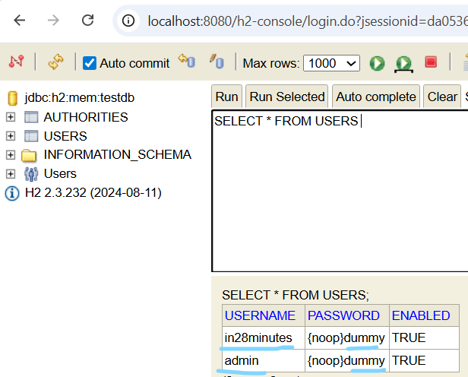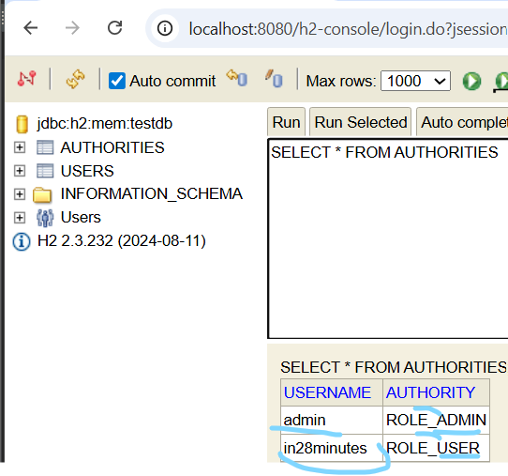

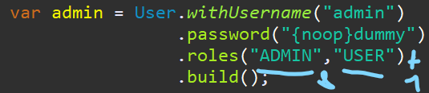

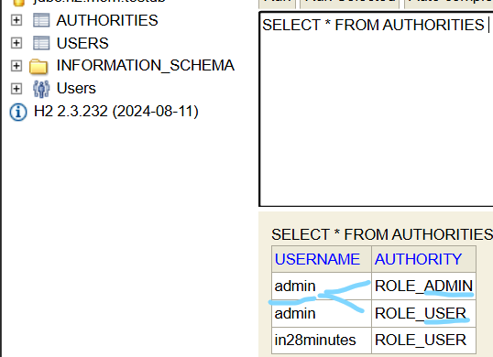

The hands on result is the creation of the tables (user&authorities) with the **user** data object **in database not only memory.**

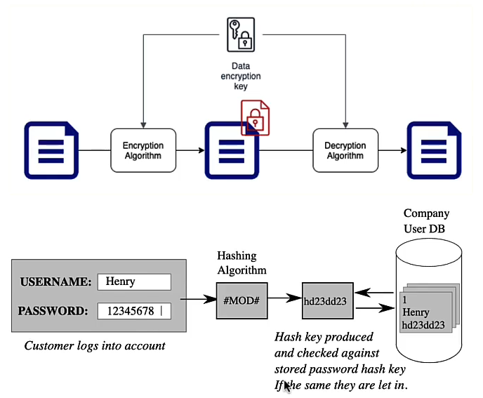

As a general overview, there are three data manipulation ways commonly used:

**Encoding** - Make a data to become another **different** one **without using** a key or password, being possible revert it to the original one. It is used in data **compression** or streaming, for instance: Base 64 (algorithm), Wav, MP3.

**Encryption -** Encoding & Decoding data **using** **a key or password to protect it.** Example: RSA.

**Hash -** Convert data into a Hash/String during a one-way **not reversible** process to make sure the data integrity not returning to be the old value and yes a comparison object. Example: bcrypt, scrypt, argon 2.

The HASH algorithm that was used so far is SHA-256, but it became no longer secure due to hardware improving for brutal force. The recommendation is to use **adaptive one way functions with Work Factor of 1 second,**  as in, functions that turn data in hash with no return of the original value with data verification of 1 second.

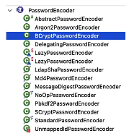

On java, **the PasswordEncoder** is **the interface** that is implemented by several classes for this adaptation.

var admin = User.withUsername("admin")

.password(**"dummy"**)

**.passwordEncoder(str -> passwordEncoder().encode(str))**....

@Bean

Public BCryptPasswordEncoder passwordEncoder(){

Return new BCryptPasswordEncoder();

}

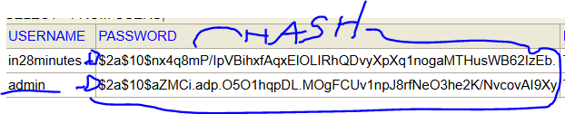

To apply the encryption, create a method to return the BCryptPasswordEncoder object and after .password on the User builder, include passwordEncoder method passing the lambda expression defining the password reference used on password method -> use the passwordEncoder method created to take the instance and call the encode method passing the password reference. The result will be the table user having the simple “dummy” password as a hashing code sequence.

Detailing the JWT (Java Web Token), it is a **standard** in authentication and authorization of users to protect the data between two parties to avoid flaws, as features in comparison to basic auth, it has expiration time for invalidating stolen tokens, save user details and authorizations and not being easily decoded.

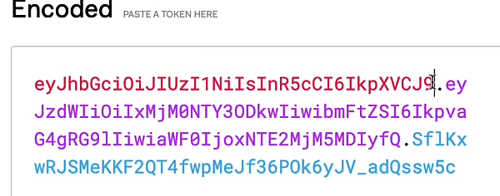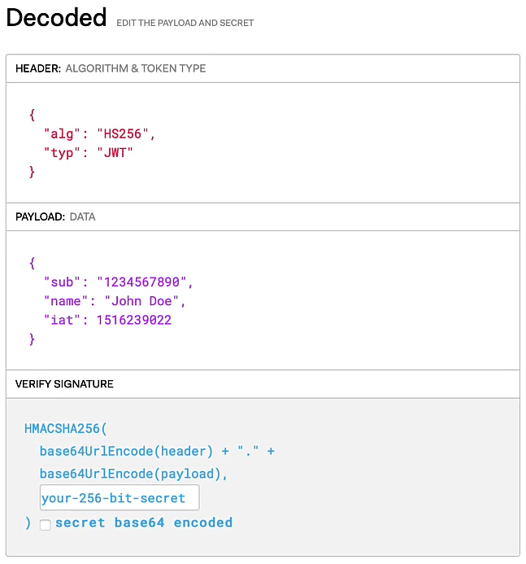

The JWT structure is header, payload and signature. The header contains the hash algorithm, type of token, the payload contains the data as iss: the issuer, sub: the subject, aud: the audience, exp: expiration time, iat: token creation date and custom attributes, the signature having the header and payload encoded and the **secret key.**

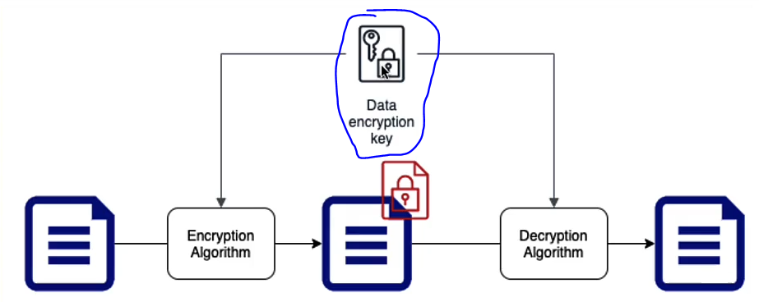

This key can be symmetric or asymmetric. The symmetric uses the **same key for encryption and decryption of the data**, choosing the right algorithm and securely sharing the key.

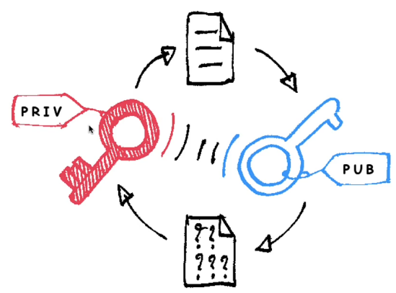

The asymmetric key is composed by **TWO keys, public and private keys,**  where the public key is shared with **trusted** everybody, encrypts the simple data and the private key shared **only with you,** decrypts the encoded data. So, one key doesn’t finds another, just for encryption or decryption, being the asymmetric key the recommended for business.

The flow is create a JWT for encoding user credentials, data and RSA key, send the JWT on header request as Authorization: Bearer ${JWT_TOKEN} to be decoded and verified using the RSA key.

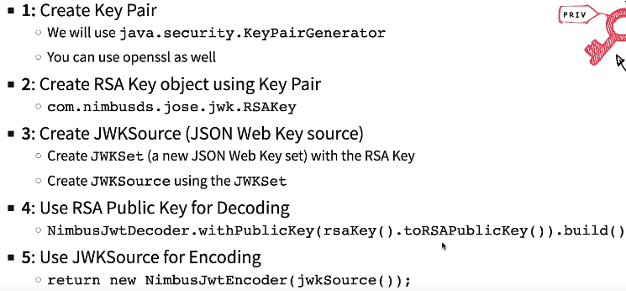

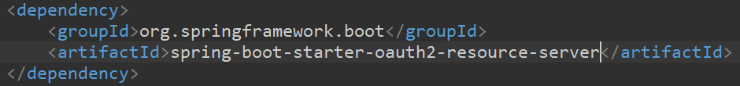

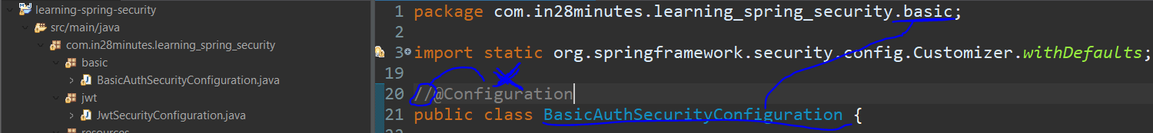

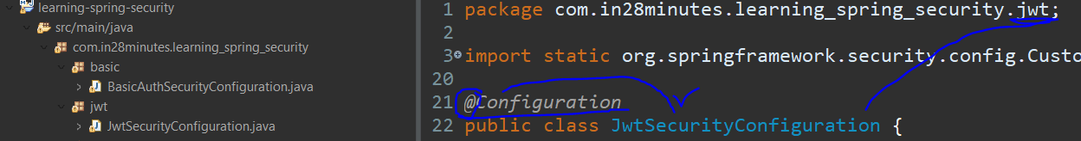

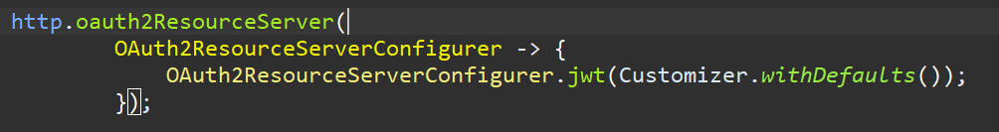

For implementing the JWT on the project is needed a lot of steps, but for getting started, include the dependency **oauth2-resource-server** on the pom.xml file, reuse the BasicAuthenticationSC code on the new JwtSecurityConfiguration class, separate them in different packages, then disable the BasicAuthSC commenting the @Configuration annotation. Just an observation, the same way the httpBasic and formLogin enable specific ways to authenticate the user, the method **oauth2ResourceServer** is responsible for enabling the **jwt authentication** like an  **authentication provider**.

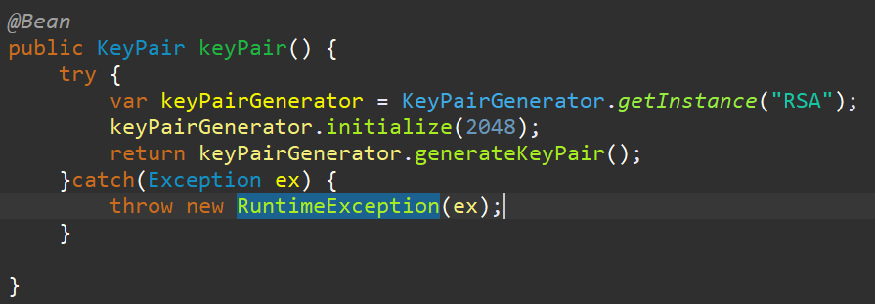

The first step is to create the **two keys** through the **KeyPair object**, using the class KeyPairGenerator to create the public and private keys using the algorithm passed as string, determine the key size bigger is better, then return the keys if by chance the algorithm doesn’t exist the exception is thrown.

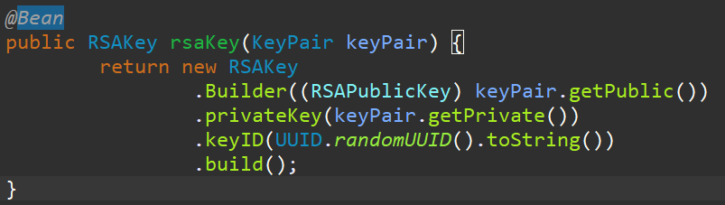

After the two keys are created, an object **RSAKey** needs to be created containing the public key, private key, and the own ID that in this case is a random one.

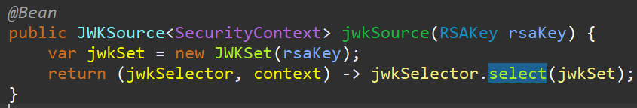

Also is needed to create JSON Web Key Source using a jwkSet with the rsaKey, being a way to store the cryptography keys in JSON format of the algorithm RSA **to validate the JWT token signatures**.

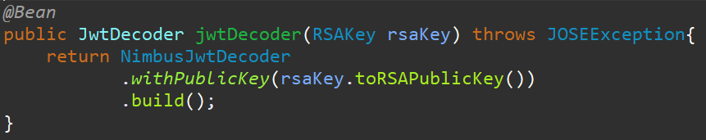

After JWKSet and source are defined, it is needed to decode the data using the public key in rsa object to return a **JwtDecoder implementation**.

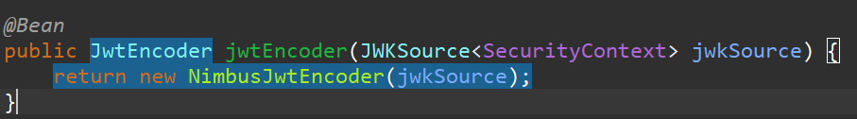

The same way the decoder is needed, the encoder is too, then the **jwtEncoder implementation object** using jwkSource as parameter is returned.

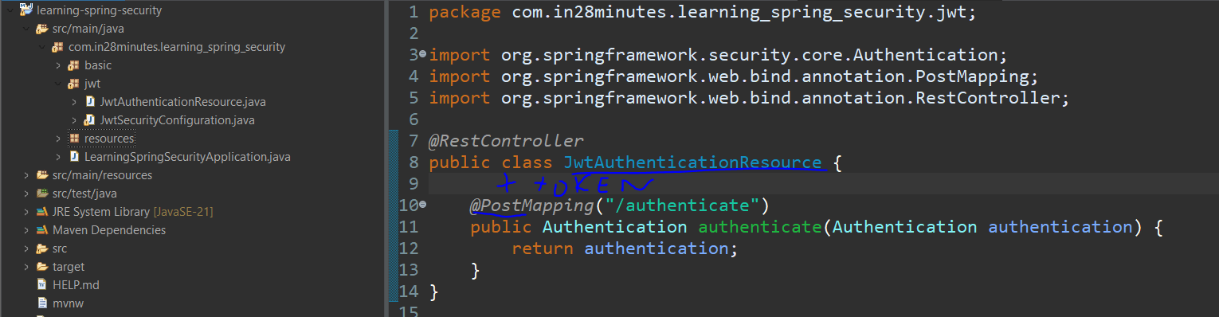

Once the configuration is done, it is needed to start building the controller to supply the jwtToken for making any other request. The Authentication object will be used to obtain the token.

Private JwtEncoder jwtEncoder;

Public JwtAuthenticationResource(JwtEncoder jwtEncoder){

This.jwtEncoder = jwtEncoder;

}

Based on the configuration, the jwtEncoder has the **algorithm, the private and public keys**, this way, declaring a new **reference** on rest controller constructor **will carry all this info**.

....

Public JwtResponse authentication(Authentication authentication){

Return new JwtResponse(createToken(authentication));

}

Private String createToken(Authentication authentication){

Var claims = JwtClaimsSet

.builder()

.issuer(“self”)

.issuedAt(Instant.now());

.expiresAt(Instant.now().plusSeconds(60L * 30L);

.subject(authentication.getName())

.claims(“scope”, createScope(authentication))

.build();

Return JwtEncoder.encode(JwtEncoderParameters.from(claims)).getTokenValue();

}

Record JwtResponse (String token){}

But it doesn’t have **the payload,** so thinking about it, a method is created to this using the authentication object as part of creation of the payload and token. This creation is encapsulated on the object **JwtClaimsSet** to define: issuer(creator),issuedAt(current time),expiresAt(current time + 30 minutes),subject(Username from auth),claims(scope of authorization from auth inside another new method ).

Now the **payload** is filled in, use the jwtEncoder method to encode **it** using the class JwtEncoderParameters with the payload, to finally obtain the validated token by JWKs in a record called JwtResponse as return of the request.

Private String createScope(Authentication authentication){

Return authentication

.getAuthorities()

.stream()

.map(a -> a.getAuthority())

.collect(Collectors.joining(“ ”));

}

This scope comes from a list of authorities, because the user can have 1 or more roles that needs to be reduced to a String like “ADMIN USER”.

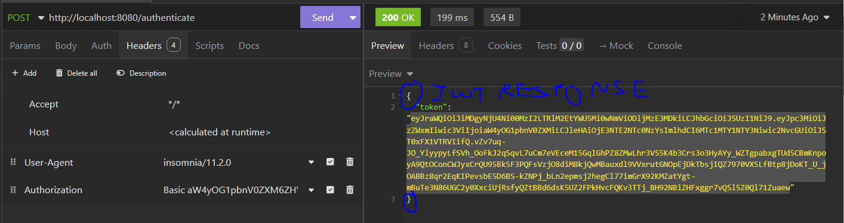

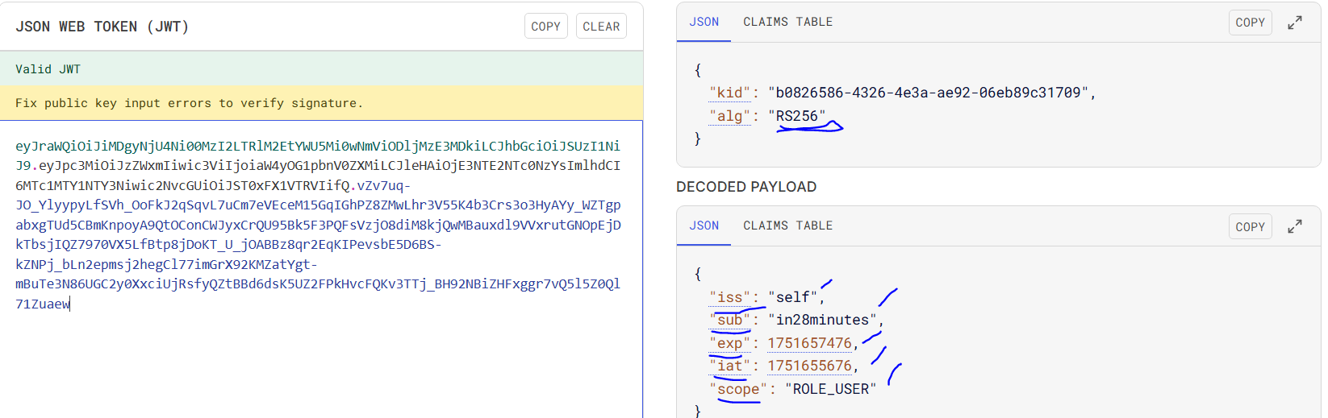

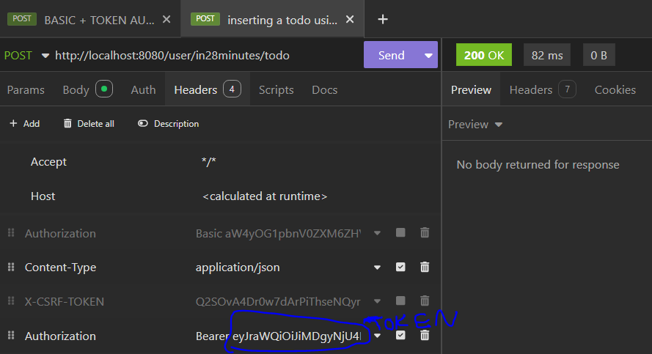

Making the request to this authentication service, the token is obtained.

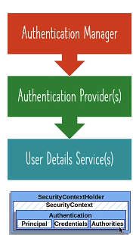

The Authentication in depth is the use of authentication manager to intercept the requests and validate them using the authentication provider (JWT) to obtain the credentials(username&password).

@Bean

public **UserDetailsService** userDetailsService(DataSource dataSource) {

var user = User.withUsername("in28minutes")

.password("dummy")

.passwordEncoder(str -> passwordEncoder().encode(str))

.roles("USER")

.build();

var admin = User.withUsername("admin")

.password("dummy")

.passwordEncoder(str -> passwordEncoder().encode(str))

.roles("ADMIN")

.build();

....

Once validated, the user data known as principal and authorities(roles) are retrieved from UserDetailsService.

The data are stored in Authentication(principal) and GrantedAuthority(roles).

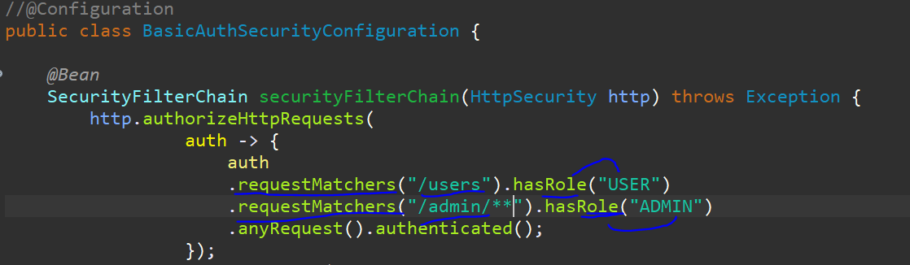

Specially about authorization, the global and method one can applied. For **global** is through the method **requestMatchers** to specify the user role allowed to do some request.

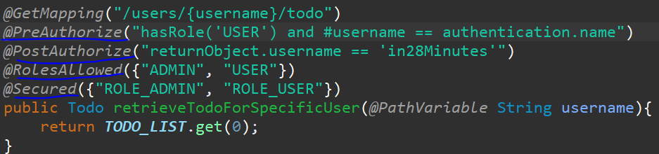

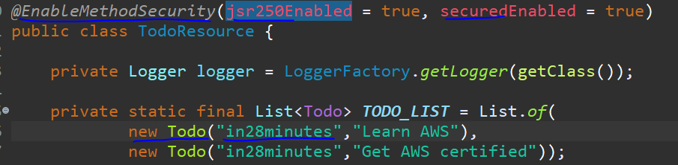

In **method security** there multiple options to protect the access to a method, including:

@PreAuthorize-> **before** making the request, it is verified if the user matches some conditions for example, role and username (pathVariable = authentication).

@PostAuthorize-> **after** making the request, it is verified the user matches some conditions for example, if the username of the return object is ‘x’.

@RolesAllowed({“”,””})-> check **the roles allowed** to request the service.

@Secured({“ROLE_...”},{“ROLE_...”})-> check **the authorities** to request the service

As a fullfilment of the OAuth, lets suppose that we want to share a google drive file with the todo management app. Then, there are some roles that can be identified:

**Resource owner**: ourselves.

**Client App**: Todo Management app.

**Resource server**: contains the resources that are being accessed- Google Drive

**Authorization Server**: Google OAuth Server

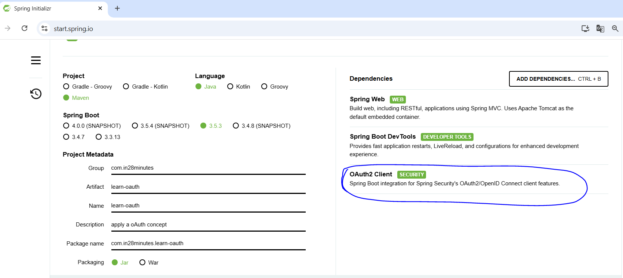

As a hands-on simulation, a new spring boot project is created with the **OAuth2 Client** dependency to make the bridge between the project and google.

Setting up the Web Security Configuration, a new file is created with the @Configuration annotation and the following method:

@Configuration

Public ...

SecurityFilterChain defaultSecurityFilterChain(httpSecurity http) throws Exception {

http.authorizeHttpRequests(

Auth -> {

Auth.anyRequest().authenticate();

})

//http.formLogin();

//http.httpBasic();

**http.oauth2Login(Customizer.withDefaults());**

Return http.build();

}

...

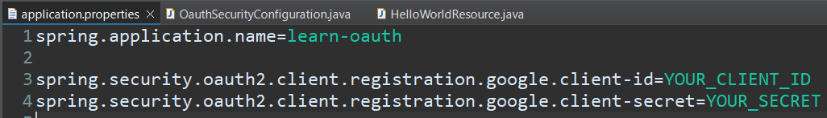

Configuring the application.properties file to store the google client id & secret to **authorize the google user** to access the project resource instead of **default formLogin and basic auth** by spring security Oauth2. For obtaining these info, it is needed to access the website [https://console.cloud.google.com/](https://console.cloud.google.com/,) , and follow these steps:

° login with your google account

°on the dashboard:

° create credentials-> OAuth client ID

° if it is the first time, it is needed to create an **OAuth consent** to authorize the external access to the resource. Because the google authentication will **share client information** **with our project** like profile info and email (scope), then it is needed to configure our project presentation to the user while authentication like app name, support email, app logo,

°After the OAuth consent is created, create credentials-> OAuth client ID

° Define the app kind, name and a default uri(s) before reach our project route like <http://localhost:8080/login/oauth2/code/google> and press create.

° A pop-up window is displayed containing the client-id and secret, copy them and replace YOUR_CLIENT_ID & YOUR_SECRET at application.properties.

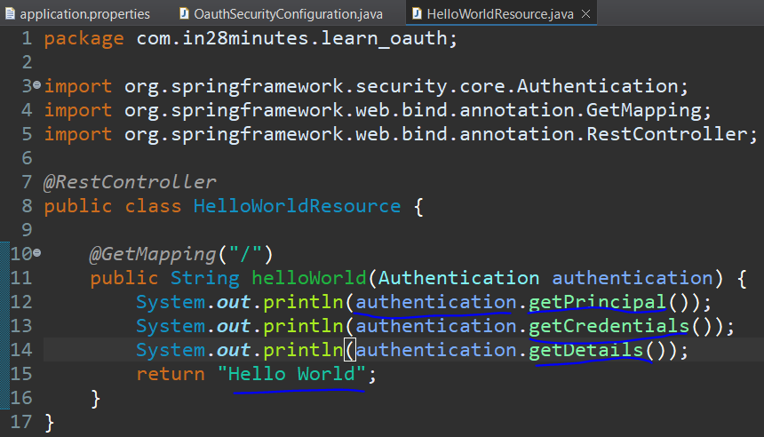

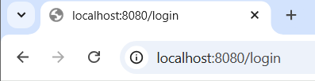



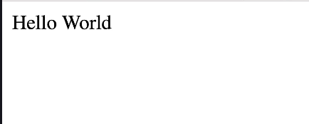

After this configuration, we are able to create the controller to return at least a “hello-world” and on the terminal to access the user details through the authentication object.

**Course link:** [Course: Go Java Full Stack with Spring Boot and Angular | Udemy](https://www.udemy.com/course/full-stack-application-development-with-spring-boot-and-angular/learn/lecture/12537676" \l "overview)

**Course Repository**: <https://github.com/in28minutes/full-stack-with-angular-and-spring-boot>

**Extras:**

#### ****Learn Python****

[THE BEST PYTHON COURSE EVER](https://links.in28minutes.com/python" \t "https://www.udemy.com/course/full-stack-application-development-with-spring-boot-and-angular/learn/lecture/_blank)

#### ****Option: Learn Cloud****

[1: EASIEST AZURE COURSE](https://links.in28minutes.com/az-900" \t "https://www.udemy.com/course/full-stack-application-development-with-spring-boot-and-angular/learn/lecture/_blank)

[2: EASIEST AWS COURSE](https://www.udemy.com/course/aws-certified-cloud-practitioner-step-by-step/?couponCode=NOV2023" \t "https://www.udemy.com/course/full-stack-application-development-with-spring-boot-and-angular/learn/lecture/_blank)